Jim Carafano  Lamb  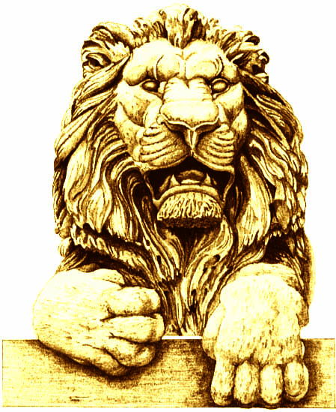 | Terry Considine  Sea Bass
Pat English  Lamb | Terri Famer  Sea Bass
Cynthia Friauf  Sea Bass | Robby George  Lamb
Rick Graber  Sea Bass | Mike Grebe  Lamb
Mike Hartmann  Lamb | Diane Hendricks  Sea Bass
Mandy Hess  Sea Bass | Roger Kimball  Sea Bass
Dionne King  Sea Bass | Dennis Kuester  Lamb
Mike Lempke  Sea Bass | Alicia Manning  Lamb *
Cleta Mitchell  Sea Bass | Art Pope  Lamb
Jan Riordan  Sea Bass | Dan Schmidt  Sea Bass
Dianne Sehler  Sea Bass | Dave Uihlein  Sea Bass
George Will

Sea Bass

