Jill Budny  Sea Bass  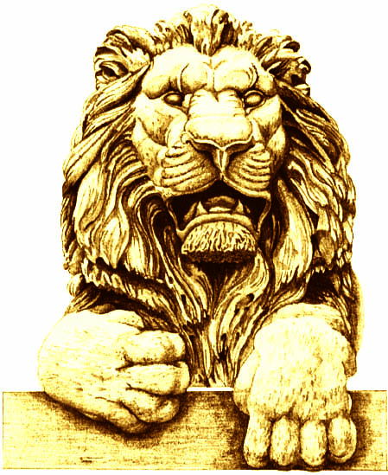 | Jessica Dean  Sea Bass
Terri Famer  NY Strip – Med. well | Cynthia Friauf  NY Strip
Dianne Sehler  NY Strip – Med. well | Terry Considine  Sea Bass
Curt Culver  NY Strip | Pat English  Sea Bass
Ben Hannemann  NY Strip | Mike Hartmann  NY Strip
Mandy Hess  NY Strip | Dionne King  Sea Bass
Robby George  NY Strip | Rick Graber  NY Strip
Mike Grebe  Sea Bass | Victor Davis Hanson  NY Strip
Mike Lempke  NY Strip – Med. well | Alicia Manning  NY Strip *
Jan Riordan  NY Strip | Dan Schmidt  NY Strip
Dennis Kuester  NY Strip – Med. rare | Cleta Mitchell  NY Strip
Art Pope  NY Strip | David Uihlein  NY Strip
George Will  Sea Bass | Sue Culver  NY Strip
Nancy Einhorn  Sea Bass | Steve Einhorn  Sea Bass
Jennifer Heyne  Sea Bass | Jason Kohout  NY Strip
Trudi Nash  Sea Bass | David Nash  NY Strip
Lyn Zigman  NY Strip | Arthur Brooks
Patty Grebe

Sea Bass

