Dave Uihlein  Steak  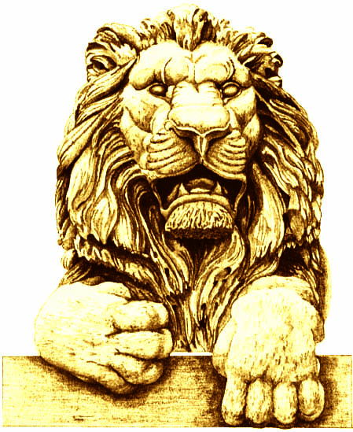 | George Will  Steak
Alicia Manning  * | Terry Considine  Salmon
Pat English  Salmon | Terri Famer  Steak - Well
Cynthia Friauf  Steak | Robby George  Steak
Mike Grebe  Steak | Mike Hartmann  Steak
Diane Hendricks  Salmon | Mandy Hess  Steak
Dionne King  Salmon – Extra well | Dennis Kuester  Steak
Mike Lempke  Steak | Cleta Mitchell  Steak - Medium
Art Pope  Steak | Jan Riordan  Salmon
Dan Schmidt  Steak | Dianne Sehler  Steak

