Dave Uihlein  Steak  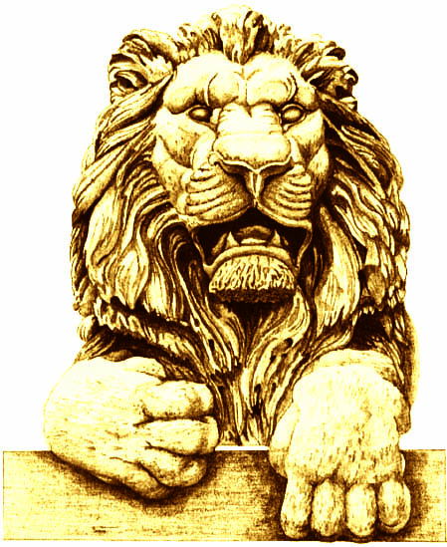 | George Will  Steak
Cynthia Friauf  Salmon | Terry Considine  Salmon
Pat English  Salmon | Terri Famer  Steak – Medium well
Jessica Dean  Salmon | Alicia Manning  Salmon *
Mike Grebe  Steak | Mike Hartmann  Steak
Mandy Hess

Steak

Dionne King  Steak – Well | Dennis Kuester  Steak
Cleta Mitchell

Steak

Victor Davis Hanson  Steak | Jan Riordan  Steak
Henry Olsen  Steak | Dan Schmidt  Steak
Dianne Sehler

Salmon - Well

Diane Hendricks  Salmon | Mike Lempke  Steak – Medium well

