Jill Budny  Filet  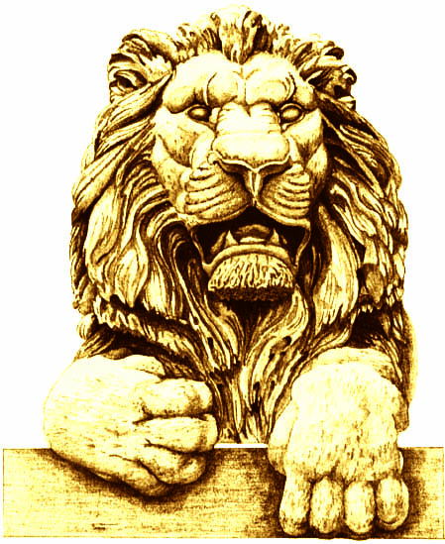 | Terry Considine  Salmon
Curt Culver  Salmon | Jessica Dean  Salmon
Pat English  Salmon | Terri Famer  Filet – Medium well
Cynthia Friauf  Filet | Robby George  Filet
Rick Graber  Filet | Mike Grebe  Filet
Ben Hannemann

Filet

Victor Davis Hanson  Chicken  Steak – Well | Mike Hartmann  Filet
Diane Hendricks

Salmon

Mandy Hess  Filet | Betsy Jones  Salmon
Roger Kimball  Salmon | Dionne King  Filet - Well
Dennis Kuester

Filet

Mike Lempke  Filet – Medium well | Alicia Manning  Filet *
Cleta Mitchell  Filet | Art Pope  Filet
Jan Riordan  Filet | Dan Schmidt  Chicken
Dianne Sehler  Salmon - Well | Dave Uihlein  Filet - Medium
George Will

Filet

