Jill Budny  Filet  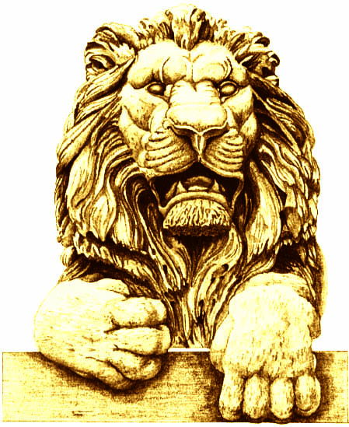 | Terry Considine  Salmon
Curt Culver  Filet | Jessica Dean  Filet
Pat English  Salmon | Terri Famer  Filet – Medium well
Cynthia Friauf

Filet

Rick Graber  Filet | Ben Hannemann  Salmon
Victor Davis Hanson  Filet – No mushrooms  Steak – Well | Mike Hartmann  Filet
Diane Hendricks

Salmon

Mandy Hess

Filet

Dionne King

Filet – Well

Dennis Kuester

Filet

Mike Lempke  Filet – Well | Alicia Manning  Salmon *
Cleta Mitchell  Filet | Heather  Mac Donald  Salmon – Special
Jan Riordan  Filet | Dan Schmidt  Filet
Dianne Sehler  Filet | Dave Uihlein  Filet

