Organizations List
[View in Use is Tax Info]
Double Click to Open the Organization’s Record

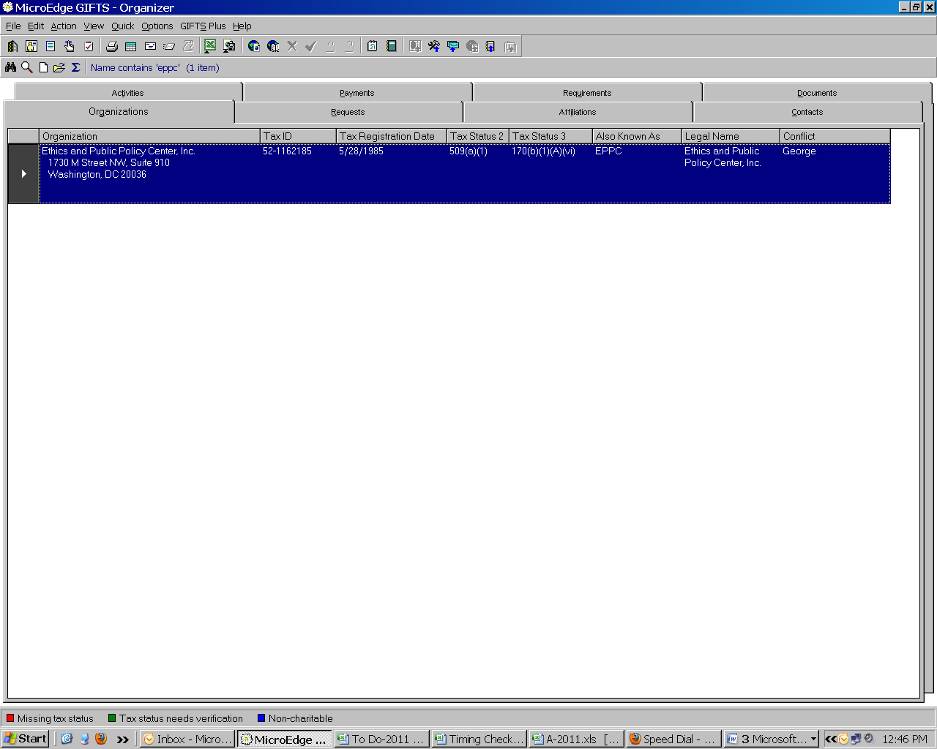

First Screen within Organizations is Organization.
This tab provides basic information about the organization.

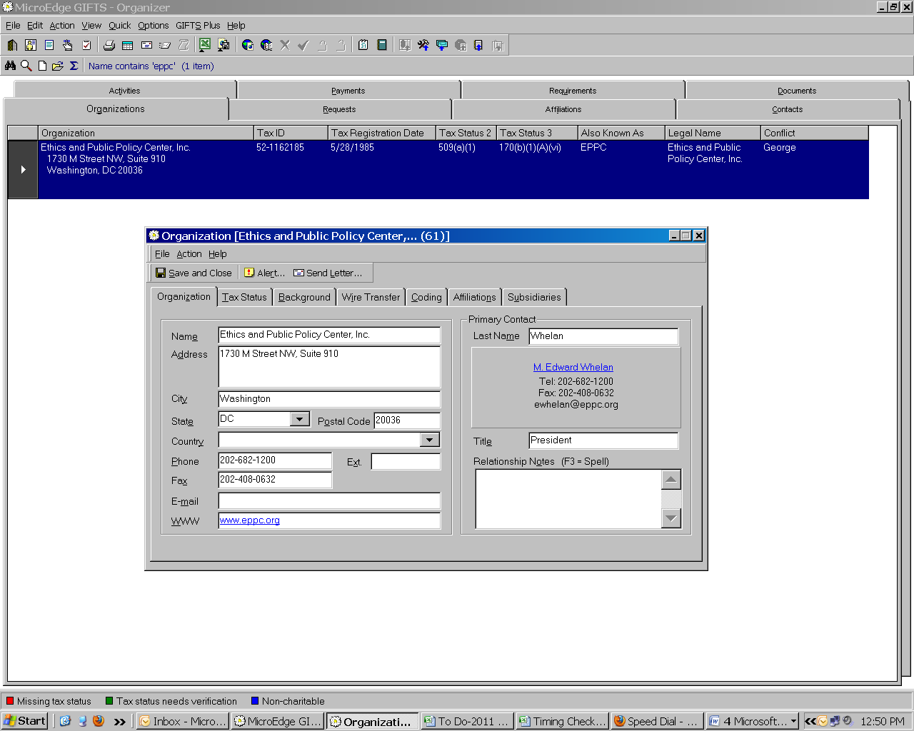

Second Screen within Organizations is Tax Status.
This tab provides information concerning tax-exempt status.

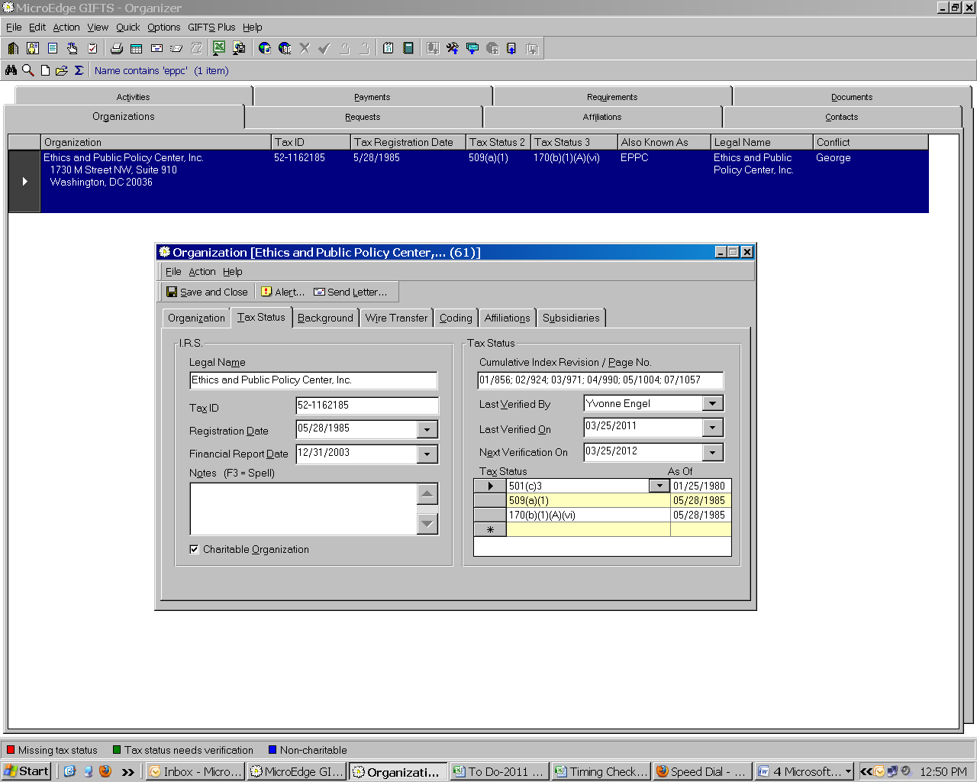

Third Screen within Organizations is Background.
This tab provides information concerning background and additional names.

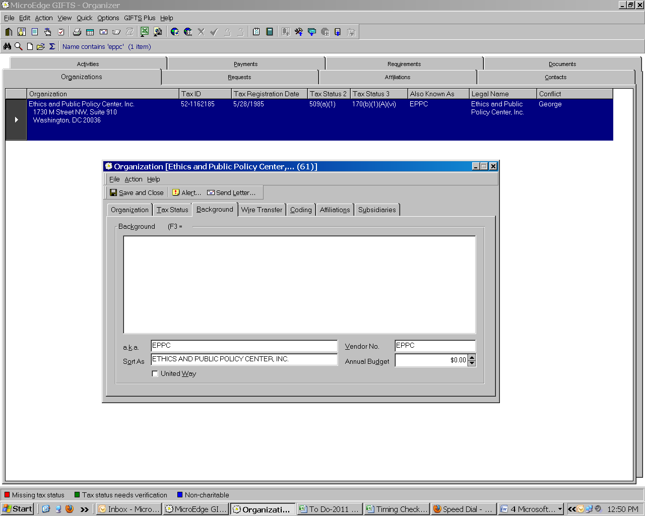

Fourth Screen within Organizations is Wire Transfer.
This tab provides information concerning the organization’s bank information.

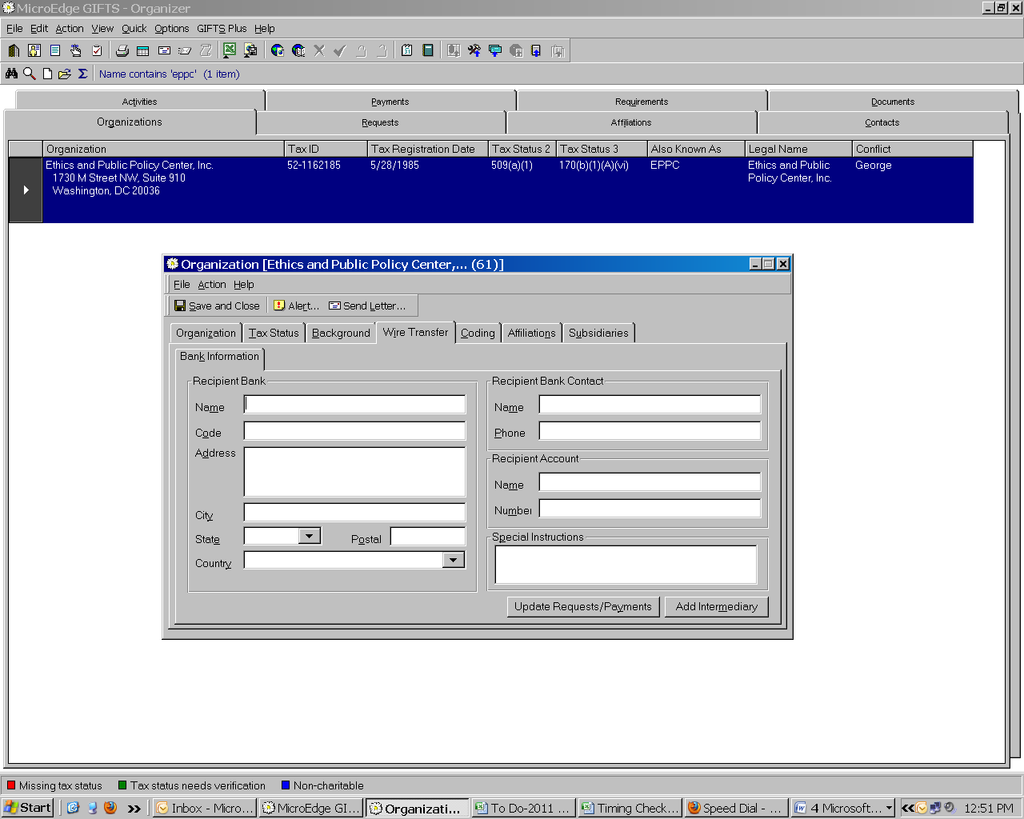

Fifth Screen within Organizations is Coding.
This tab records information concerning coding categories of the Foundation.

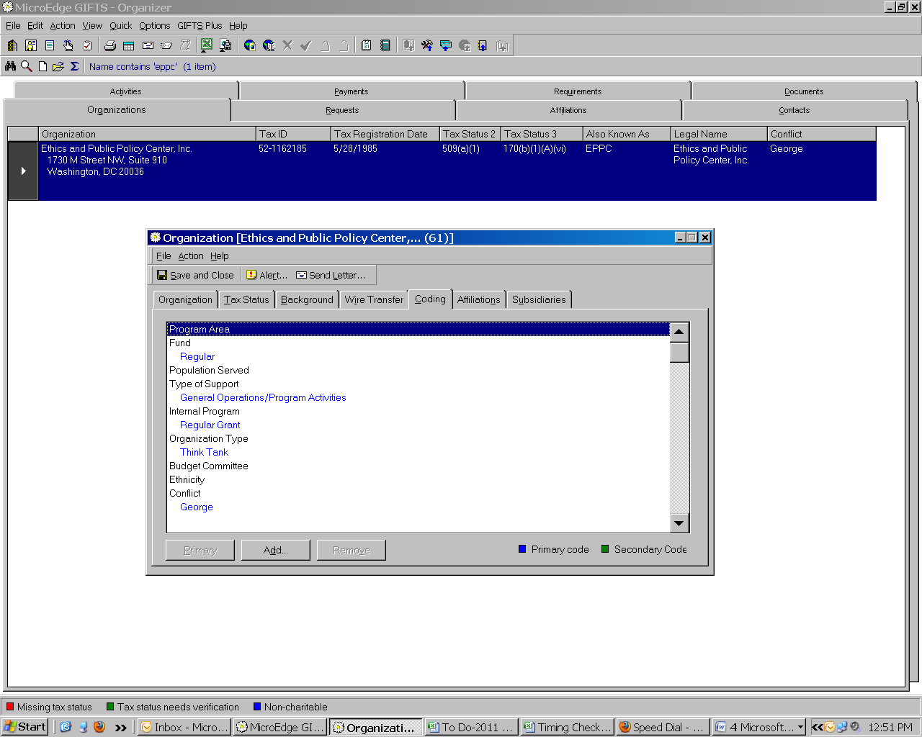

Sixth Screen within Organizations is Affiliations.
This tab indicates persons affiliated with the organization in any capacity.

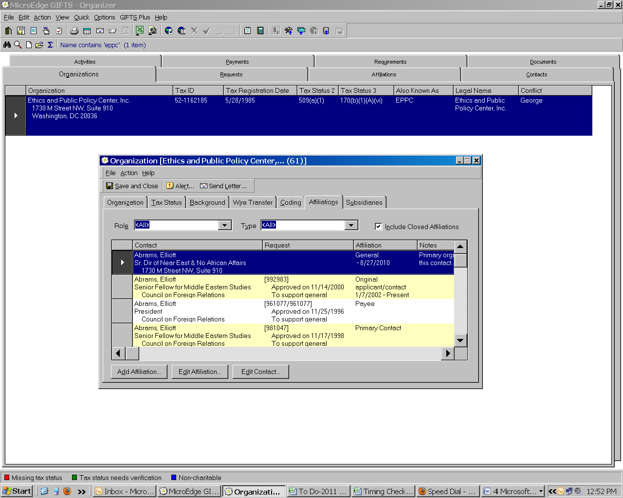

Seventh Screen within Organizations is Subsidiaries.
This tab links related organizations together.

