**AFFILIATIONS RECORD**

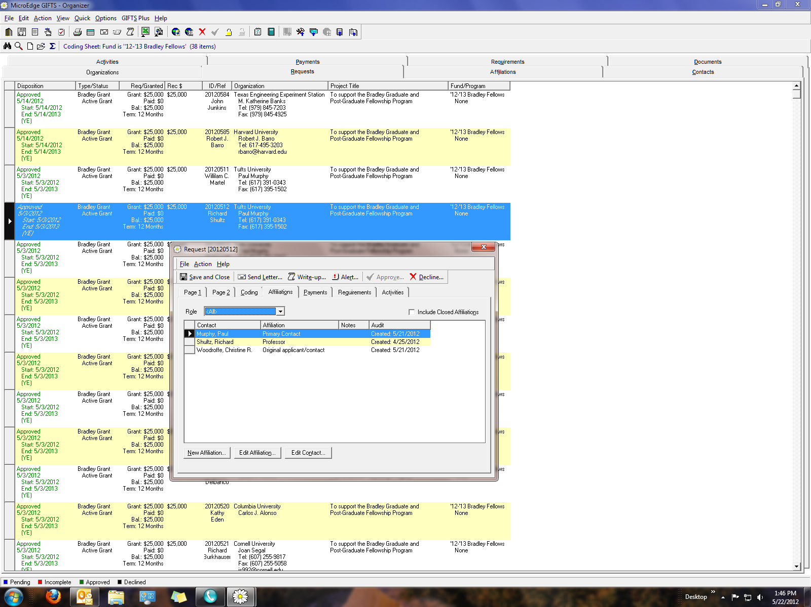

**This is the Affiliations Screen.**

**This example explains why three affiliations are needed with this one request.**

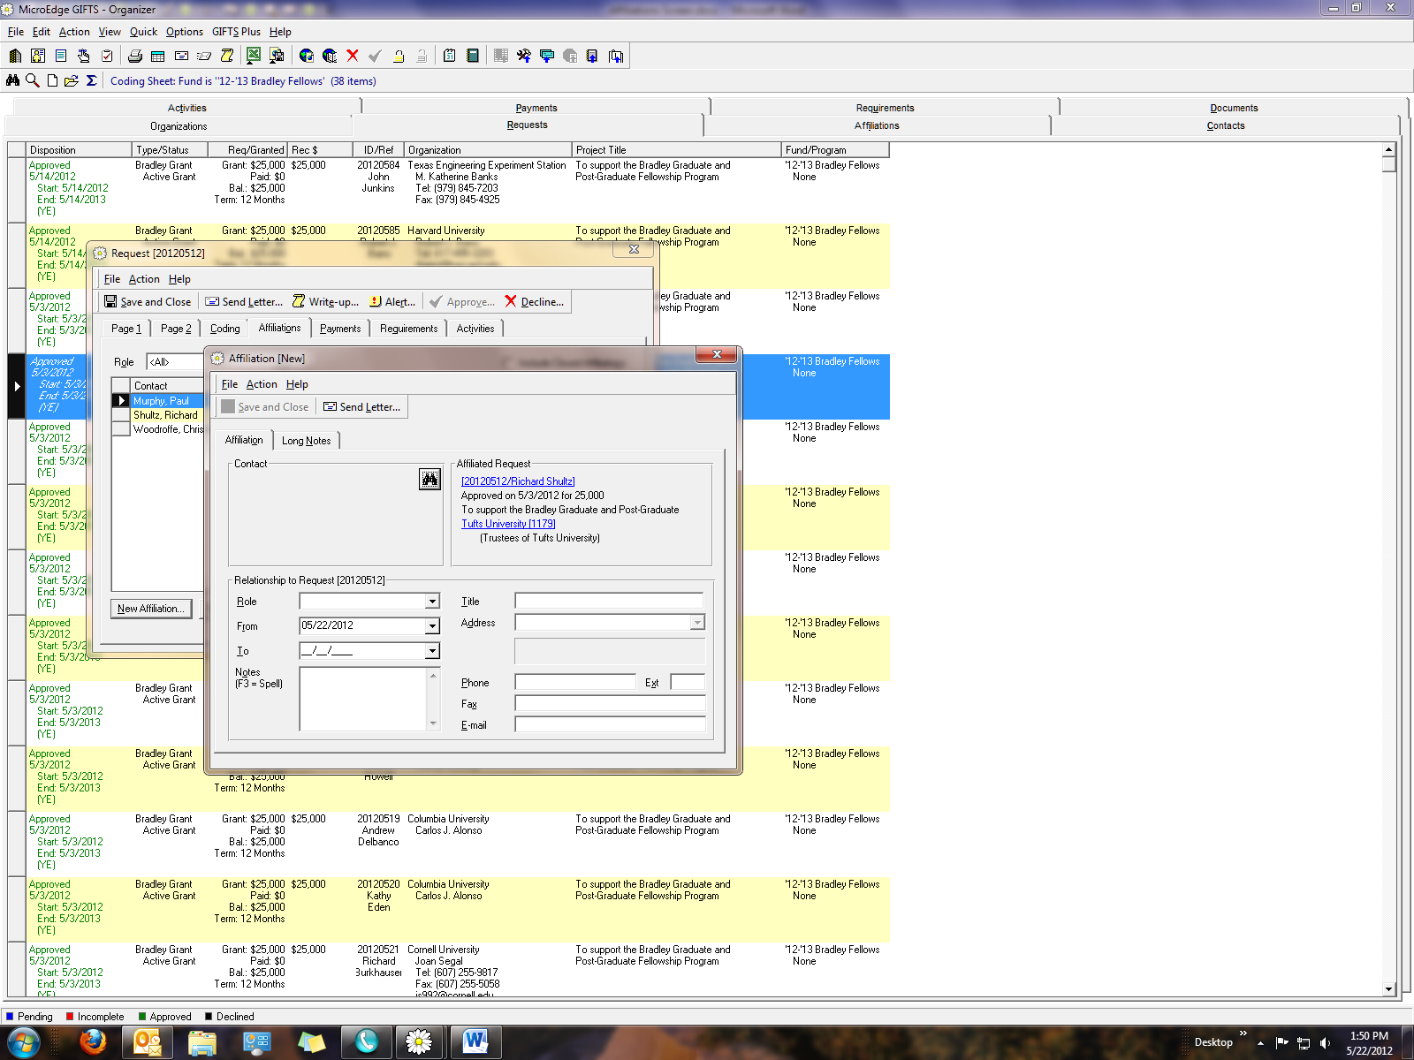

**This is an example of the “New Affiliation” screen.**

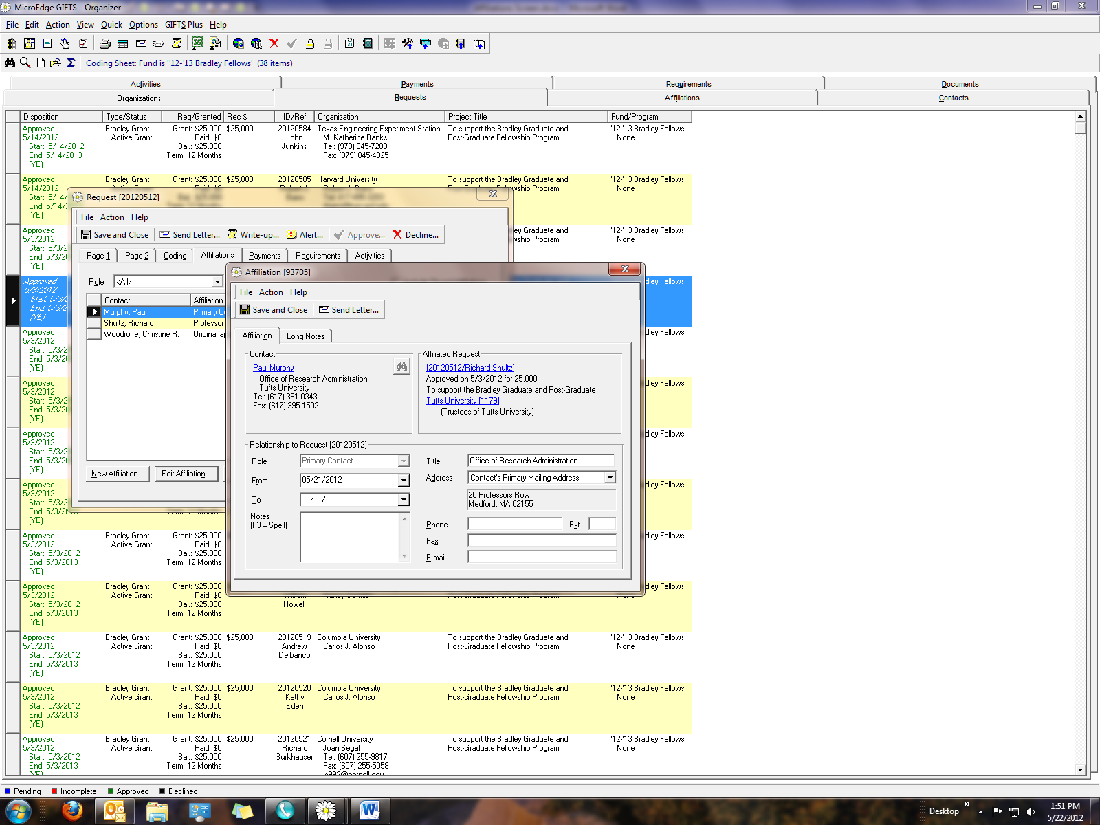

**This is an example of the “Edit Affiliation” screen.**

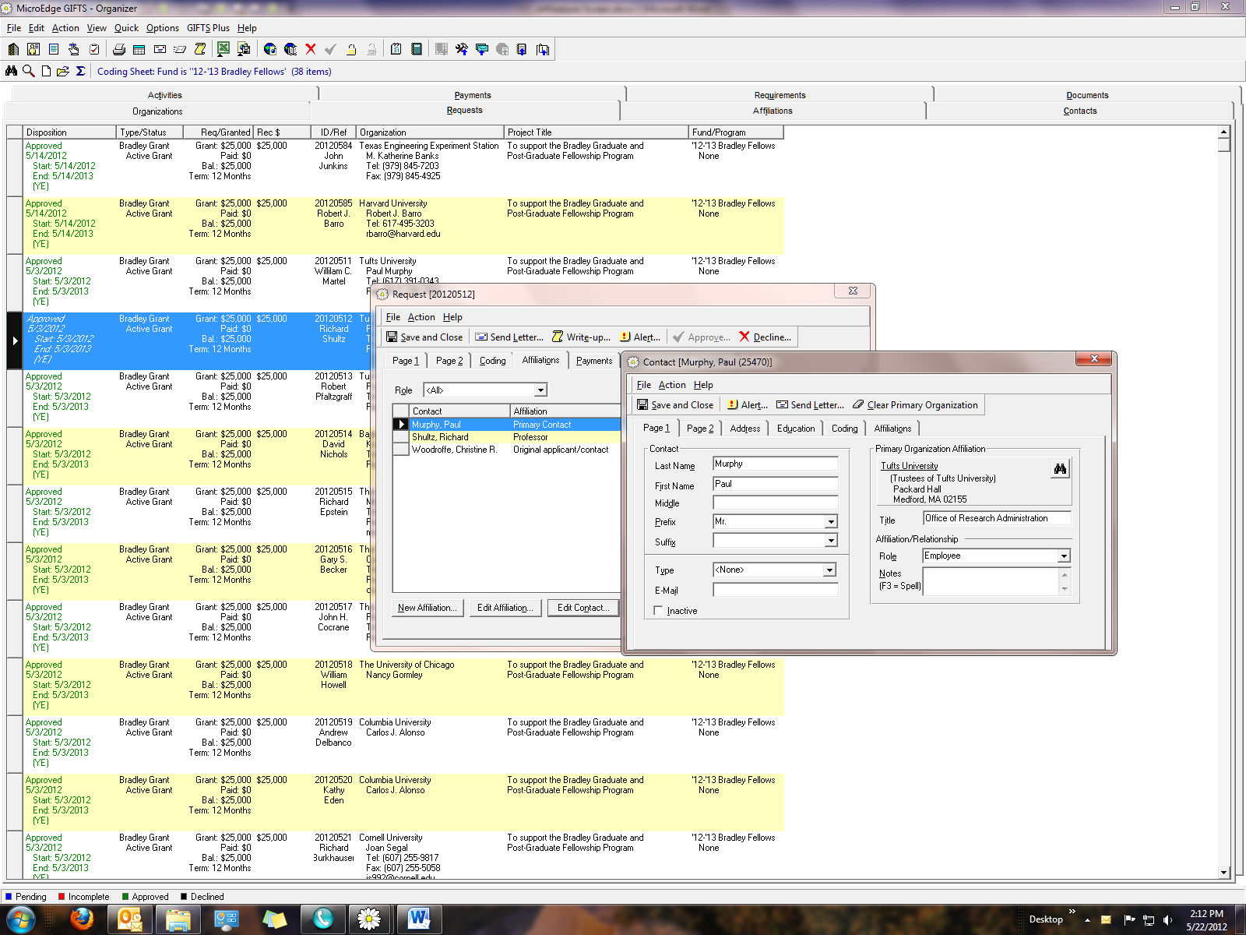

**This is an example of the “Edit Contact” screen, which actually opens the person’s contact record.**

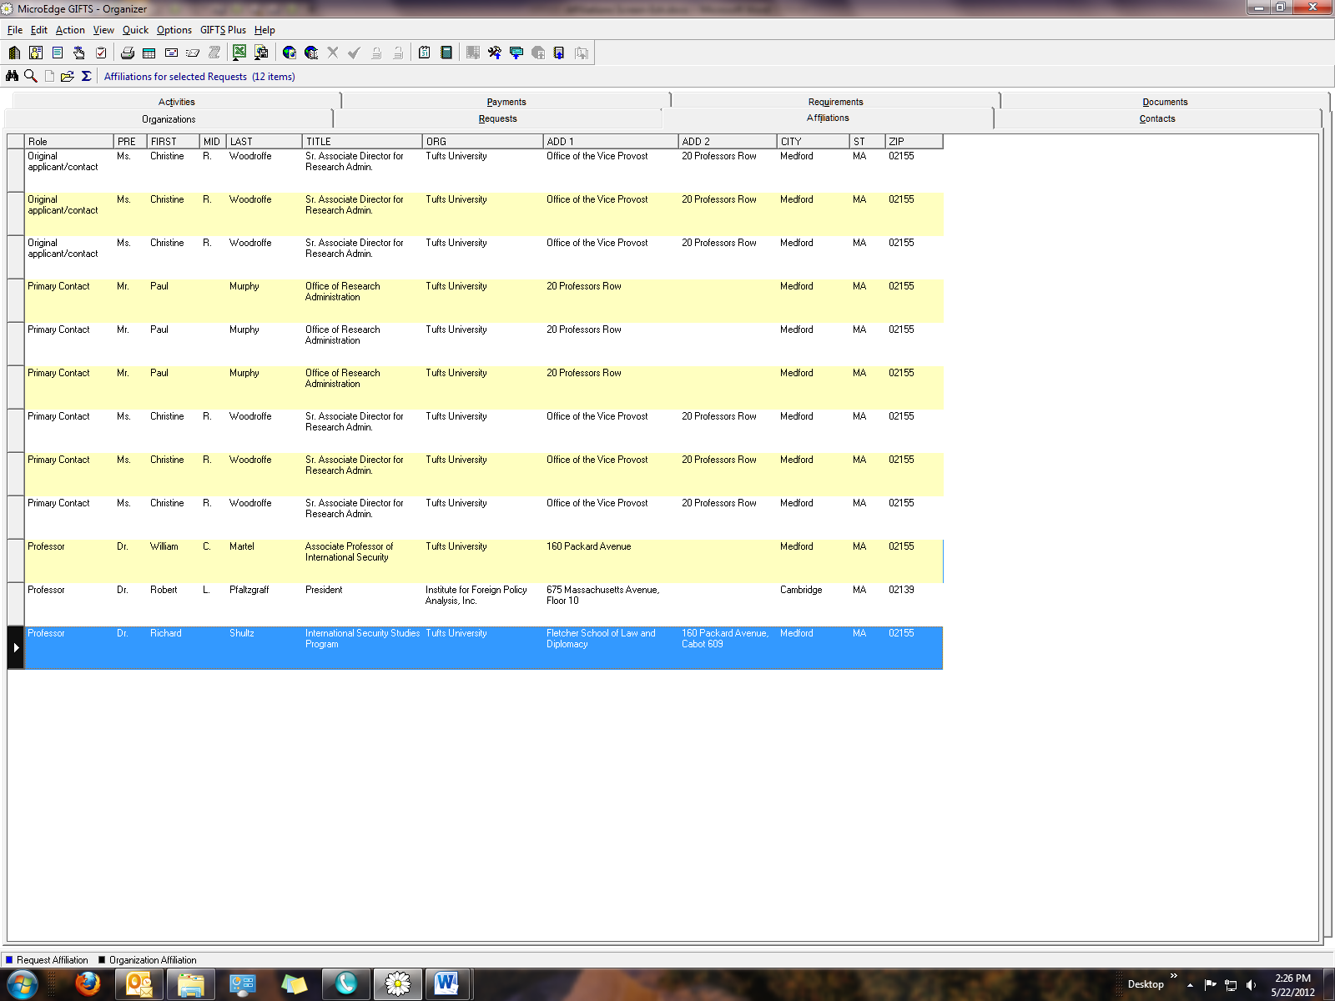

**Closed request, focused on list (or part of list), and moved to Affiliations tab.**

**This view sorts by “Role” so it is easy to select the role to merge a batch of correspondence.**