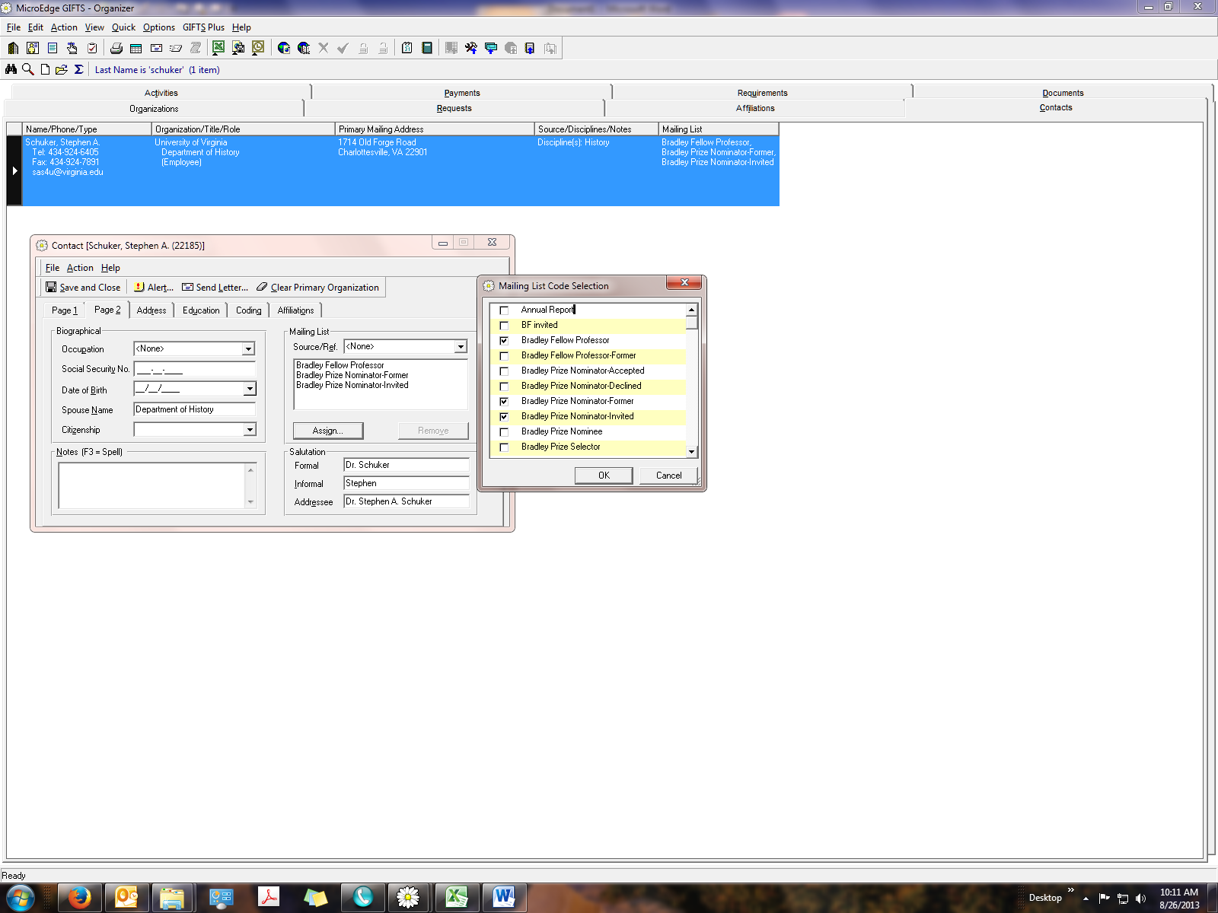

Requests record, page 2, Mailing List