Back at requests tab, the list indicates all grants of the organization. Focus on the grant you originally started with and move to the Requirements tab.

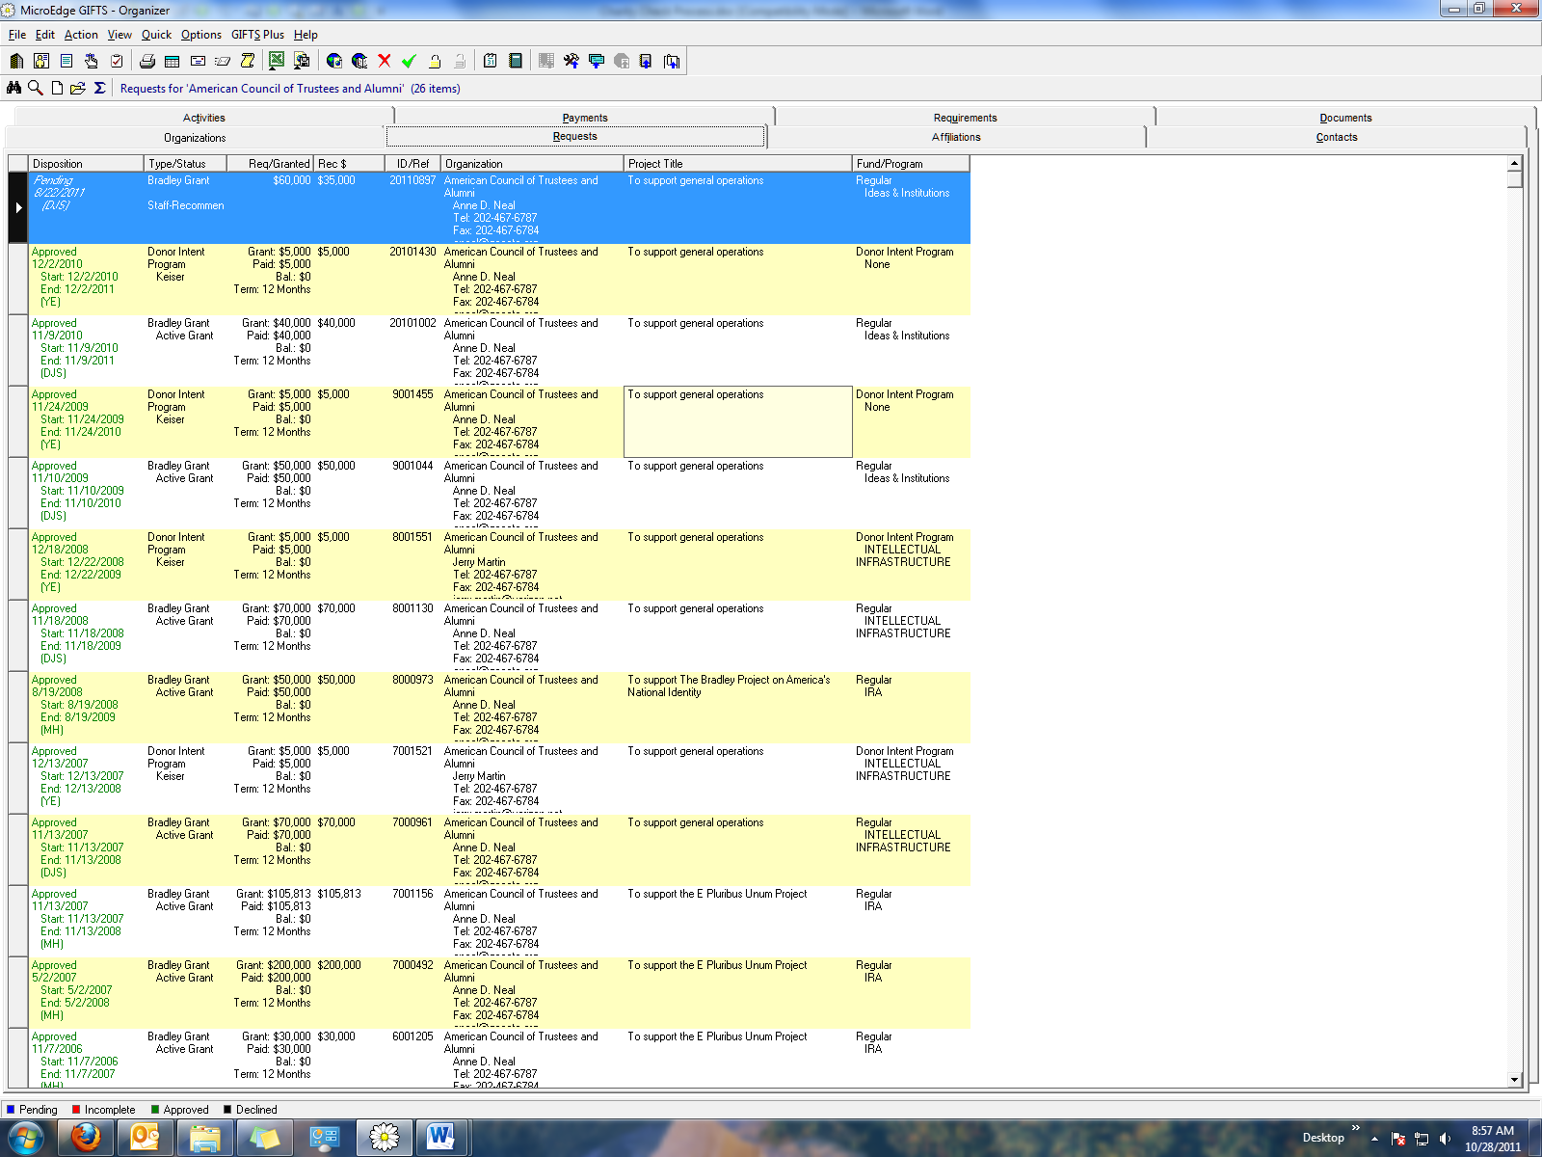

Click on “new” (the blank page icon at the top of the page).

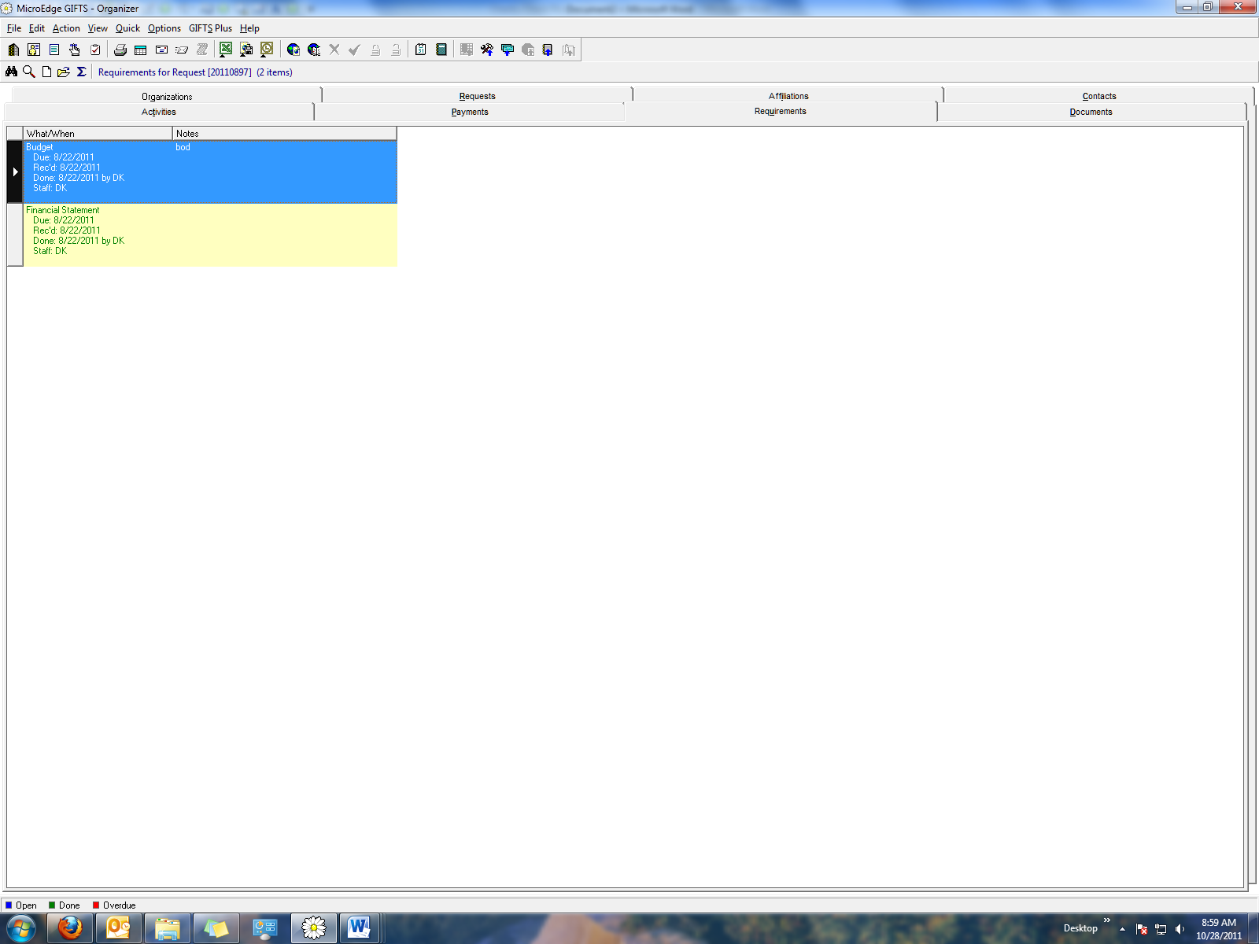

Insert your name in Staff field and select from Type “Charity Check” and mark as done.

