Documents Tab

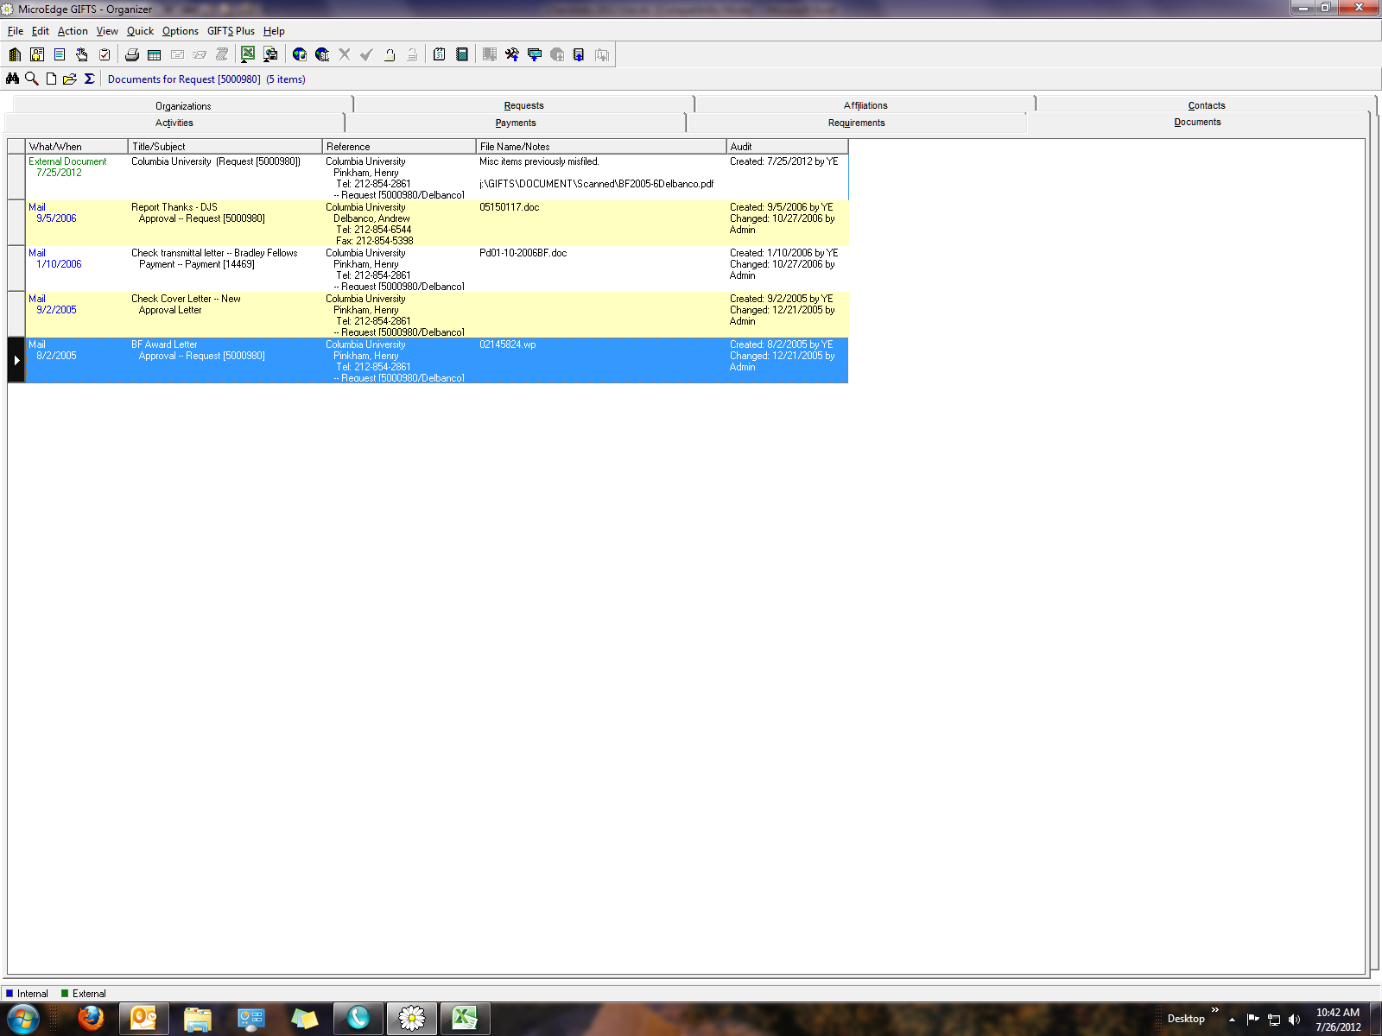

**A)** This is an external document, scanned as a PDF and attached to the system.

**B)** This is a mail document the system has saved and automatically assigned a file name.

**C)** This document was saved by the system, but a file name was assigned by the user during the  
 merge process.

**D)** This is a record of correspondence generated, but not saved.