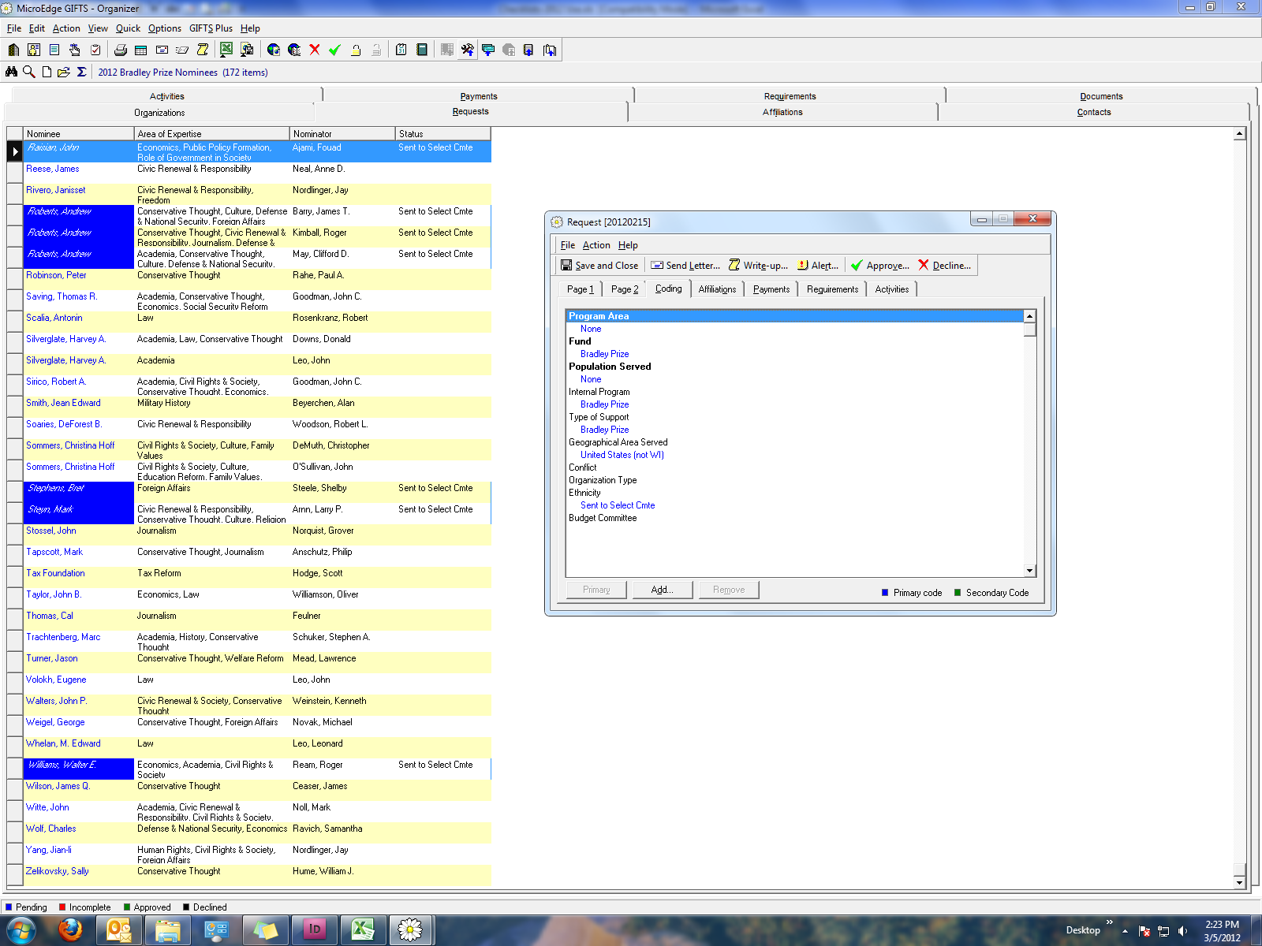

Updating “ethnicity” field of the BP nomination request record with   
“sent to Select Cmte” or “Top 10” code.

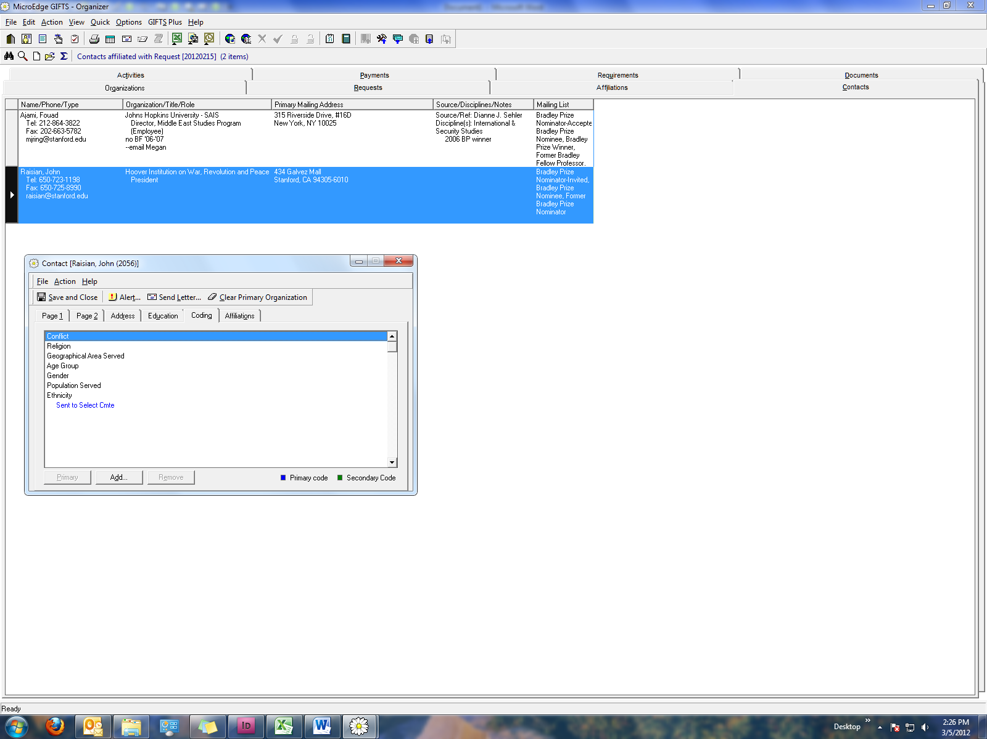

Updating “ethnicity” field of the BP nominee contact record with

“sent to Select Cmte” or “Top 10” code.

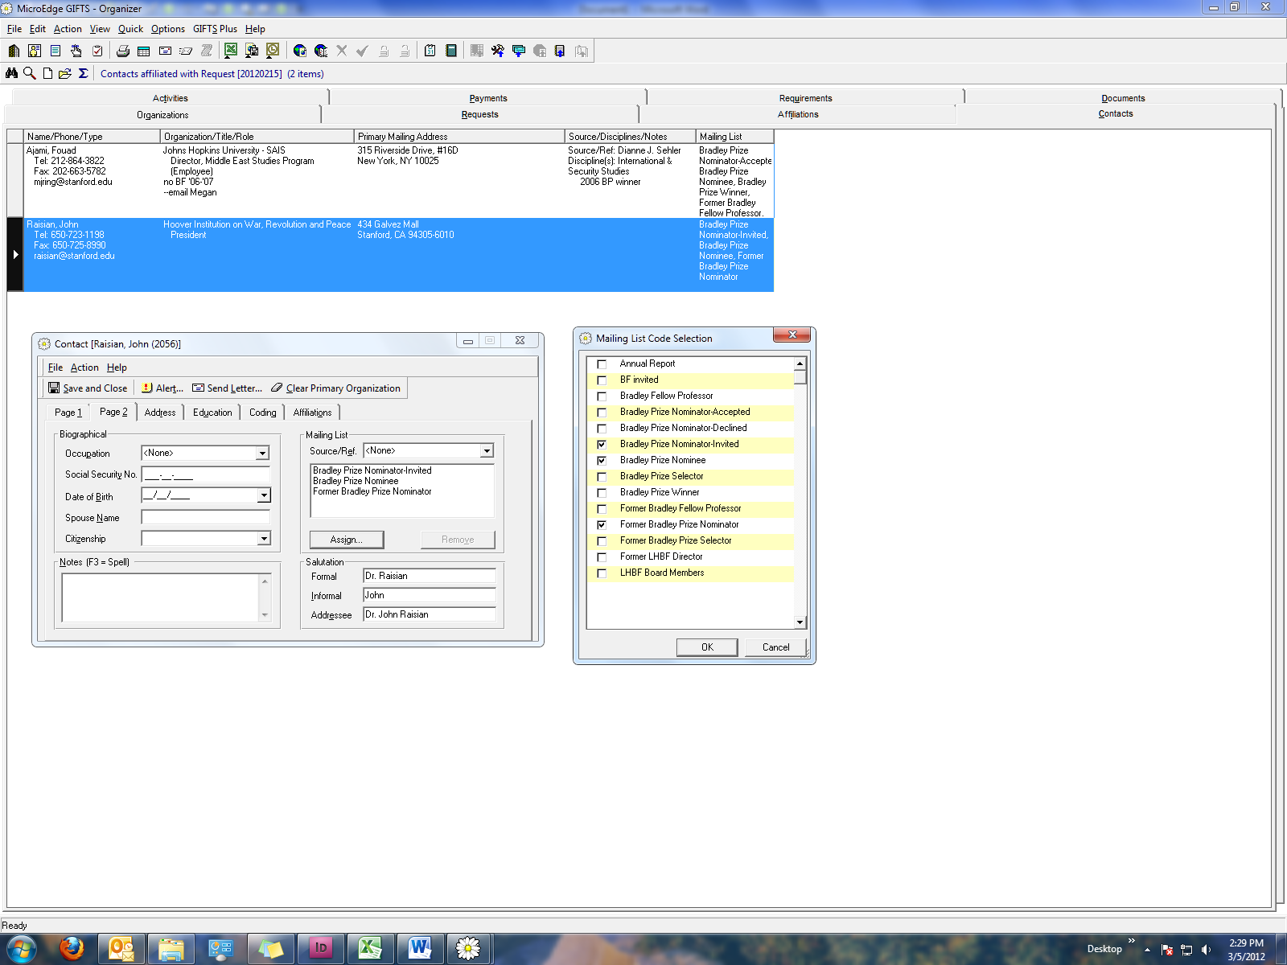

Updating the Mailing List on Page 2 of the nominee’s contact record:

Click Assign. Select BP Nominee, Ok; save and close the record.

Same applies for removing nominator accepted (or declined) and returning to the Nominator Invited mail list code (and “former BP nominator code as well).

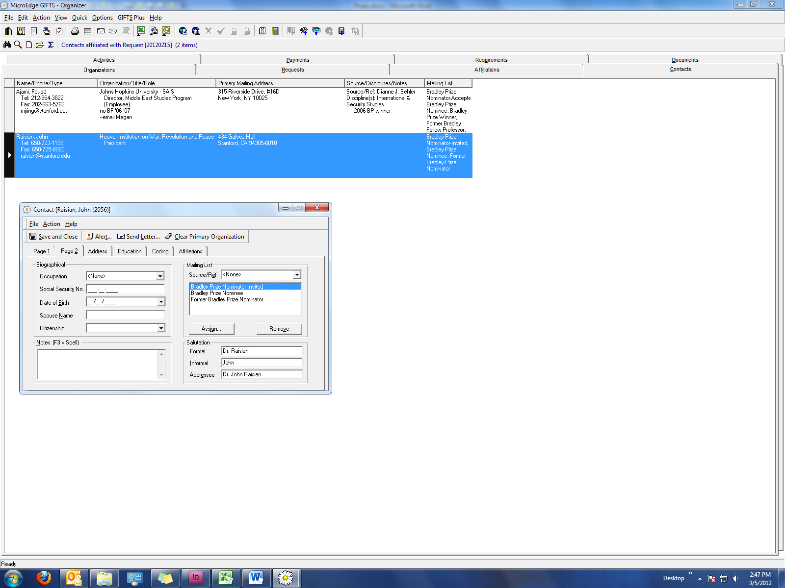

Select “Remove” on the right side of screen to remove contact from that mailing list;

Select “Assign” and choose from the pull-down menu to select what is needed.

Also, “Notes” field (bottom left) is where you’ll need to indicate the winner’s year of award.