Grants Administrator View
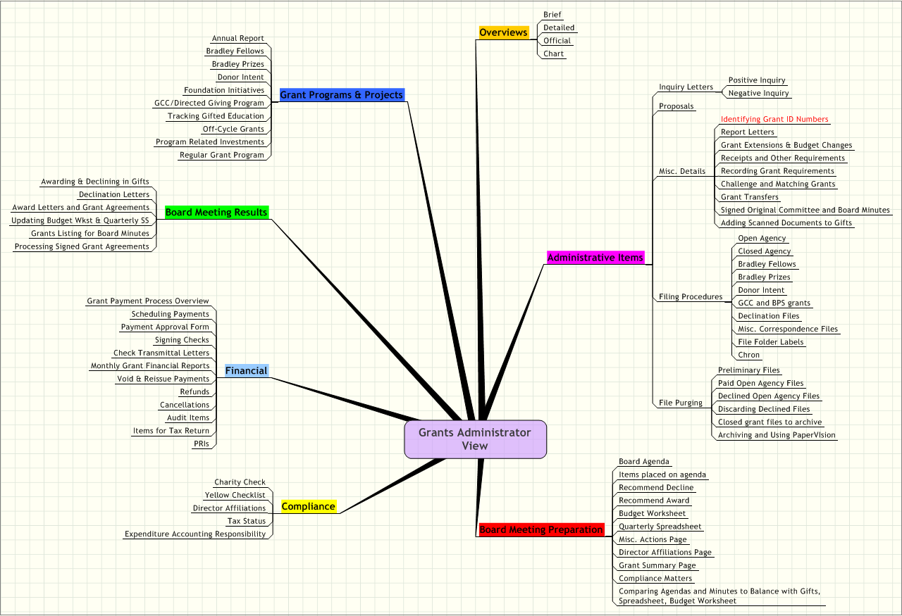

Grants Administrator View 1
A Overviews 4
A.1 Brief 4
A.2 Detailed 4
A.3 Official 4
A.4 Chart 4
B Administrative Items 4
B.1 Inquiry Letters 4
B.1.1 Positive Inquiry 4
B.1.2 Negative Inquiry 4
B.2 Proposals 4
B.3 Misc. Details 4
B.3.1 Identifying Grant ID Numbers 4
B.3.2 Report Letters 4
B.3.3 Grant Extensions & Budget Changes 4
B.3.4 Receipts and Other Requirements 4
B.3.5 Recording Grant Requirements 4
B.3.6 Challenge and Matching Grants 4
B.3.7 Grant Transfers 4
B.3.8 Signed Original Committee and Board Minutes 4
B.3.9 Adding Scanned Documents to Gifts 4
B.4 Filing Procedures 4
B.4.1 Open Agency 4
B.4.2 Closed Agency 4
B.4.3 Bradley Fellows 5
B.4.4 Bradley Prizes 5
B.4.5 Donor Intent 5
B.4.6 GCC and BPS grants 5
B.4.7 Declination Files 5
B.4.8 Misc. Correspondence Files 5
B.4.9 File Folder Labels 5
B.4.10 Chron 5
B.5 File Purging 5
B.5.1 Preliminary Files 5
B.5.2 Paid Open Agency Files 5
B.5.3 Declined Open Agency Files 5
B.5.4 Discarding Declined Files 5
B.5.5 Closed grant files to archive 5
B.5.6 Archiving and Using PaperVIsion 5
C Board Meeting Preparation 5
C.1 Board Agenda 5
C.2 Items placed on agenda 5
C.3 Recommend Decline 5
C.4 Recommend Award 5
C.5 Budget Worksheet 5
C.6 Quarterly Spreadsheet 5
C.7 Misc. Actions Page 5
C.8 Director Affiliations Page 6
C.9 Grant Summary Page 6
C.10 Compliance Matters 6
C.11 Comparing Agendas and Minutes to Balance with Gifts, Spreadsheet, Budget Worksheet 6
D Compliance 6
D.1 Charity Check 6
D.2 Yellow Checklist 6
D.3 Director Affiliations 6
D.4 Tax Status 6
D.5 Expenditure Accounting Responsibility 6
E Financial 6
E.1 Grant Payment Process Overview 6
E.2 Scheduling Payments 6
E.3 Payment Approval Form 6
E.4 Signing Checks 6
E.5 Check Transmittal Letters 6
E.6 Monthly Grant Financial Reports 6
E.7 Void & Reissue Payments 6
E.8 Refunds 6
E.9 Cancellations 6
E.10 Audit Items 6
E.11 Items for Tax Return 6
E.12 PRIs 7
F Board Meeting Results 7
F.1 Awarding & Declining in Gifts 7
F.2 Declination Letters 7
F.3 Award Letters and Grant Agreements 7
F.4 Updating Budget Wkst & Quarterly SS 7
F.5 Grants Listing for Board Minutes 7
F.6 Processing Signed Grant Agreements 7
G Grant Programs & Projects 7
G.1 Annual Report 7
G.2 Bradley Fellows 7
G.3 Bradley Prizes 7
G.4 Donor Intent 7
G.5 Foundation Initiatives 7
G.6 GCC/Directed Giving Program 7
G.7 Tracking Gifted Education 7
G.8 Off-Cycle Grants 7
G.9 Program Related Investments 7
G.10 Regular Grant Program 7

- Overviews
  - Brief
  - Detailed
  - Official
  - Chart
- Administrative Items
  - Inquiry Letters
    - Positive Inquiry
    - Negative Inquiry
  - Proposals
  - Misc. Details
    - Identifying Grant ID Numbers
    - Report Letters
    - Grant Extensions & Budget Changes
    - Receipts and Other Requirements
    - Recording Grant Requirements
    - Challenge and Matching Grants
    - Grant Transfers
    - Signed Original Committee and Board Minutes
    - Adding Scanned Documents to Gifts
  - Filing Procedures
    - Open Agency
    - Closed Agency
    - Bradley Fellows
    - Bradley Prizes
    - Donor Intent
    - GCC and BPS grants
    - Declination Files
    - Misc. Correspondence Files
    - File Folder Labels
    - Chron
  - File Purging
    - Preliminary Files
    - Paid Open Agency Files
    - Declined Open Agency Files
    - Discarding Declined Files
    - Closed grant files to archive
    - Archiving and Using PaperVIsion
- Board Meeting Preparation
  - Board Agenda
  - Items placed on agenda
  - Recommend Decline
  - Recommend Award
  - Budget Worksheet
  - Quarterly Spreadsheet
  - Misc. Actions Page
  - Director Affiliations Page
  - Grant Summary Page
  - Compliance Matters
  - Comparing Agendas and Minutes to Balance with Gifts, Spreadsheet, Budget Worksheet
- Compliance
  - Charity Check
  - Yellow Checklist
  - Director Affiliations
  - Tax Status
  - Expenditure Accounting Responsibility
- Financial
  - Grant Payment Process Overview
  - Scheduling Payments
  - Payment Approval Form
  - Signing Checks
  - Check Transmittal Letters
  - Monthly Grant Financial Reports
  - Void & Reissue Payments
  - Refunds
  - Cancellations
  - Audit Items
  - Items for Tax Return
  - PRIs
- Board Meeting Results
  - Awarding & Declining in Gifts
  - Declination Letters
  - Award Letters and Grant Agreements
  - Updating Budget Wkst & Quarterly SS
  - Grants Listing for Board Minutes
  - Processing Signed Grant Agreements
- Grant Programs & Projects
  - Annual Report
  - Bradley Fellows
  - Bradley Prizes
  - Donor Intent
  - Foundation Initiatives
  - GCC/Directed Giving Program
  - Tracking Gifted Education
  - Off-Cycle Grants
  - Program Related Investments
  - Regular Grant Program

