Grants Administrator View
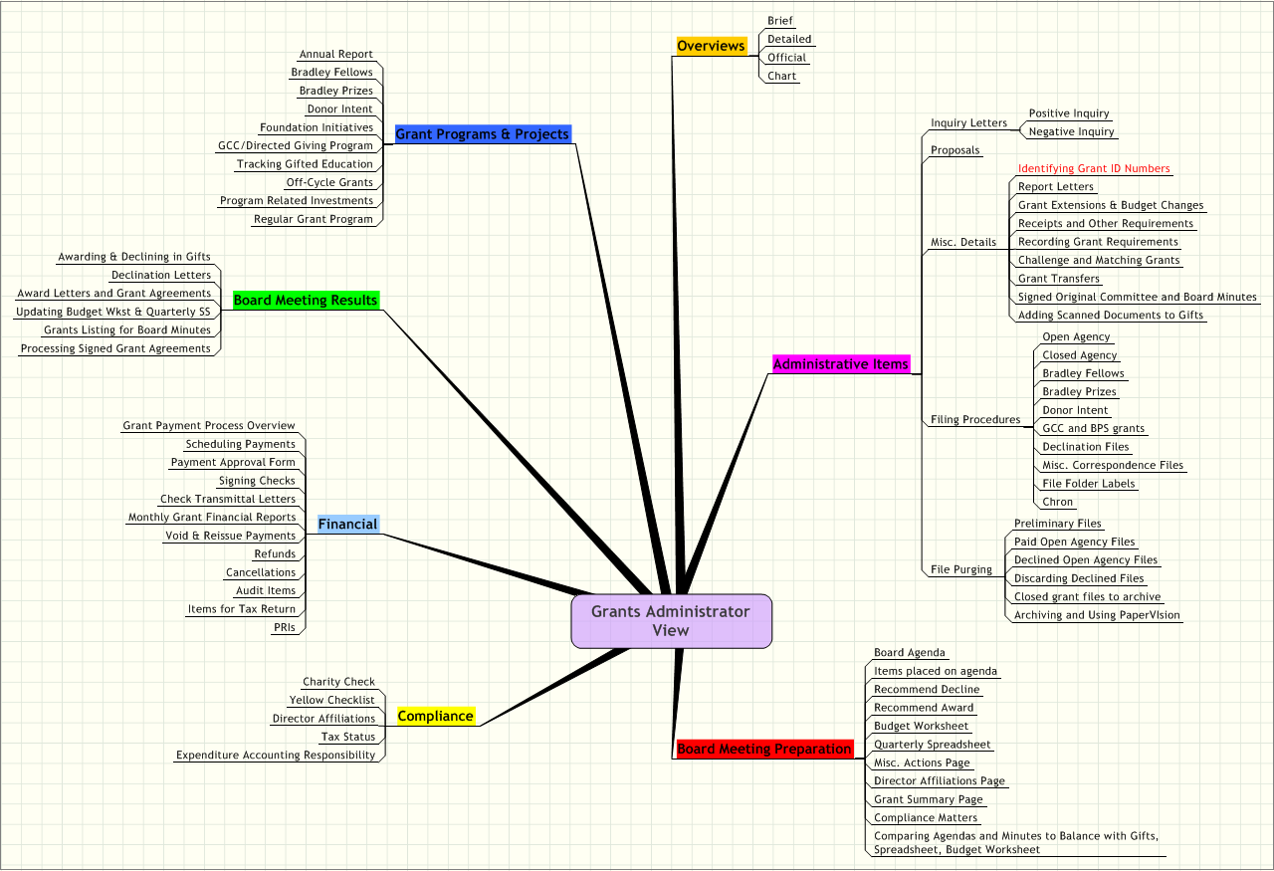

GRANTS ADMINISTRATOR VIEW

Overview of Grant Process I.
Brief 1
Detailed 2
Official 3
Chart 4

Administrative Items II.
Inquiry Letters 1
Positive Inquiry A
Negative Inquiry B
Proposals 2
Misc. Details 3
Identifying Grant ID Numbers A
Report Letters B
Grant Extensions & Budget Changes C
Receipts and Other Requirements D
Recording Grant Requirements E
Challenge and Matching Grants F
Grant Transfers G
Signed Original Committee and Board Minutes H
Adding Scanned Documents to Gifts I
Filing Procedures 4
Open Agency A
Closed Agency B
Bradley Fellows C
Bradley Prizes D
Donor Intent E
GCC and BPS grants F
Declination Files G
Misc. Correspondence Files H
File Folder Labels I
Chron J
File Purging 5
Preliminary Files A
Paid Open Agency Files B
Declined Open Agency Files C
Discarding Declined Files D
Closed grant files to archive E
Archiving and Using PaperVIsion F

Board Meeting Preparation III.
Board Agenda 1
Items placed on agenda 2
Recommend Decline 3
Recommend Award 4
Budget Worksheet 5
Quarterly Spreadsheet 6
Misc. Actions Page 7
Director Affiliations Page 8
Grant Summary Page 9
Compliance Matters 10
Comparing Agendas and Minutes to Balance with Gifts, Spreadsheet, Budget Worksheet 11

Compliance IV.
Charity Check 1
Yellow Checklist 2
Director Affiliations 3
Tax Status 4
Expenditure Accounting Responsibility 5

Financial V.
Grant Payment Process Overview 1
Scheduling Payments 2
Payment Approval Form 3
Signing Checks 4
Check Transmittal Letters 5
Monthly Grant Financial Reports 6
Void & Reissue Payments 7
Refunds 8
Cancellations 9
Audit Items 10
Items for Tax Return 11
PRIs 12

Board Meeting Results VI.
Awarding & Declining in Gifts 1
Declination Letters 2
Award Letters and Grant Agreements 3
Updating Budget Wkst & Quarterly SS 4
Grants Listing for Board Minutes 5
Processing Signed Grant Agreements 6

Grant Programs & Projects VII.
Annual Report 1
Bradley Fellows 2
Bradley Prizes 3
Donor Intent 4
Foundation Initiatives 5
GCC/Directed Giving Program 6
Tracking Gifted Education 7
Off-Cycle Grants 8
Program Related Investments 9
Regular Grant Program 10

Overviews
      - Brief
      - Detailed
      - Official
      - Chart
Administrative Items
Inquiry Letters
Positive Inquiry
Negative Inquiry
Proposals
Misc. Details
Identifying Grant ID Numbers
Report Letters
Grant Extensions & Budget Changes
Receipts and Other Requirements
Recording Grant Requirements
Challenge and Matching Grants
Grant Transfers
Signed Original Committee and Board Minutes
Adding Scanned Documents to Gifts
Filing Procedures
Open Agency
Closed Agency
Bradley Fellows
Bradley Prizes
Donor Intent
GCC and BPS grants
Declination Files
Misc. Correspondence Files
File Folder Labels
Chron
File Purging
Preliminary Files
Paid Open Agency Files
Declined Open Agency Files
Discarding Declined Files
Closed grant files to archive
Archiving and Using PaperVIsion
Board Meeting Preparation
Board Agenda
Items placed on agenda
Recommend Decline
Recommend Award
Budget Worksheet
Quarterly Spreadsheet
Misc. Actions Page
Director Affiliations Page
Grant Summary Page
Compliance Matters
Comparing Agendas and Minutes to Balance with Gifts, Spreadsheet, Budget Worksheet
Compliance
Charity Check
Yellow Checklist
Director Affiliations
Tax Status
Expenditure Accounting Responsibility
Financial
Grant Payment Process Overview
Scheduling Payments
Payment Approval Form
Signing Checks
Check Transmittal Letters
Monthly Grant Financial Reports
Void & Reissue Payments
Refunds
Cancellations
Audit Items
Items for Tax Return
PRIs
Board Meeting Results
Awarding & Declining in Gifts
Declination Letters
Award Letters and Grant Agreements
Updating Budget Wkst & Quarterly SS
Grants Listing for Board Minutes
Processing Signed Grant Agreements
Grant Programs & Projects
Annual Report
Bradley Fellows
Bradley Prizes
Donor Intent
Foundation Initiatives
GCC/Directed Giving Program
Tracking Gifted Education
Off-Cycle Grants
Program Related Investments
Regular Grant Program

