Organizations List (Results of a Search)

VIEW is the format appearing on the screen.
It includes and removes columns, places them in the order you choose,
sorts data according to your selection, and allows formatting.

View in this example is Tax Info

Double Click to Open the Organization’s Record

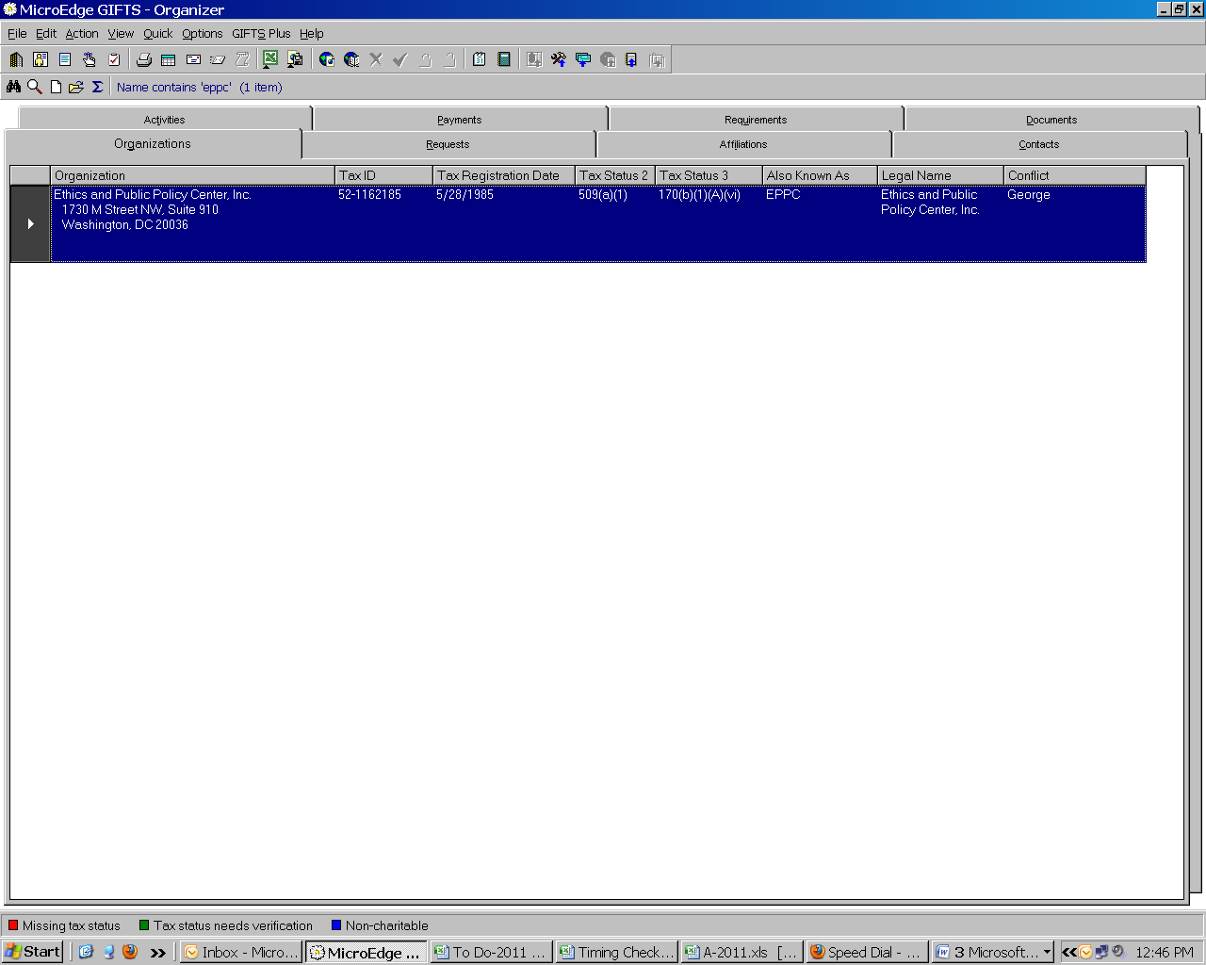

Organization screen provides basic information about the organization.

The left side of this screen includes the name, address, phones, email, website of the organization. The right side of the screen identifies the main contact for the organization.

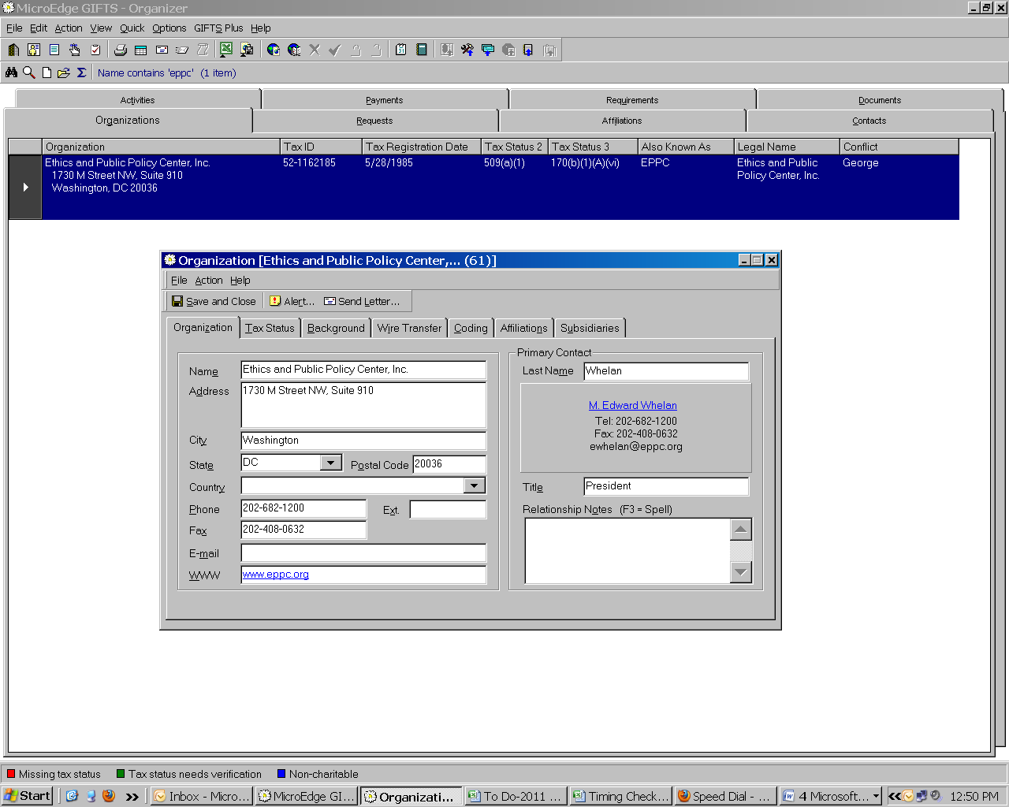

Tax Status screen provides information concerning tax-exempt status.

The name used here is the legal name. The tax id number is the EIN (Employer Identification Number). The registration date is the date of the most recent IRS tax-exempt status form we have on file. A field is available for the date of the most recent financial report from the organizations. Notes can be anything noteworthy.

Be sure the box at the bottom left of the screen (Charitable Organization) is checked. This opens up the tax status fields on the right. Previously, the year/page # where the organization was listed in the cumulative index was recorded on the top line. Currently, Guidestar’s Charity Check report is run and printed for each grant made, so this line is no longer used. Last verified by identifies the person who checked the current exempt status (pull-down menu available); the next line indicates on what date it was verified; the third line denotes when the next verification is due (one year from verified on date). Several lines are available for tax status. The first status selected should always be 501(c)(3). Within that status are sub-categories. The 509(a)(1) or 509(a)(2) or 509(a)(3) should be the next status listed. If there is a further delineation, i.e. like frequently used 170(b)(1)(A)(vi), that should be on the third line. The dates next to each of the exempt status should be the date on which the IRS approved the status, if not available, the date of the most recent determination letter on file will suffice.

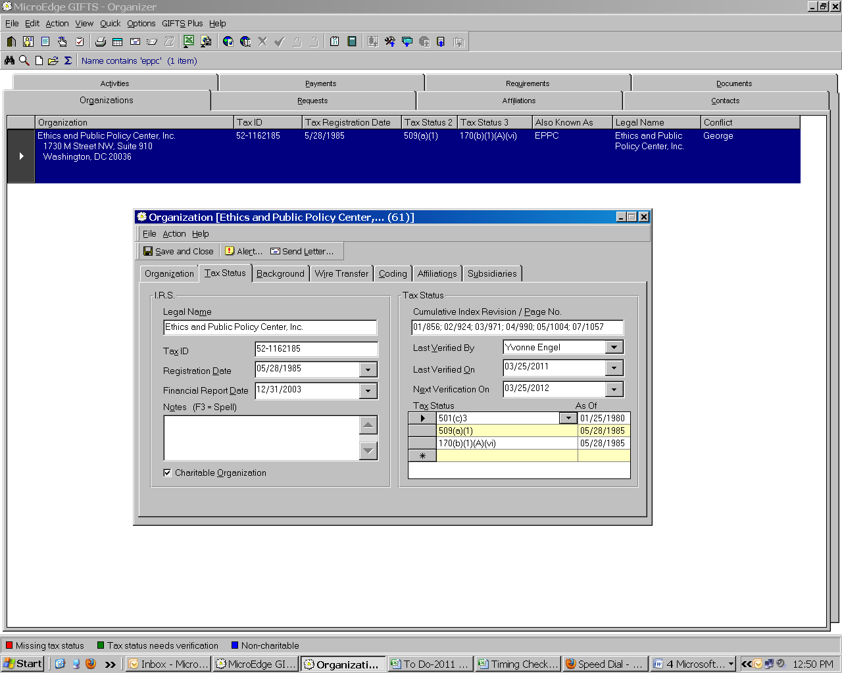

Background screen provides information concerning background and additional names.

The background screen was designed to contain a brief description of the organization and its work; we use it for notes. The a.k.a. (also known as) should contain any other names the organization is know by, or perhaps the organization’s acronym. The Sort As field will populate itself with all capital letters of the name of the organization as listed on page one of the record. However, you should spell out Saint when page one lists St. and move a name starting with “The” to the end, preceded by a comma. Any other alphabetizing should be made clear here. The vendor number will be automatically assigned by the accounting software when the first payment is made. Annual budget is not used.

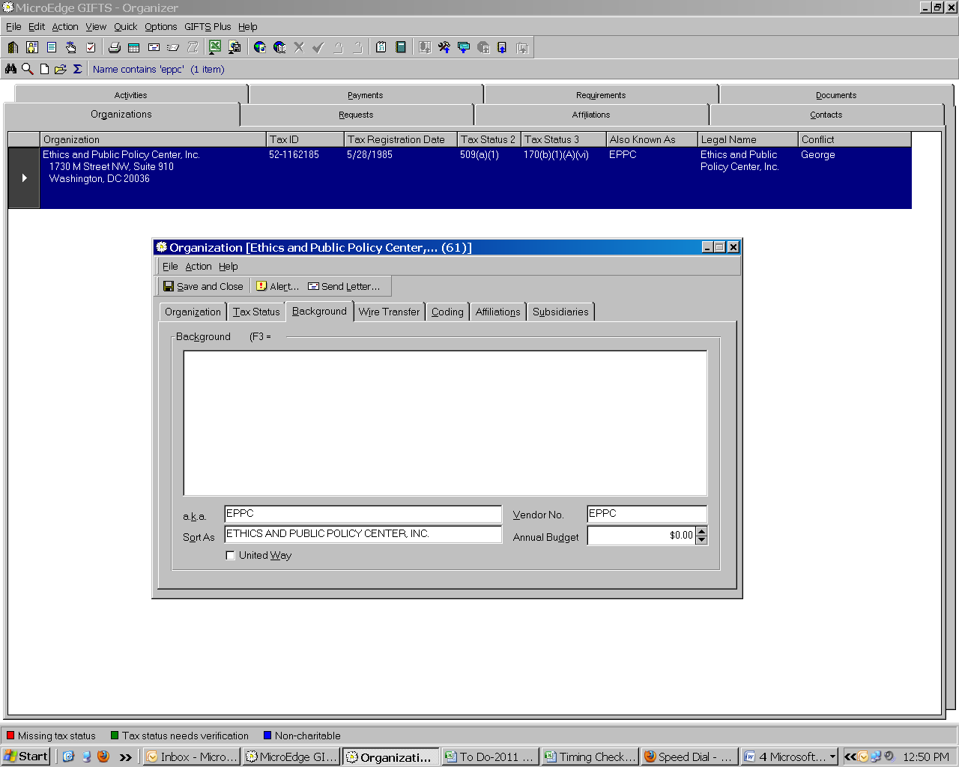

Wire Transfer screen provides information concerning the organization’s banking information.

Wire transfer tab is available to record banking information if payment will be made by wire. Currently, the finance department has chosen not to use this record.

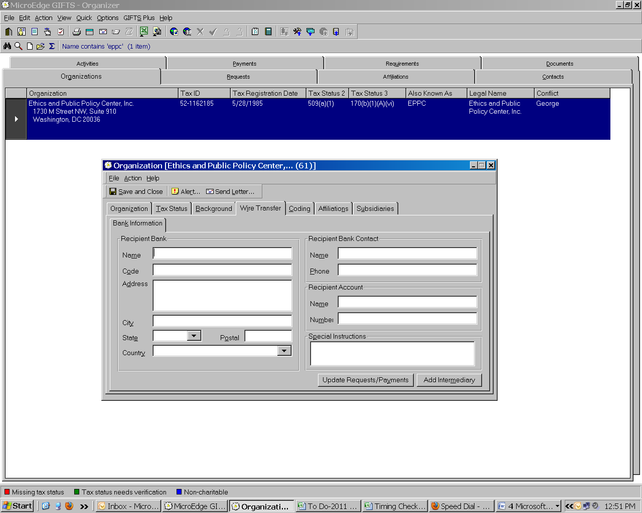

Coding screen records information concerning coding categories of the Foundation.

The coding tab is important for searching and retrieving specific types of information. The coding fields used in this organization tab will be the default codes when requests are entered. If any code is used for all requests the organization might have, go ahead and use it. The most important codes for the organization are Conflict and Internal Program. From the Conflict field, select any director affiliated with this organization (information comes from annual Disclosure forms sent by the President and subsequently entered into this field). The Internal Program field is usually Regular Grant, unless the organization is a foreign entity or needs Expenditure Accounting. Note also if the organization is a 509(a)(3)-Type 3 entity. The other codes are not as important in the Organizations tab, but become important when entering a proposal within the Requests tab.

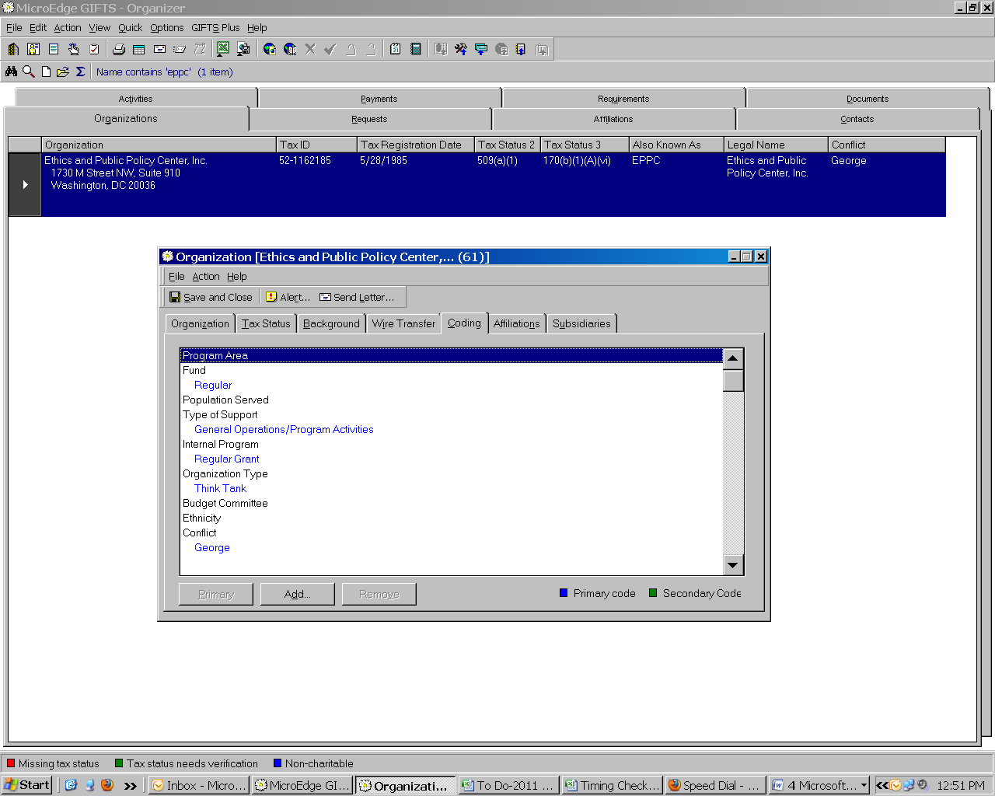

Affiliations screen indicates persons affiliated with the organization in any capacity.

Affiliations are automatically populated by Gifts as names are added to the organization through the Requests or Contacts tabs.

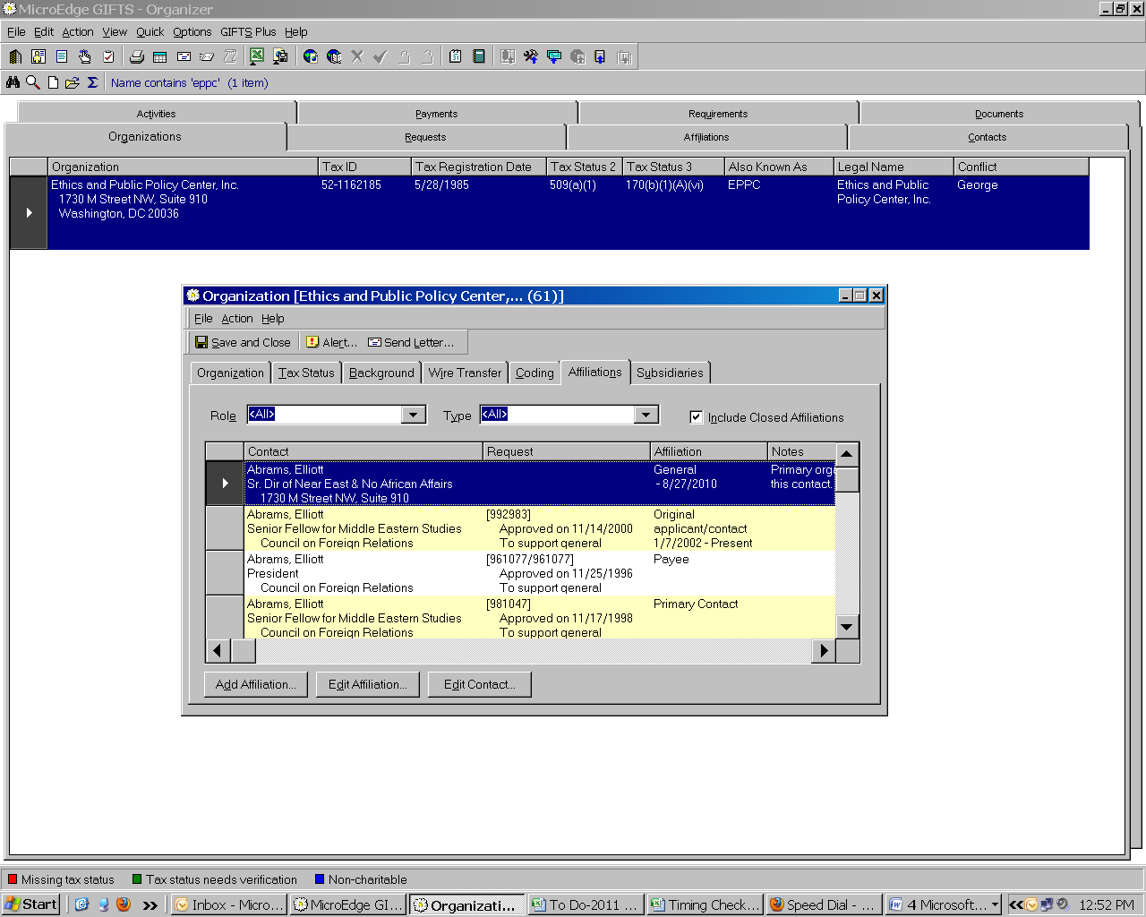

Subsidiaries screen link related organizations together.

Subsidiaries are seldom needed so I will not dwell on them at this time.

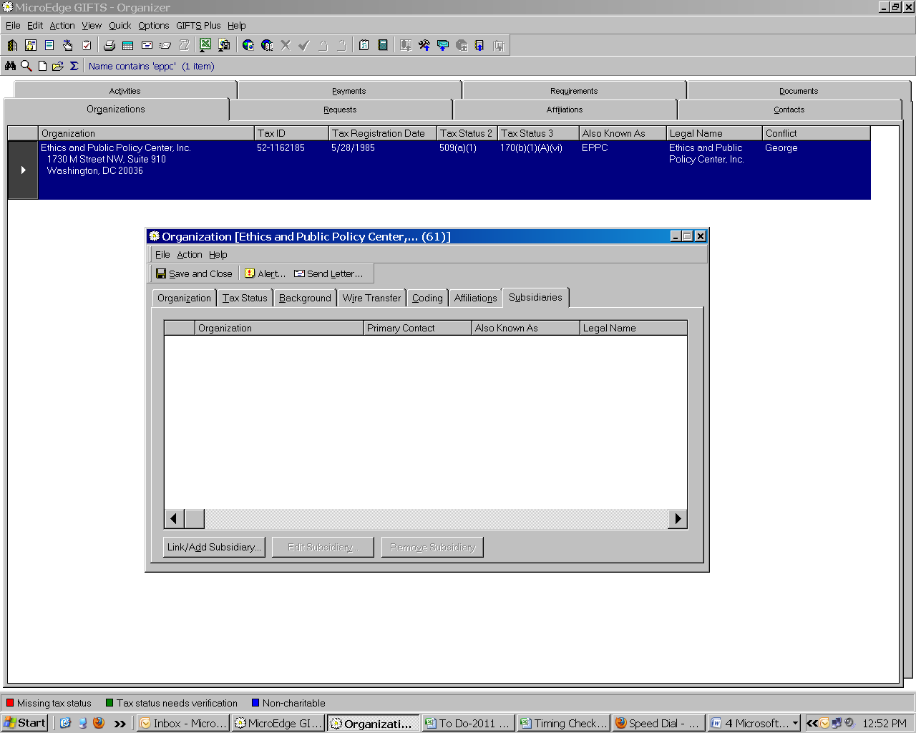

The following two paragraphs describe static commands, usable in all tabs.

Just above the seven tabs within the Organizations record are commands that will facilitate actions regarding the organization. “Save and Close” does just that. “Alert” opens another screen allowing you to call attention to anyone using the system of any important information.
“Send Letter” opens the correspondence wizard; we have no letter templates set up for use with organizations at this time.

Above these three commands are three more: File, which contains the actions of Save and Close, Delete, Close; Actions, which contains options of Send Letter, Alert, Clear Contact; and Help, which is just that. Of these, Clear Contact is the one to remember. When the primary contact of the organization needs to be changed, this is the command to choose. The system will not remove the Contact record (the person remains in the system); it will not change the affiliations (relationships) of the contact, but only removes the name from this screen to allow another name to be inserted.

Anything highlighted in blue will take you to another screen. The web address will automatically open if you select www; the contact’s record will open if you select the underlined, blue name under Primary Contact.

