REQUESTS LISTS
[View in Use is A Regular; Search is all EPPC Requests]
Double Click to Open the Highlighted Request Record

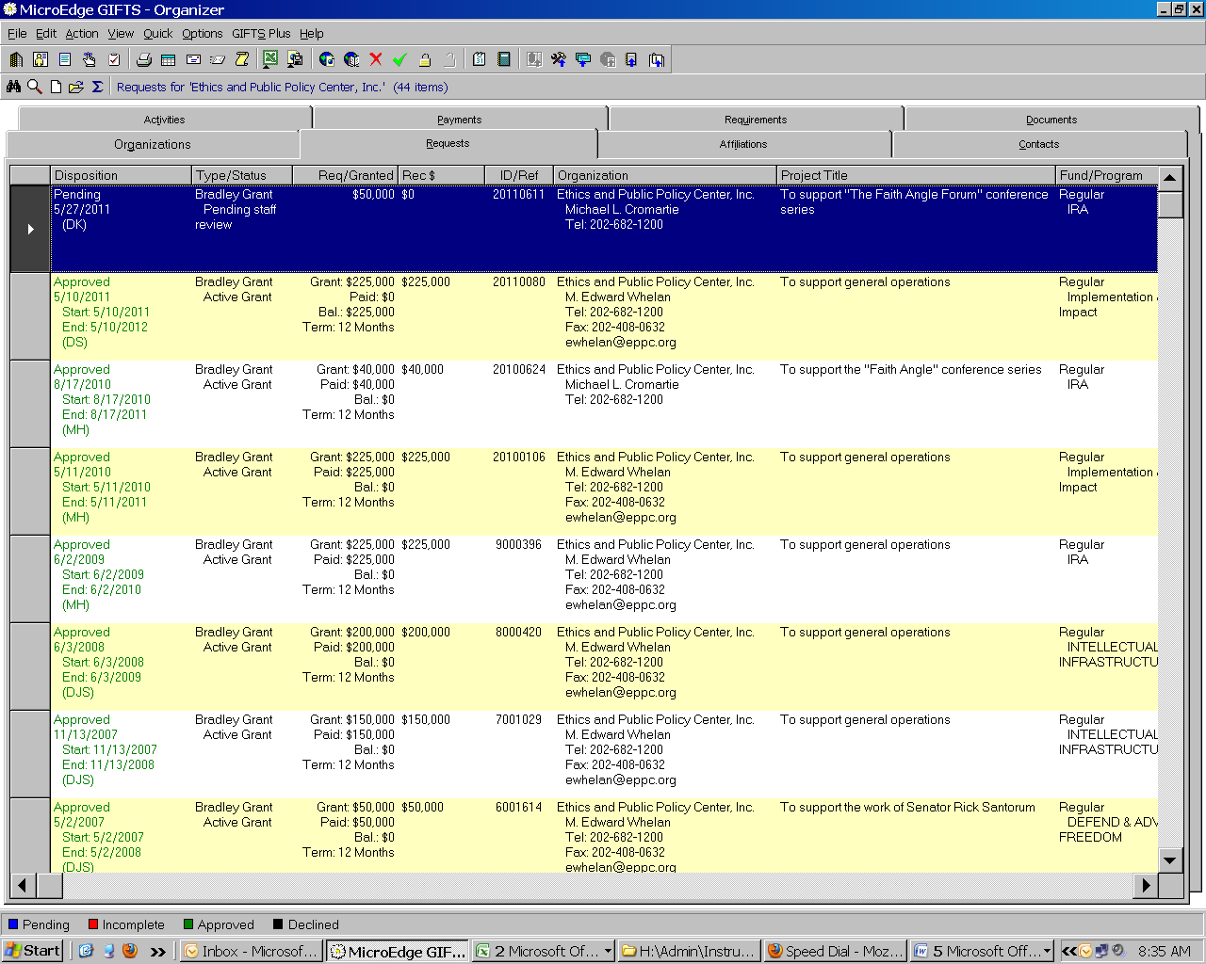

PENDING REQUEST SCREEN – PAGE 1

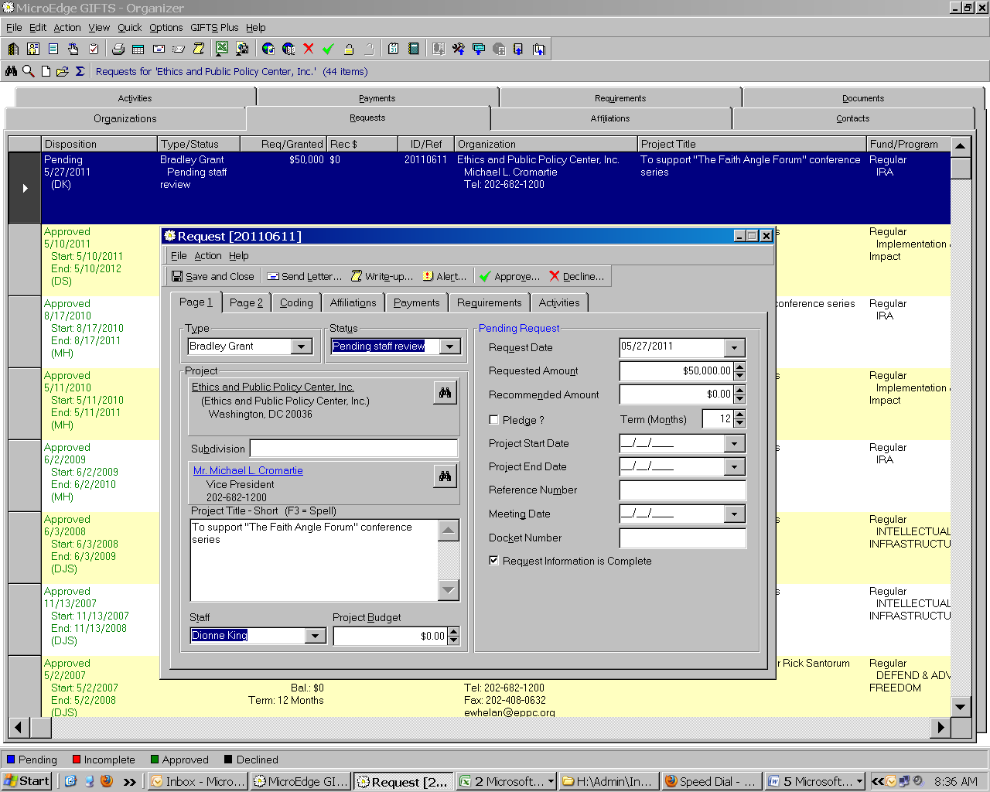

APPROVED REQUEST SCREEN – PAGE 1

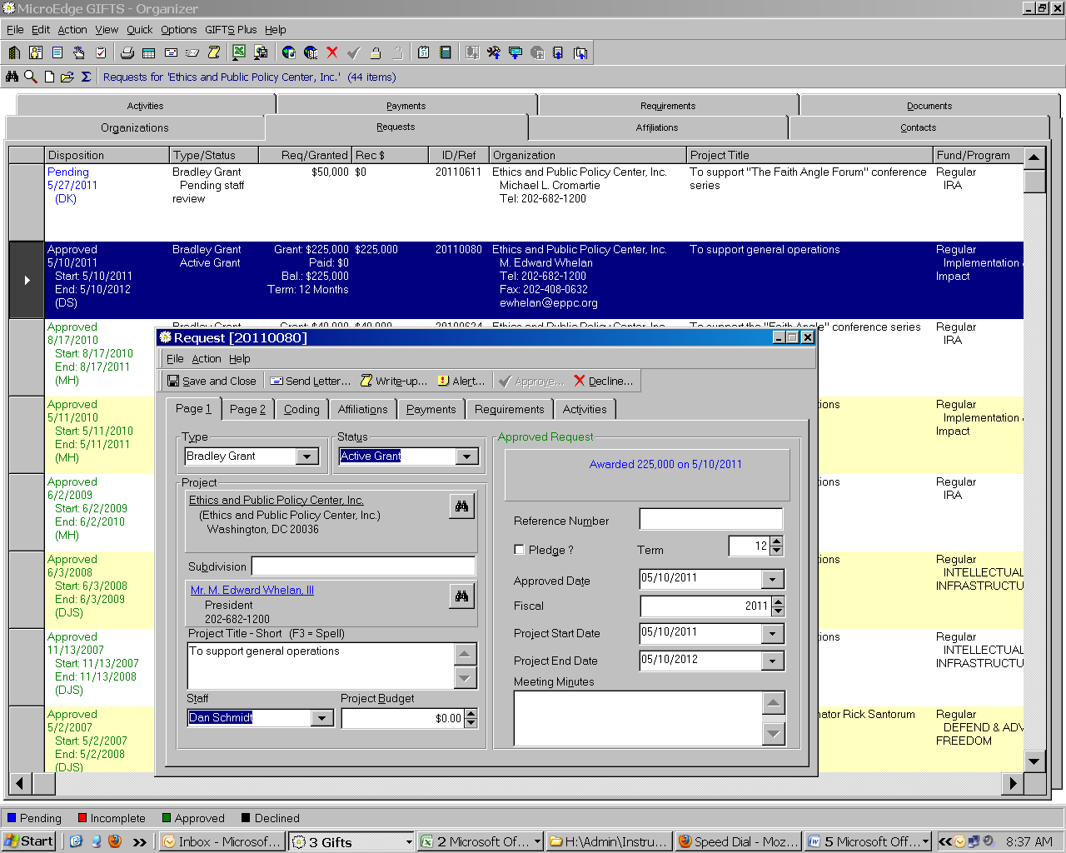

DECLINATION REQUEST SCREEN – PAGE 1
#20110668
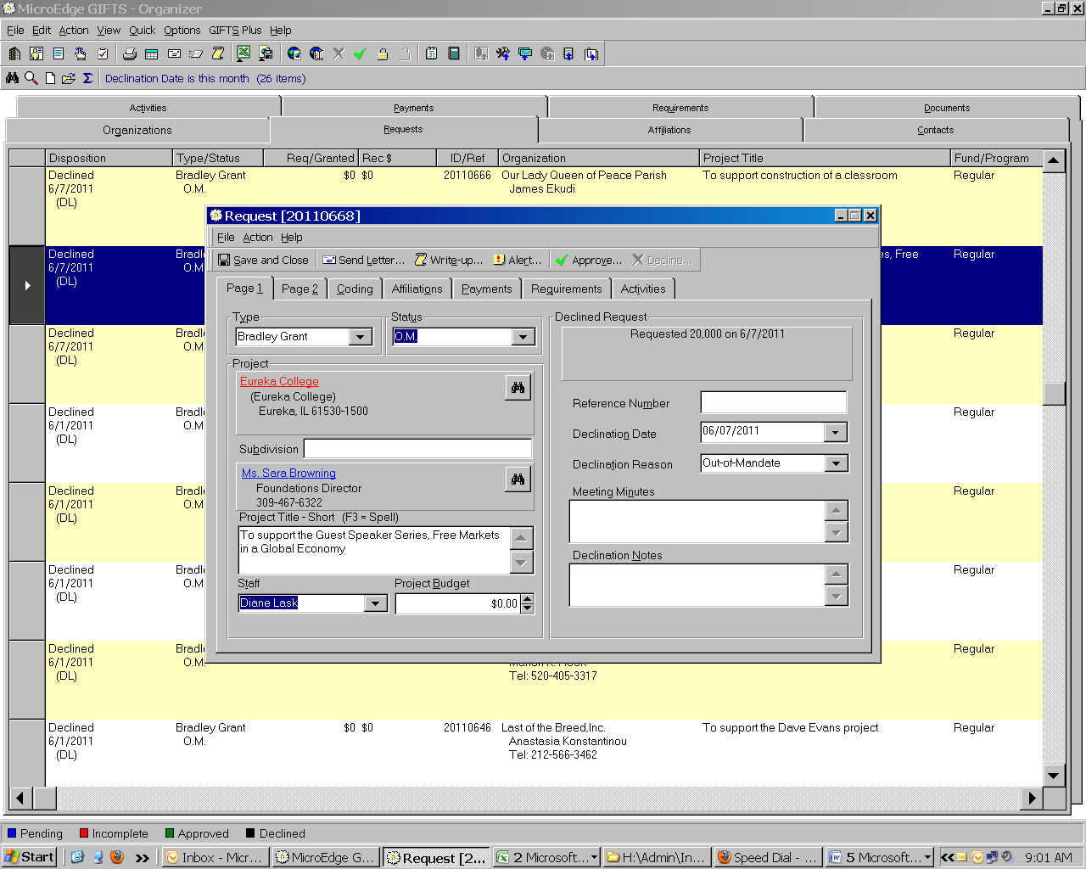
PENDING REQUEST SCREEN – PAGE 2

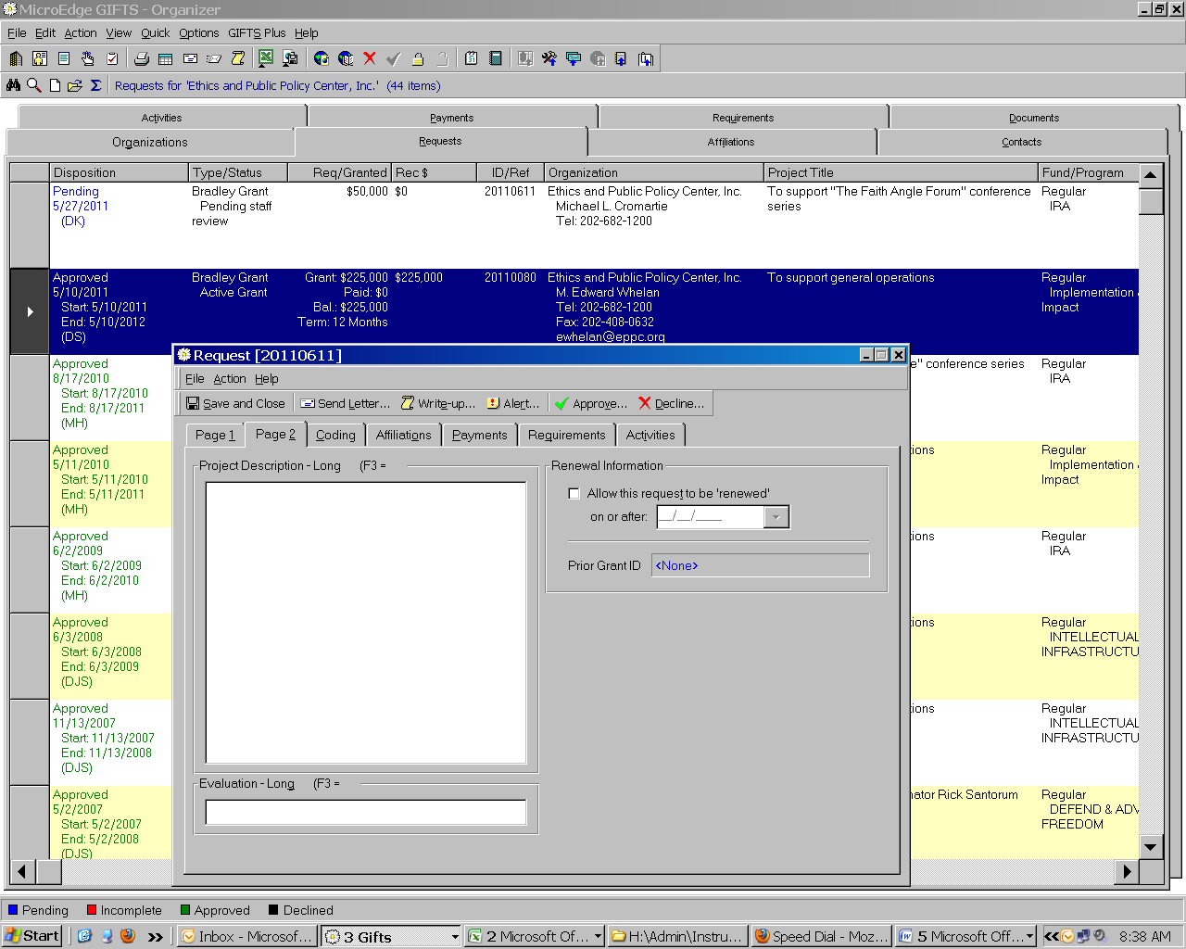

APPROVED REQUEST SCREEN – PAGE 2

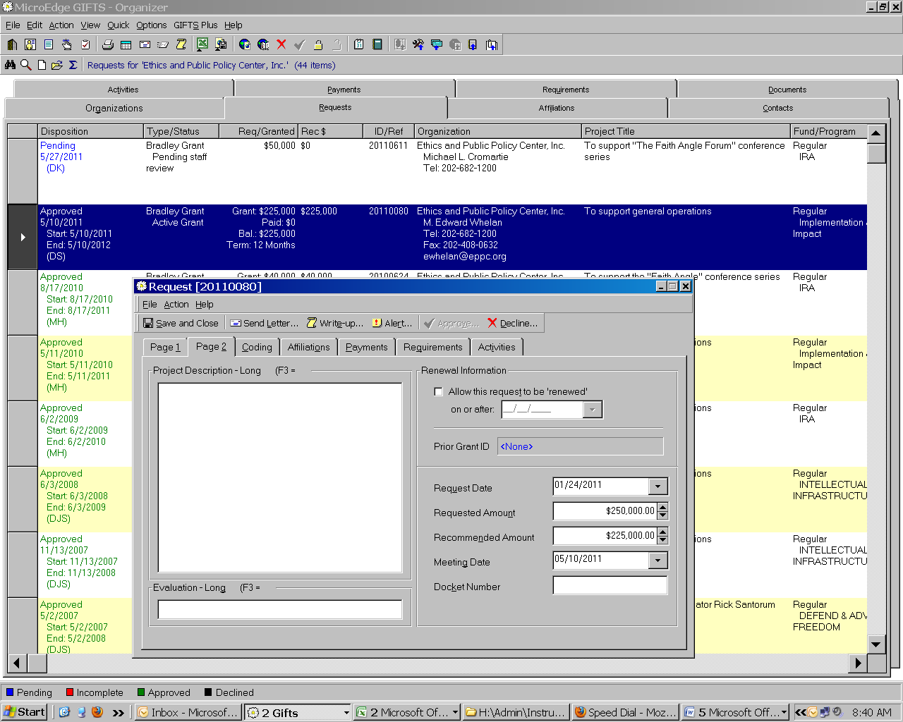

DECLINATION REQUEST SCREEN – PAGE 2

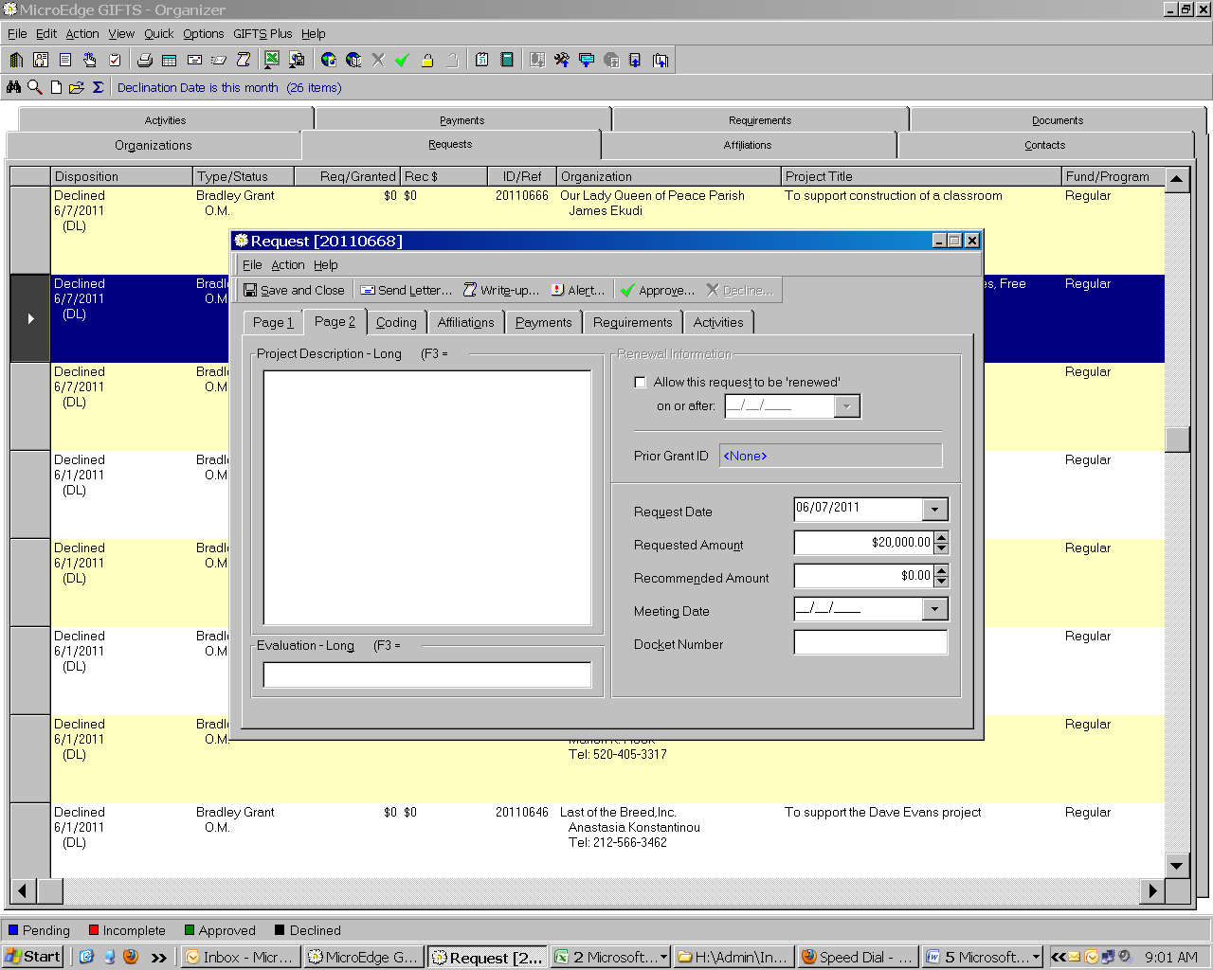

CODING REQUEST SCREEN – ALL DISPOSITIONS

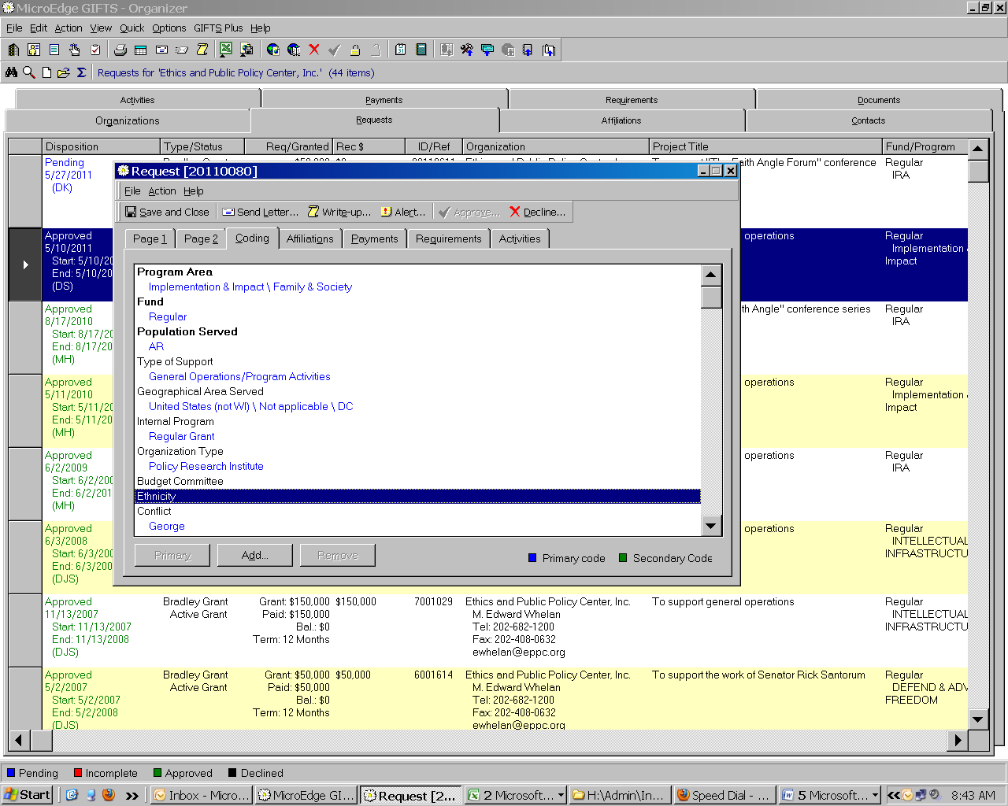

AFFILIATIONS SCREEN – ALL DISPOSITIONS

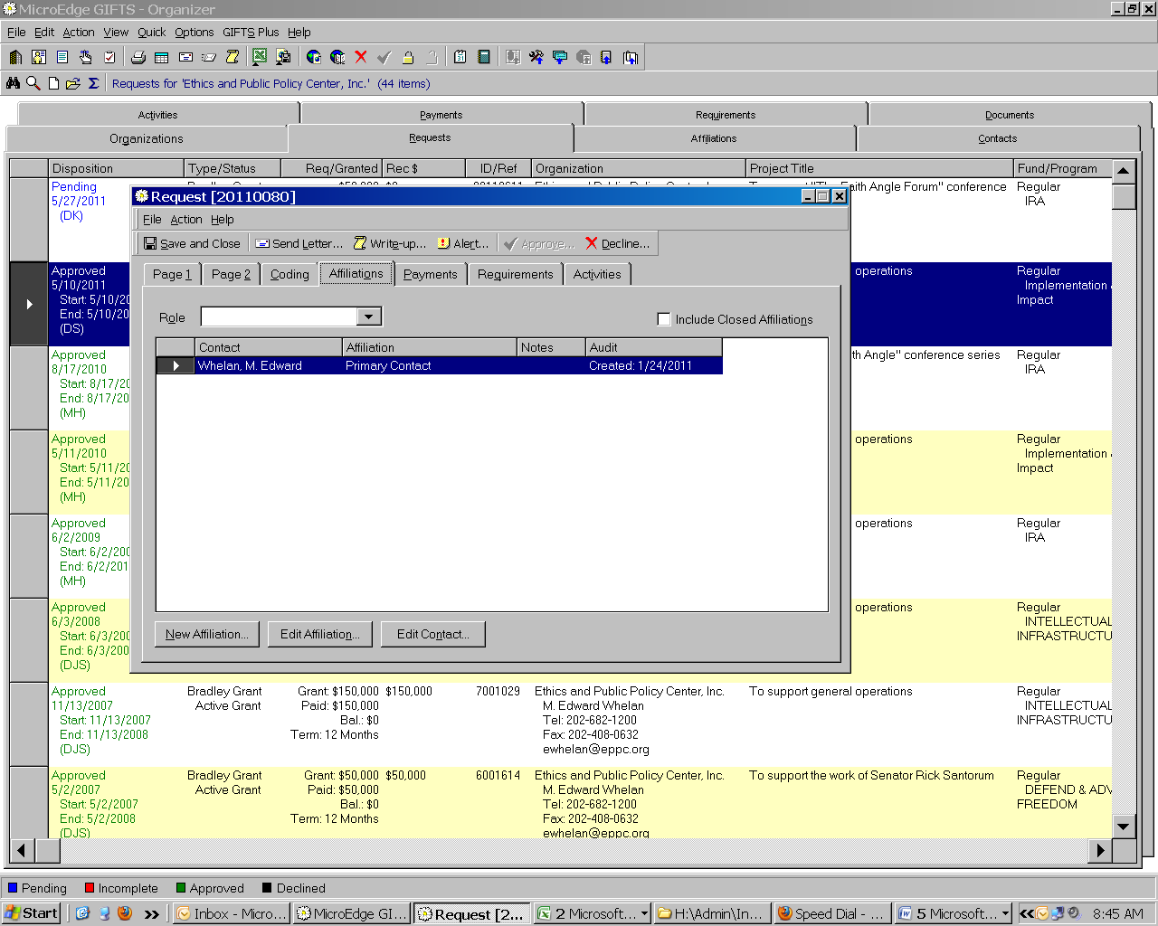

PAYMENTS SCREEN – ALL DISPOSITIONS

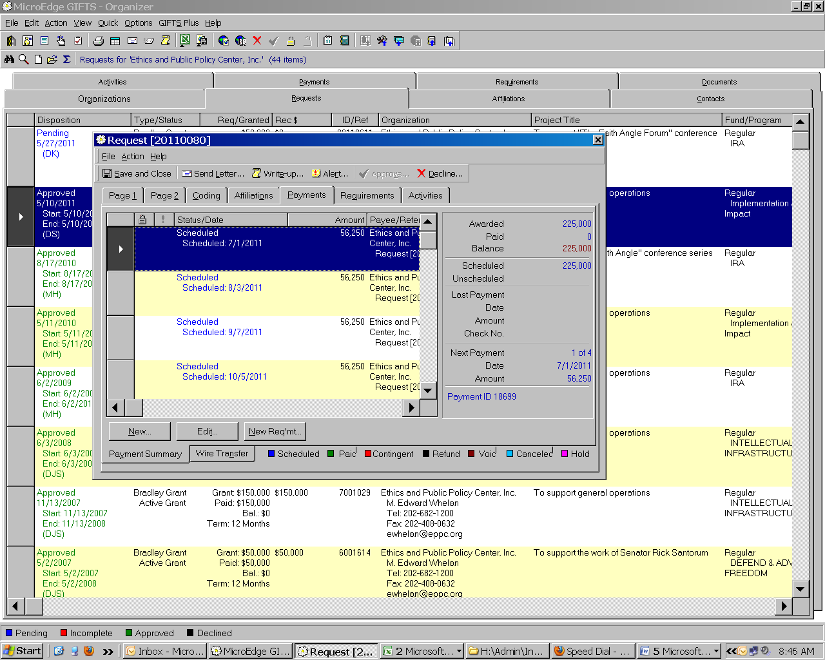
REQUIREMENTS SCREEN – ALL DISPOSITIONS

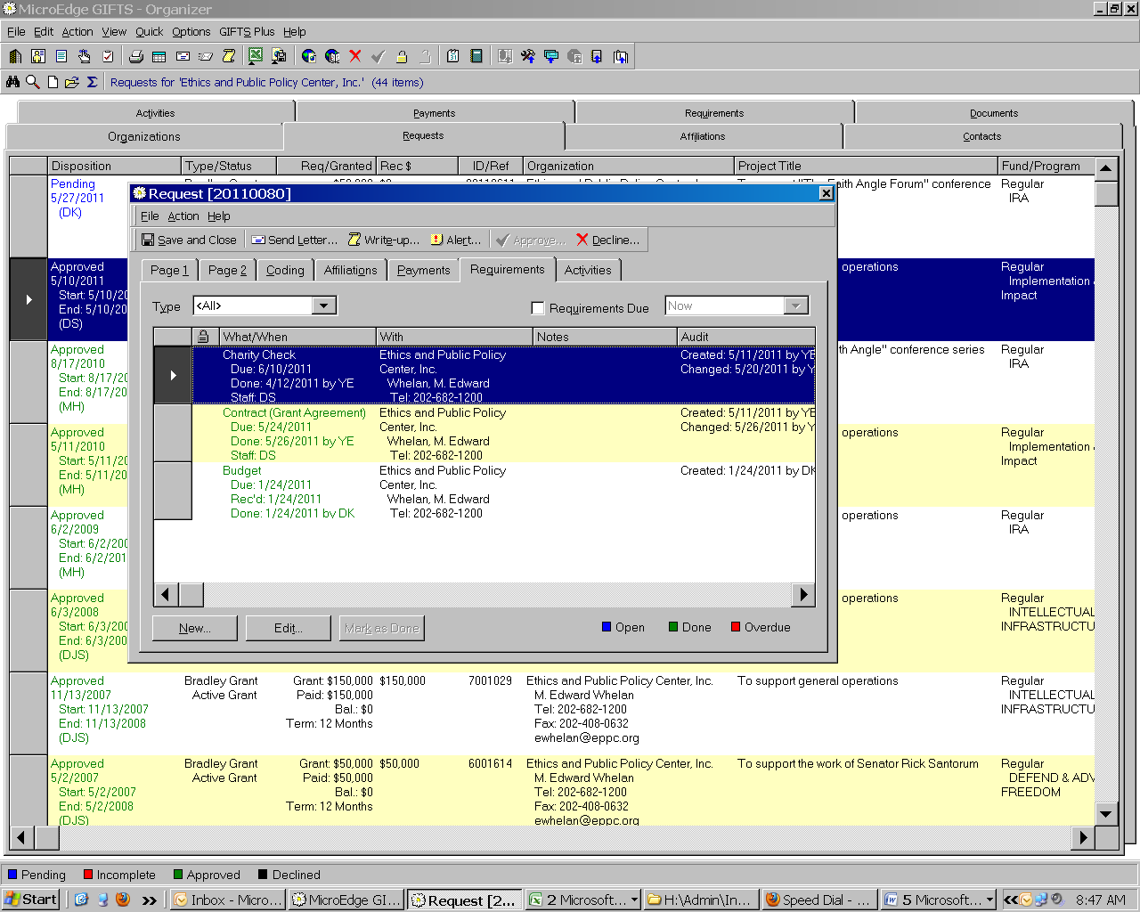
ACTIVITIES SCREEN – ALL DISPOSITIONS

