How to install a Trusted Application from the internet for Software Restriction Policy.

1. Download and save the application.

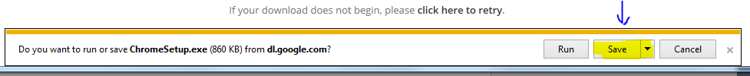

1. Open your Library and select the Downloads in the upper left.

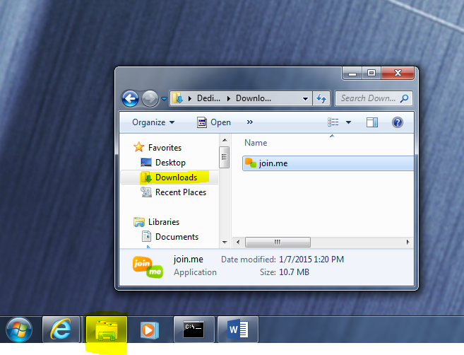

1. Right Click on the File you downloaded, then Left Click and select the RUN AS ADMINISTRATOR option.

