**Word Mail Merge instructions**

Before starting the mail merge, it’s helpful to know the items listed below before you start your mail merge so that you are not going between the spreadsheet and word document. Locate and write down the following items on the spreadsheet:

* If there are multiple tabs, the name of the tab where the addresses are located
* The name of each column that will be used for the address fields
* The name of the column where the salutation is located

**Mail Merging a Letter**

If there is already a letter created, open that document.

Make sure the cursor is in the location where you want the address field to be.

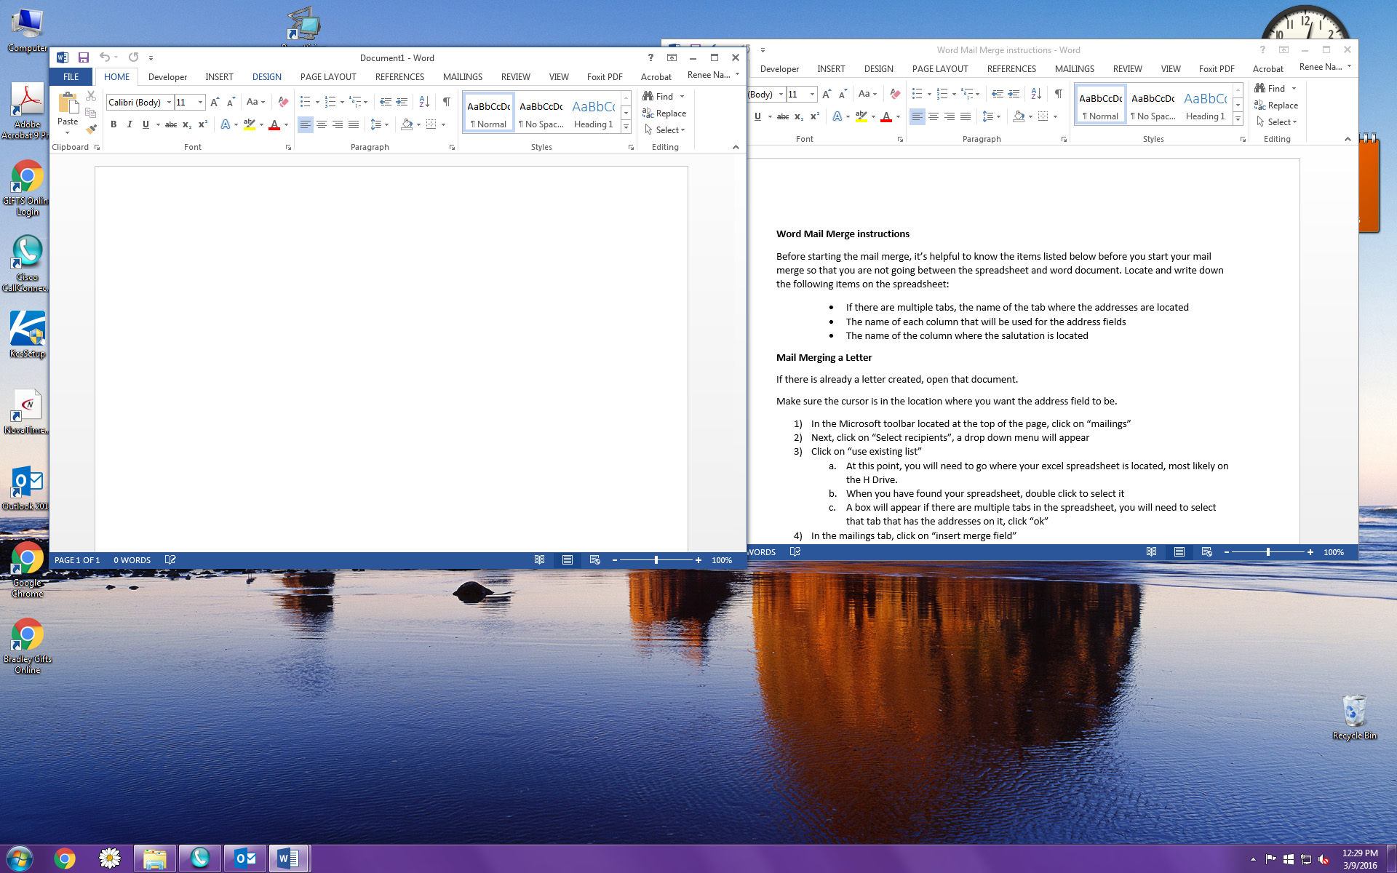In the Microsoft toolbar located at the top of the page, click on “mailings”

1. 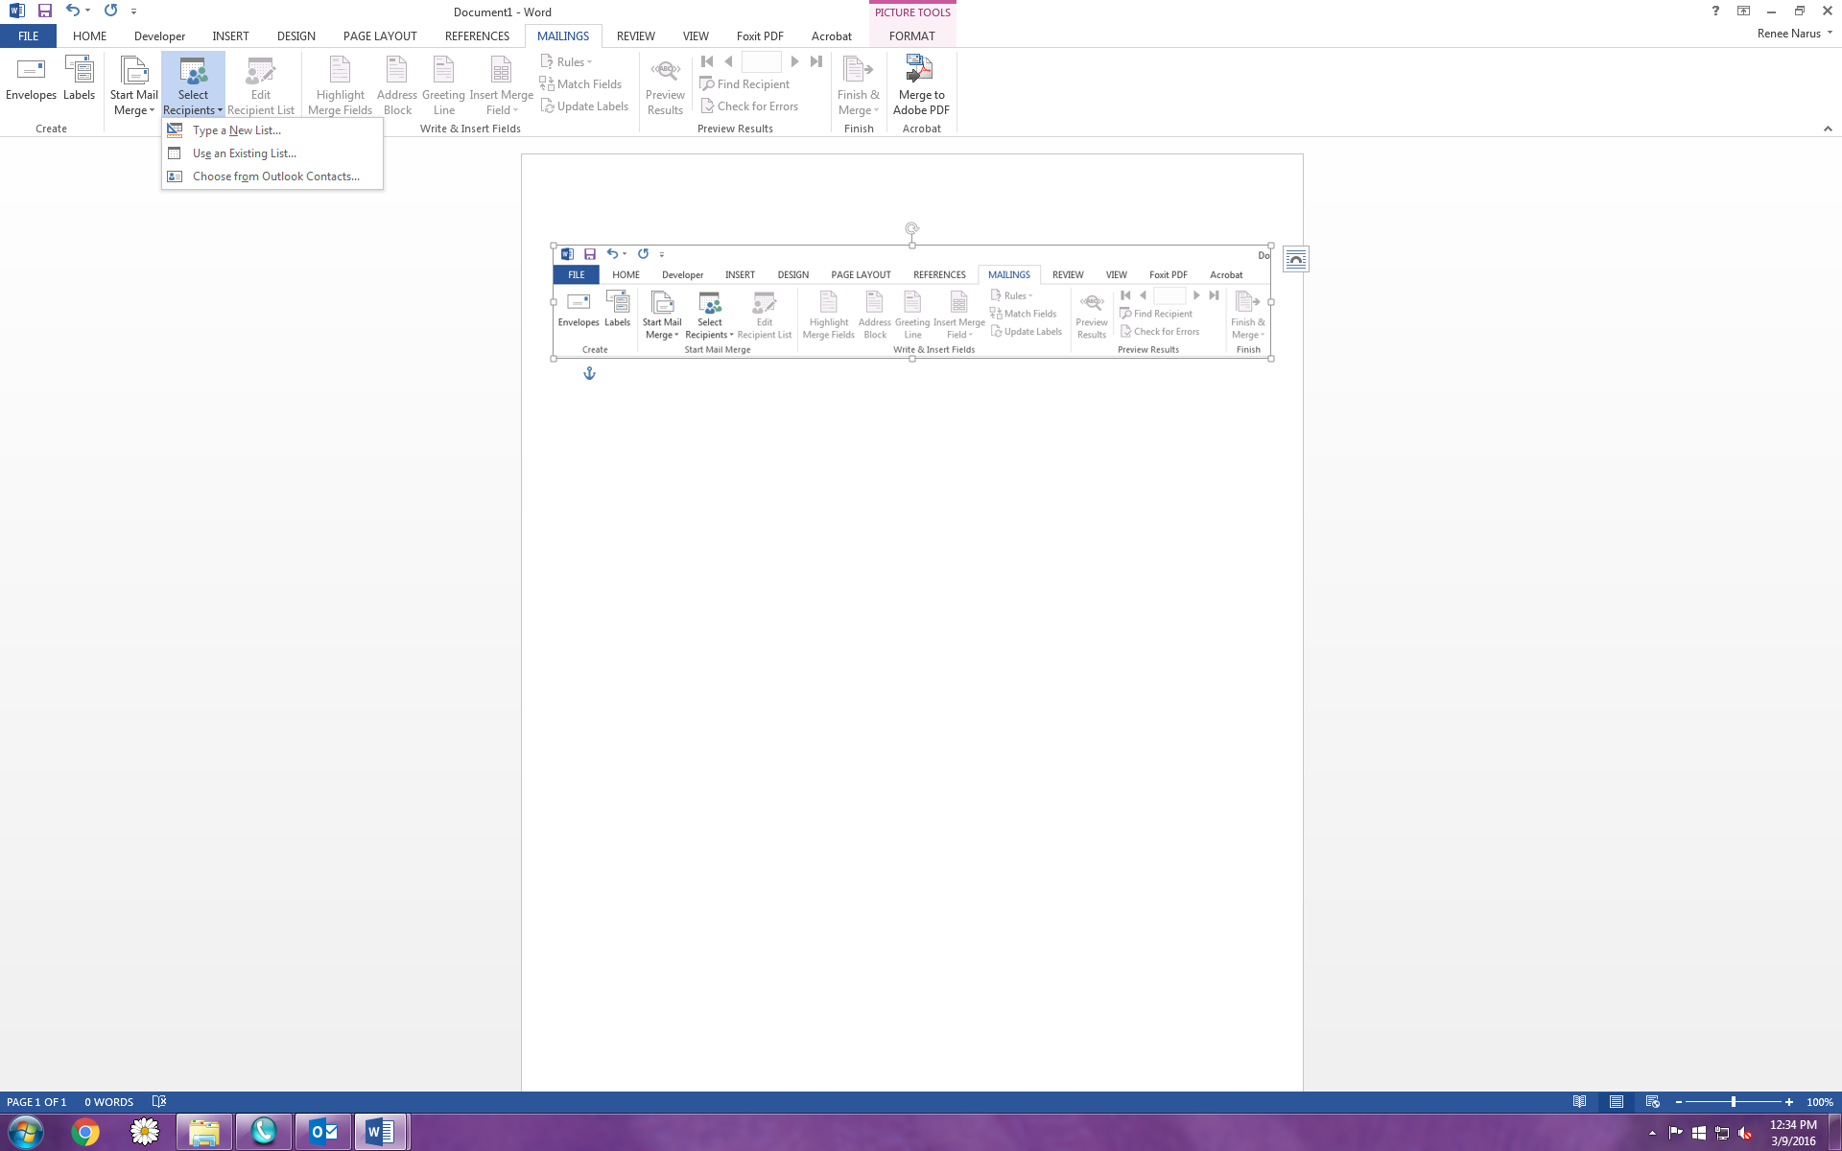Next, click on “Select recipients”, a drop down menu will appear
2. Click on “use existing list”
   1. At this point, you will need to go where your excel spreadsheet is located, most likely on the H Drive.
   2. When you have found your spreadsheet, double click to select it
   3. A box will appear if there are multiple tabs in the spreadsheet, you will need to select that tab that has the addresses on it, click “ok”

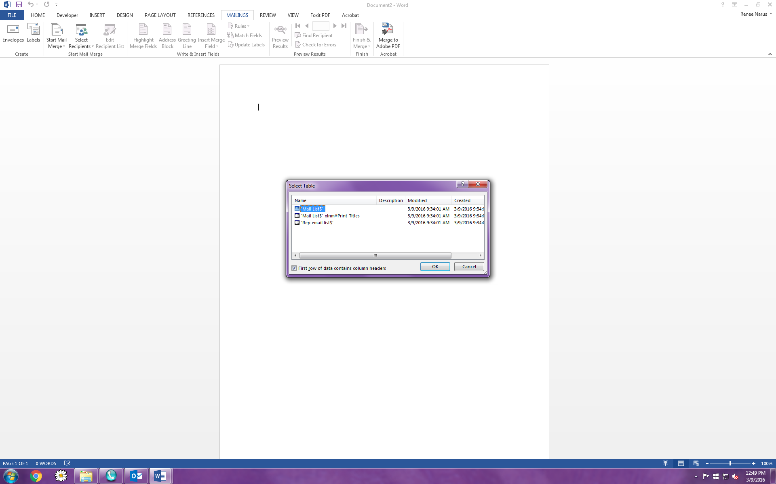

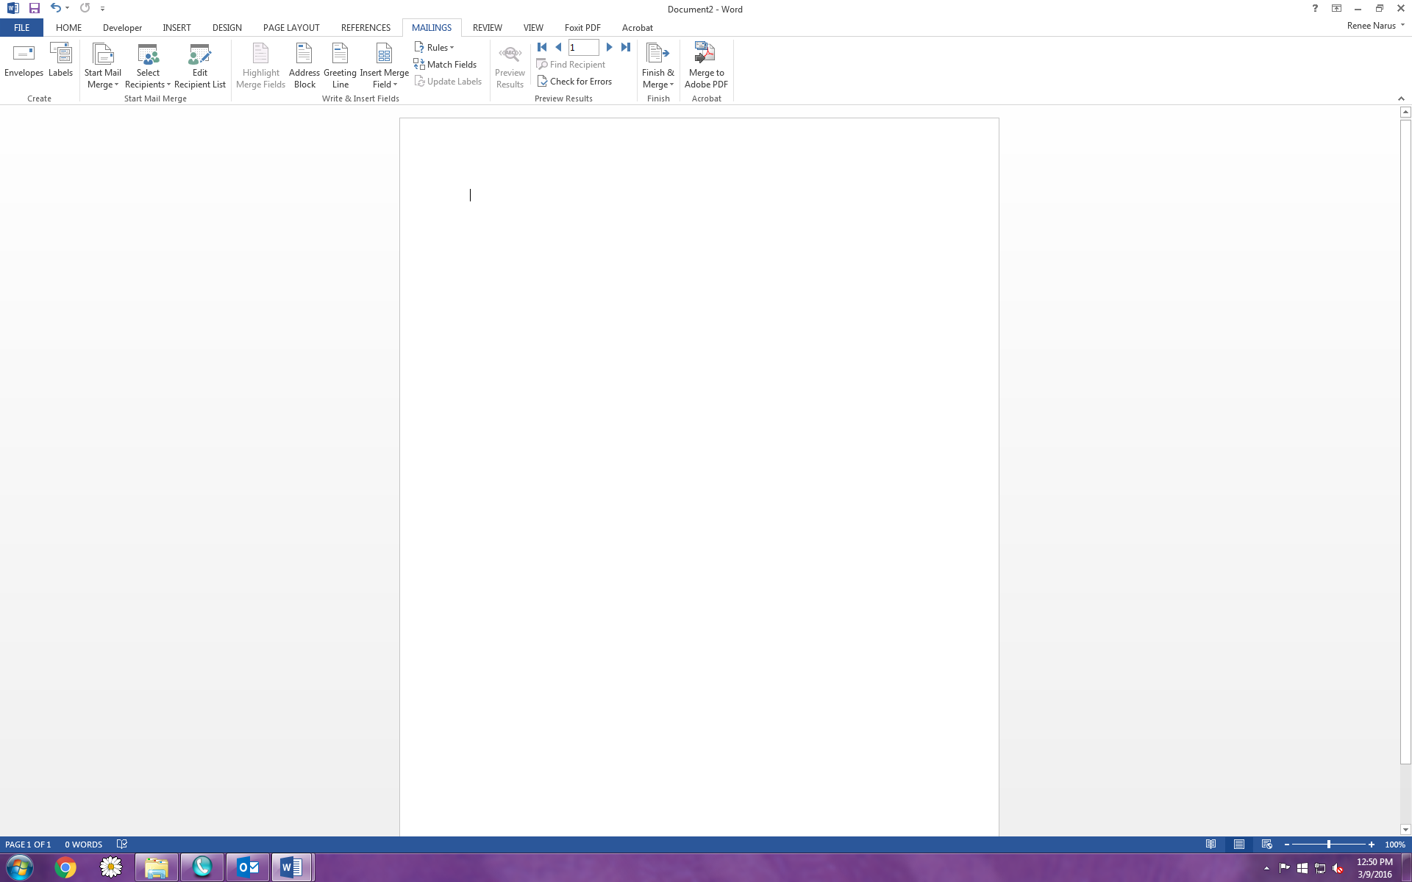

1. In the mailings tab, click on “insert merge field”
   1. Choose all the fields that you would like to appear in the address field – there are 2 ways to do this
      1. 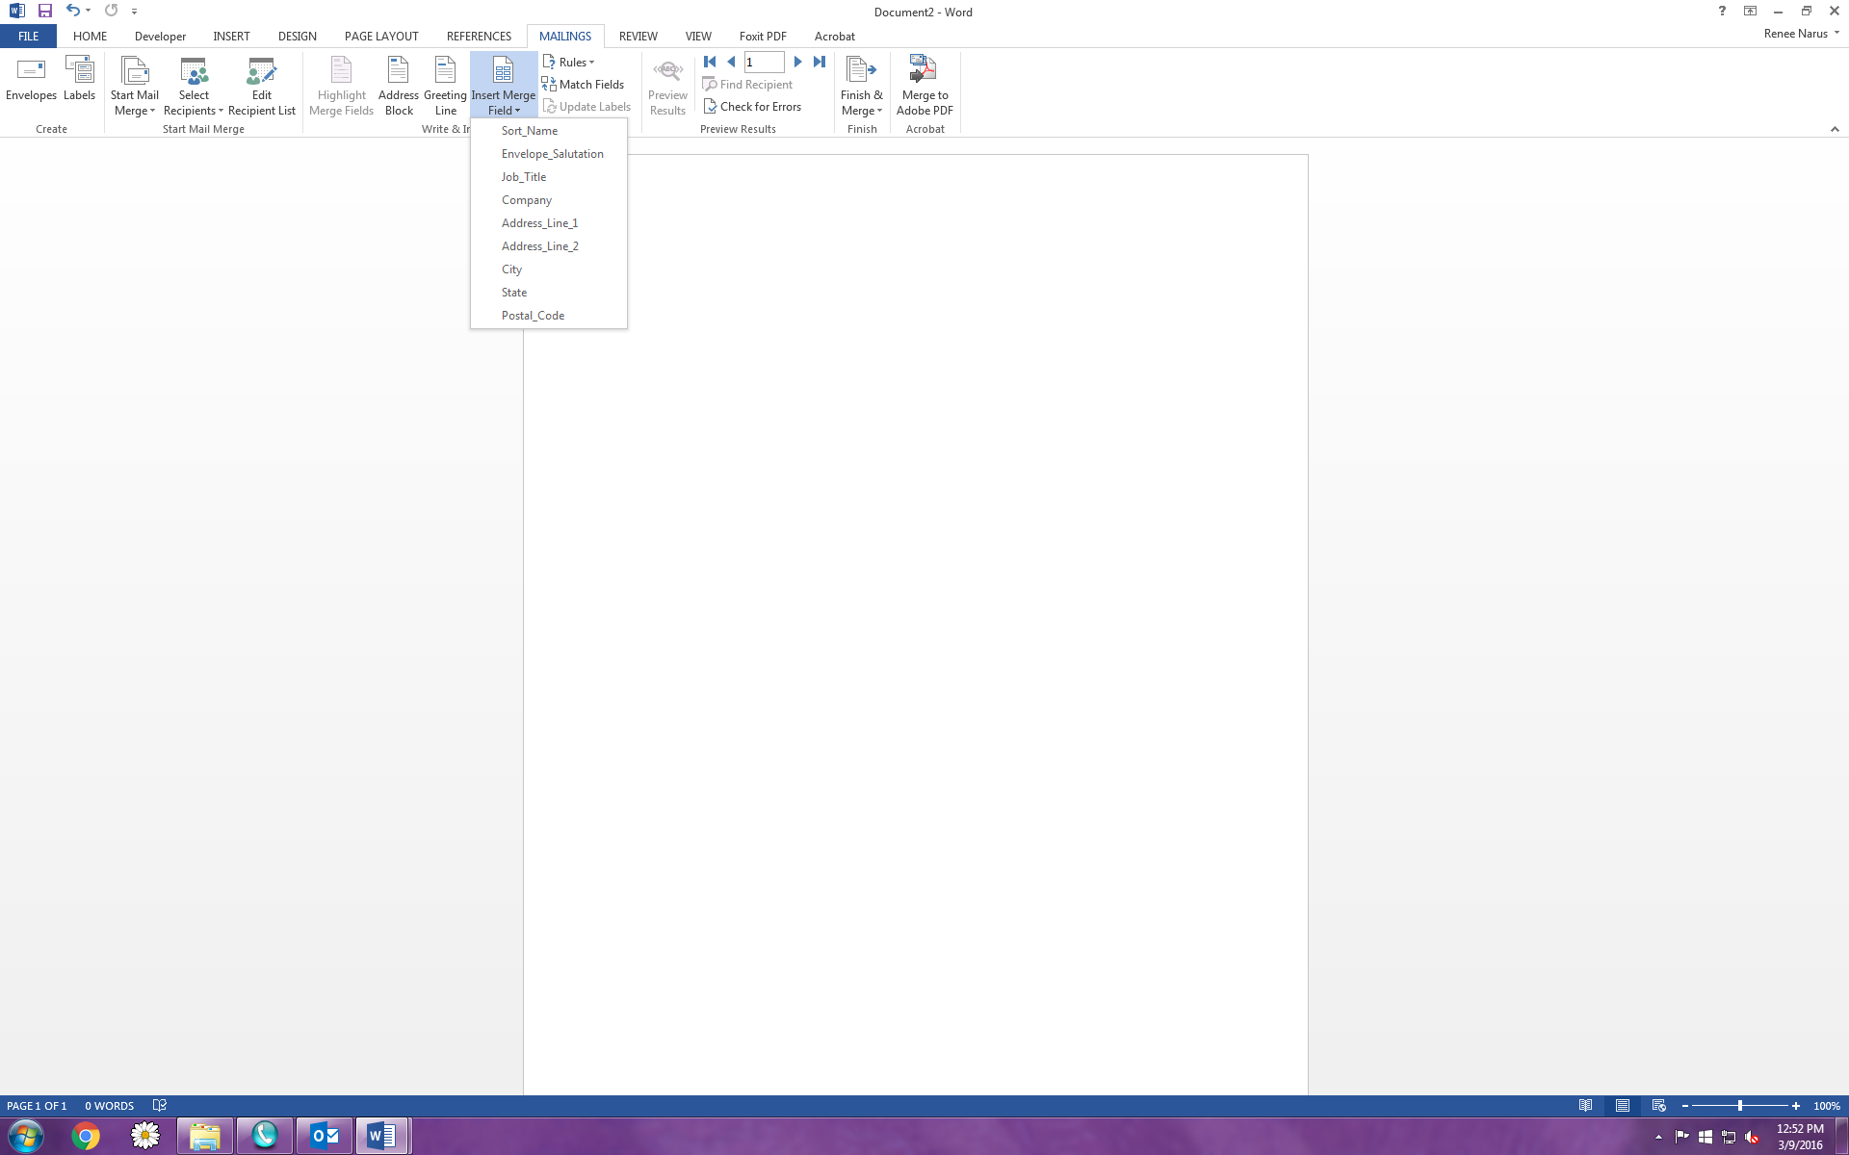The first way is to use the drop down arrow and select each field individually
      2. When selecting each field, you will need to remember to add a return after each field, with the exception of the “City, State Zip” fields. When you get to that row, add in a comma after inserting the city field, a space after the comma, insert State field, then add a space and insert the zip field.
      3. The second way to is to double click on the “page” located directly above “Insert Merge Field”
      4. 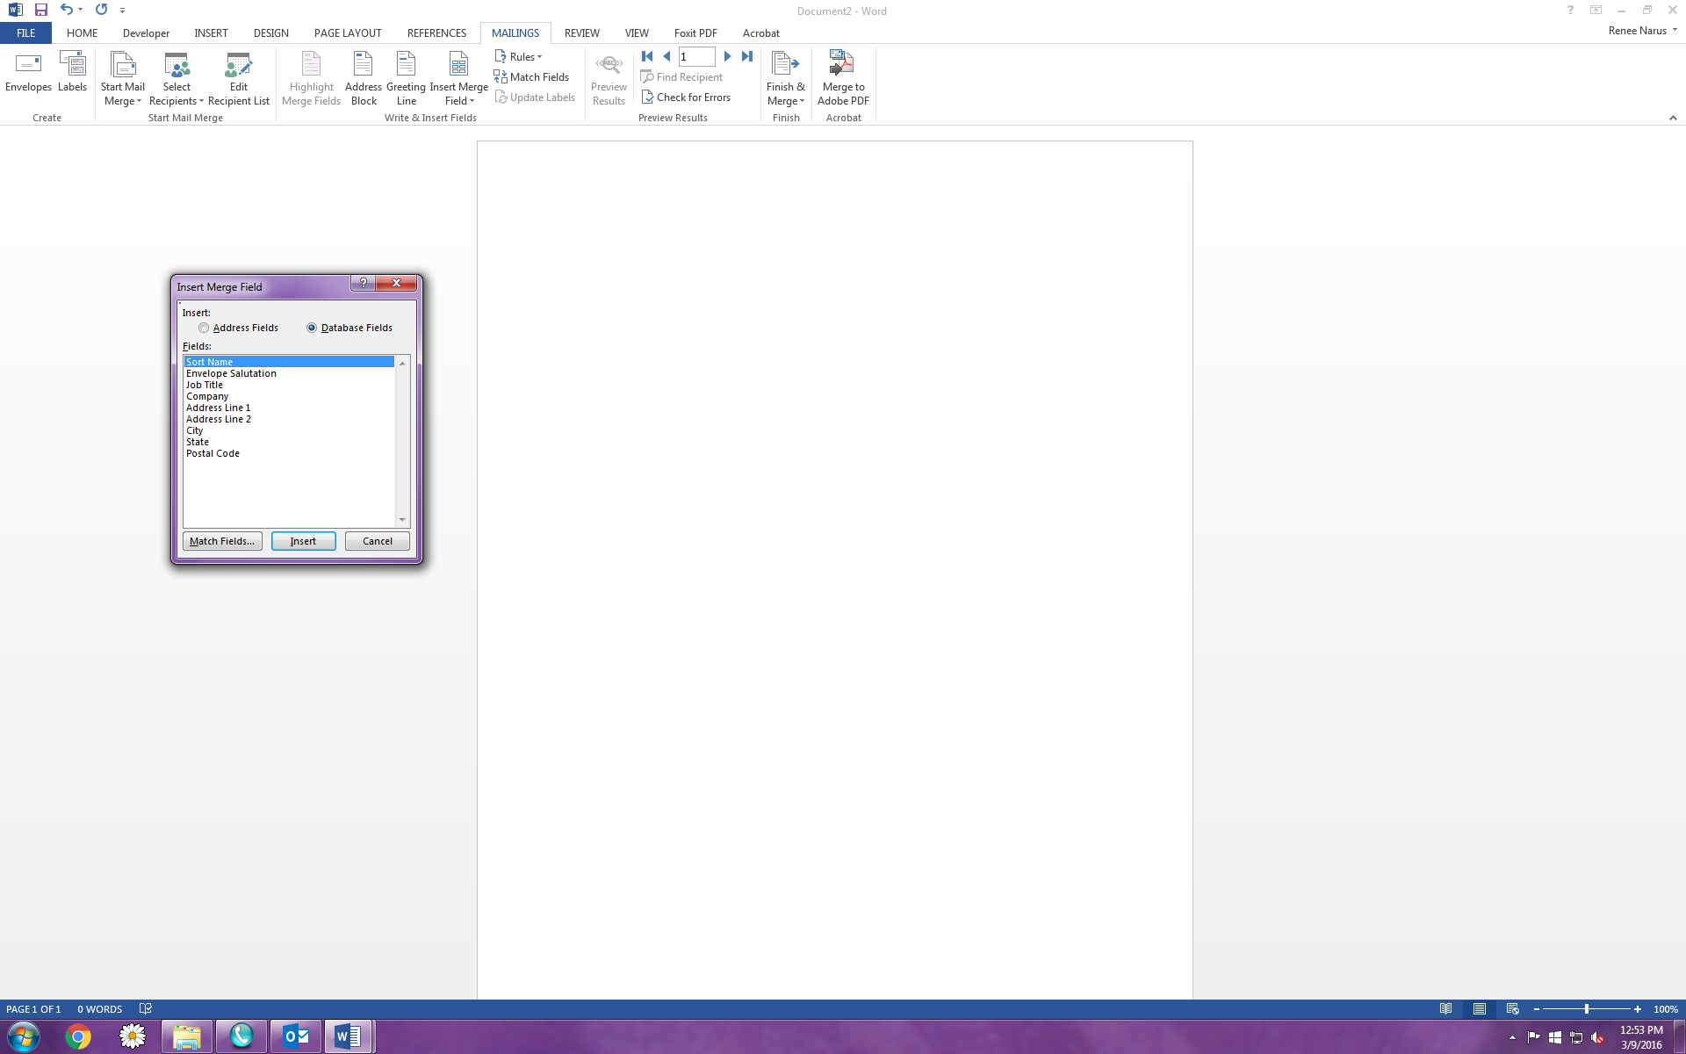A box will appear. At this point, you can select all the fields you need by double clicking on each field, or by selecting a field, then clicking “insert”.
      5. After everything is added, you will have to go into your letter and insert the returns and spaces because everything will be lumped together.
      6. The last field you need to add is the “Salutation field”. Go down to the salutation and after “dear”, be sure to add a space and insert the salutation field using the directions above.
2. After you have added all the merge fields, you can preview the first letter to make sure everything will work with the merge by doing the following:
   1. 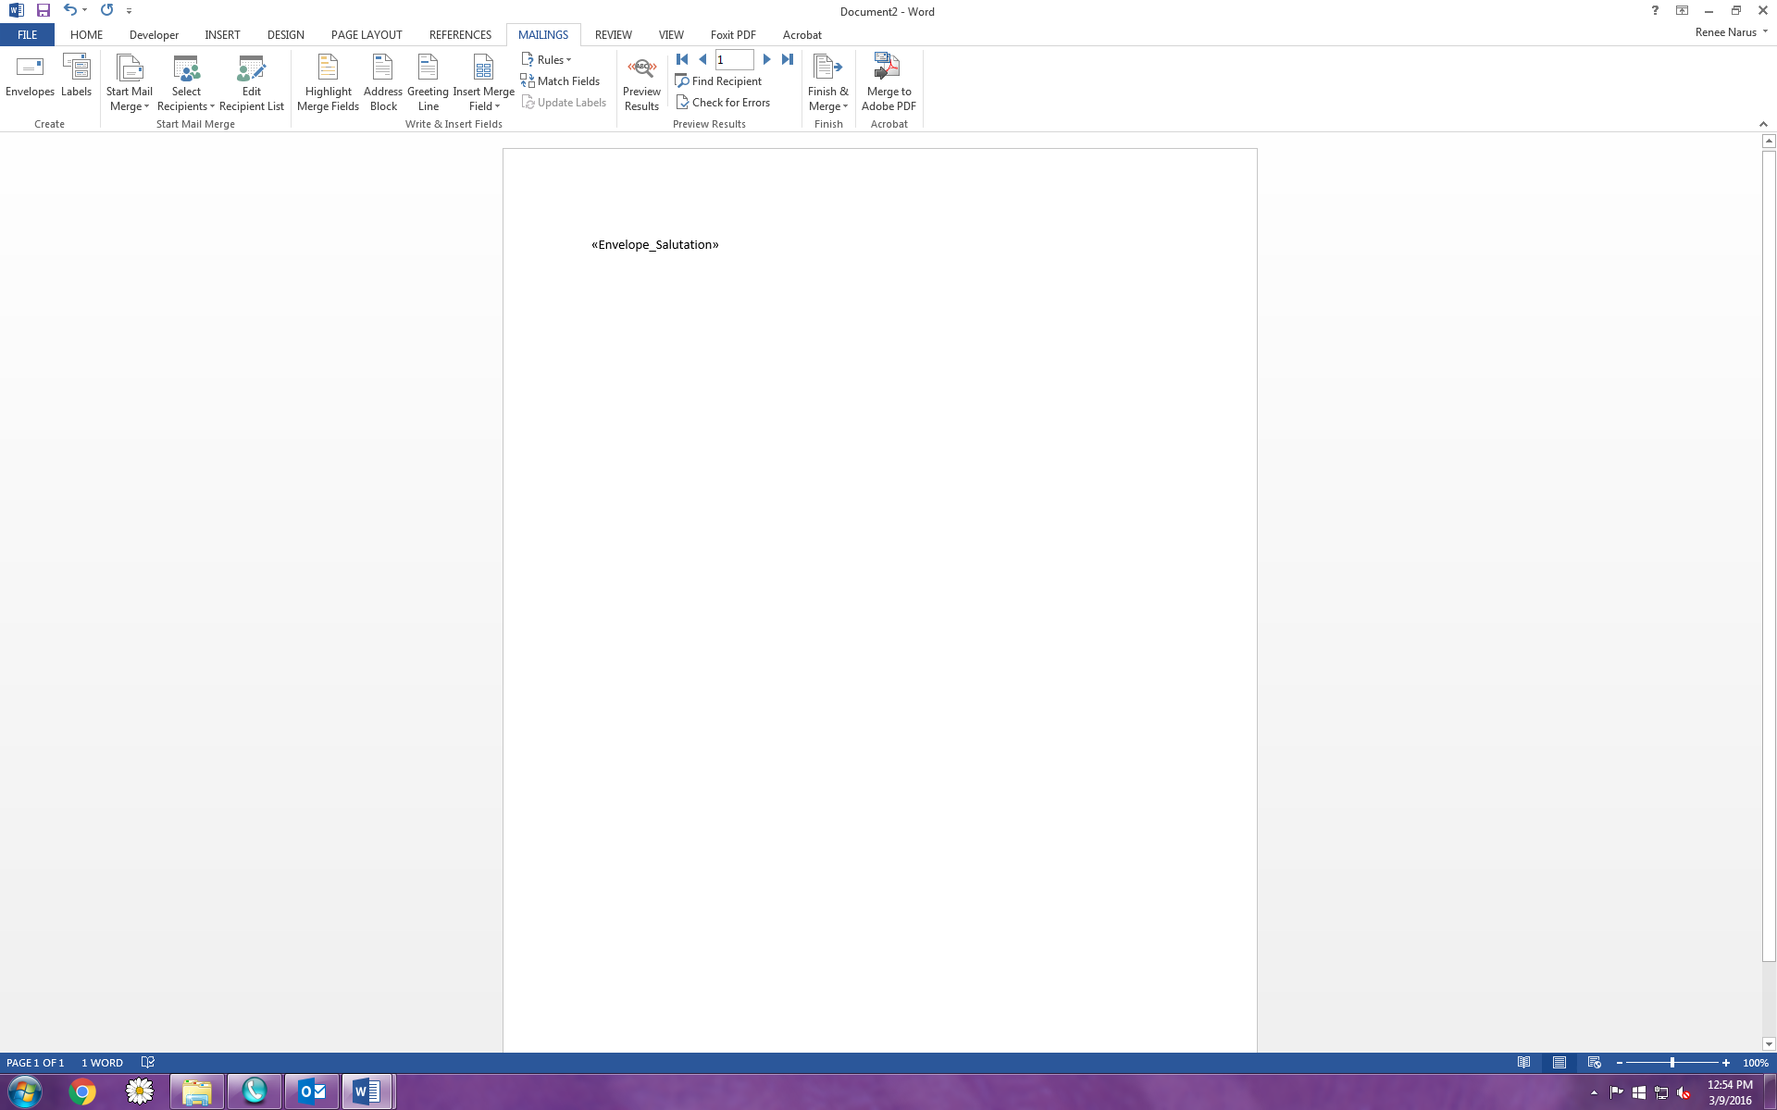In the Mailings menu, click on “preview results”, this will show you what the letter will look like after the address has been merged into it.
   2. This is a good time to make sure that everything still fits on the one page and there aren’t any extra spaces anywhere. It’s a good time to proof everything.
3. 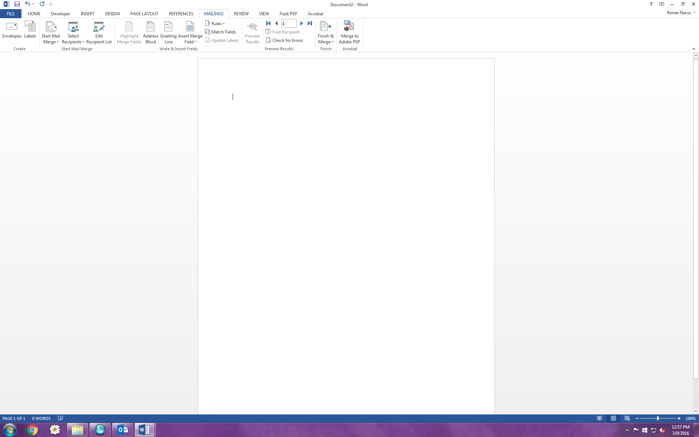If everything looks good, you can select the “Finish & Merge” field.
   1. Click on the down arrow
   2. 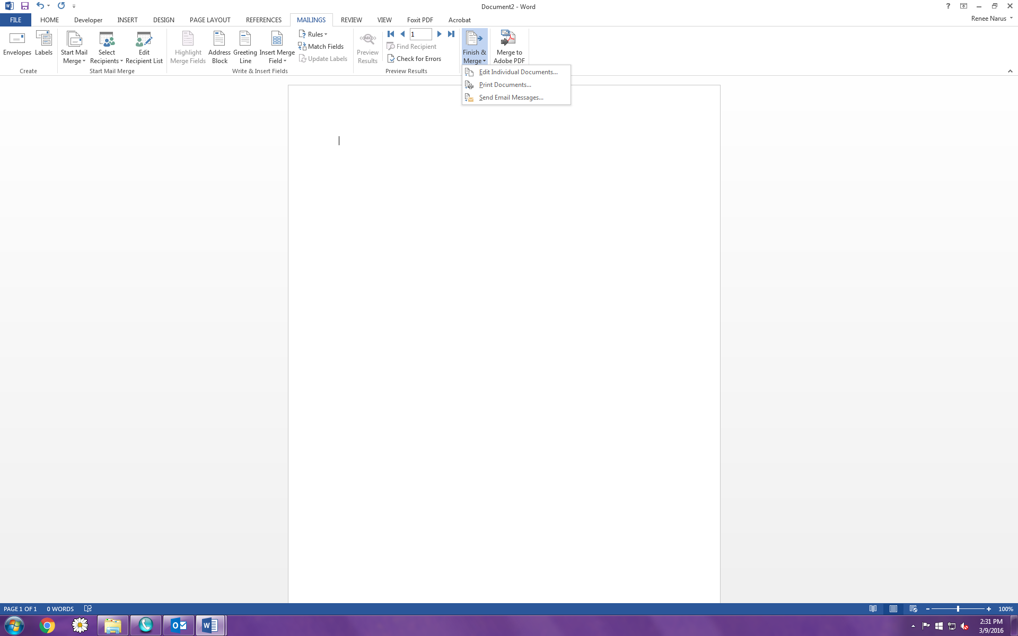Click on “Edit individual documents”
   3. Everything will be merged into a new document
4. Always double check each letter to make sure the merge didn’t alter the letter so that it’s now on 2 pages. (This can happen if the individual has a long address)
5. If everything looks great, then print your letters!

**Mail merging envelopes**

1. Open a new word document
2. Go to the “mailings” tab located in the word toolbar at the top of your document
3. Choose the “Start mail merge” icon.
   1. Click the down arrow
   2. 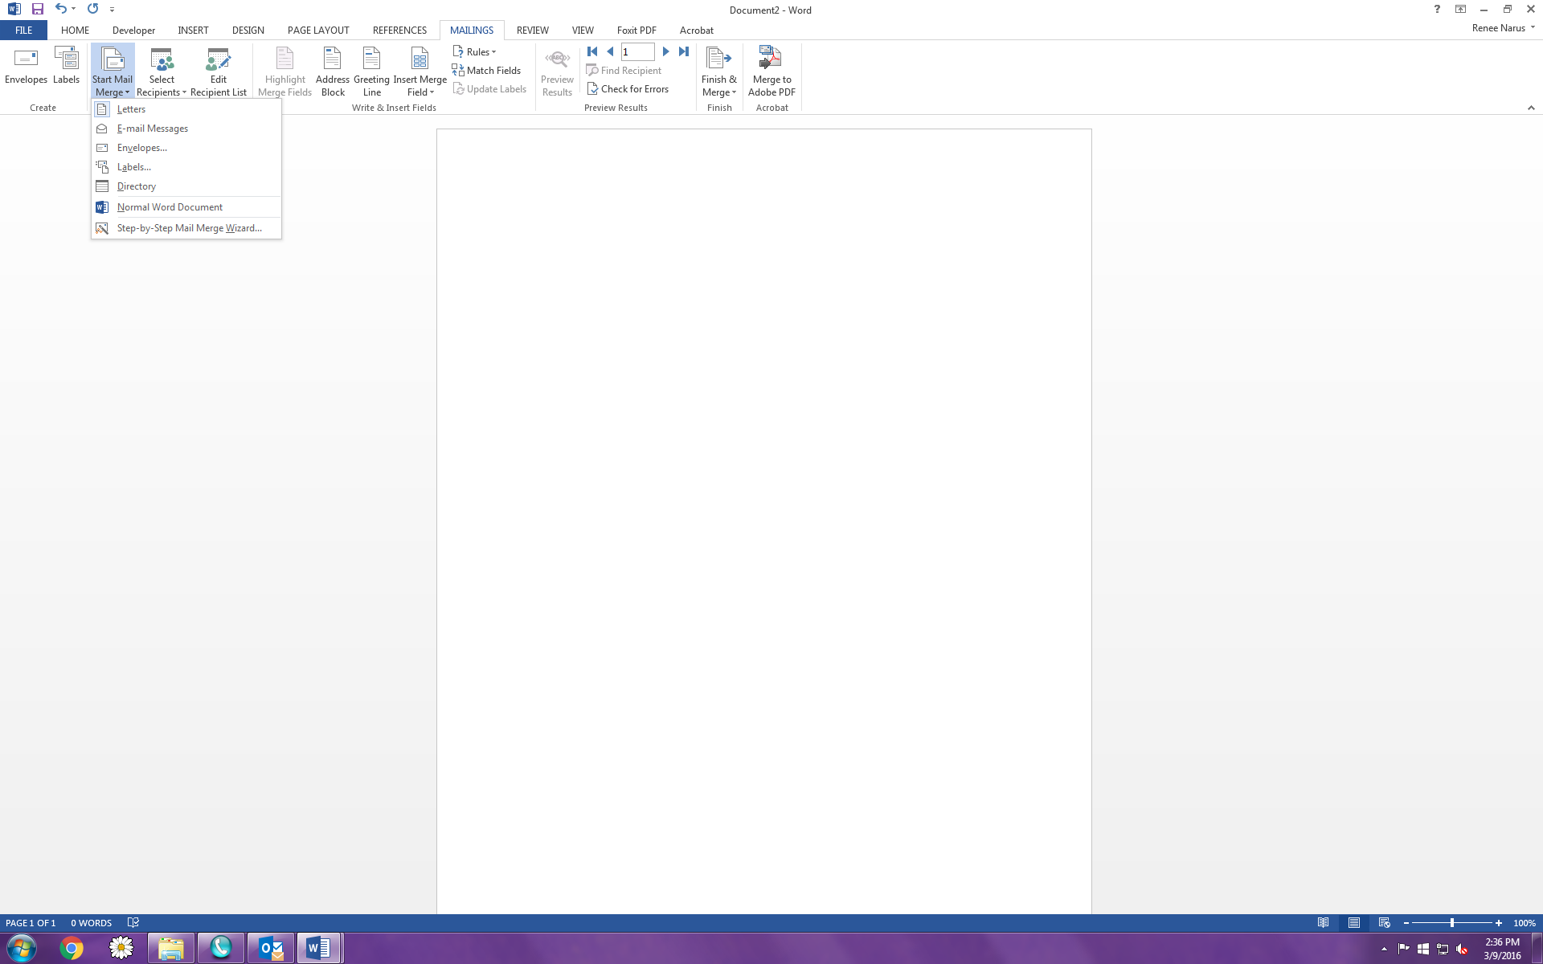Select envelopes
   3. A box will appear, select the type of envelope you are using, typically it’s a size 10
   4. When the outline of the envelope appears, you need to locate the field/box where you will add the addresses. You can do this by clicking your mouse halfway down the envelope until the box appears.
4. Once your cursor is in the box, you need to insert the address information
   1. Choose the “Select recipients” icon
   2. Choose “use an existing list”
   3. 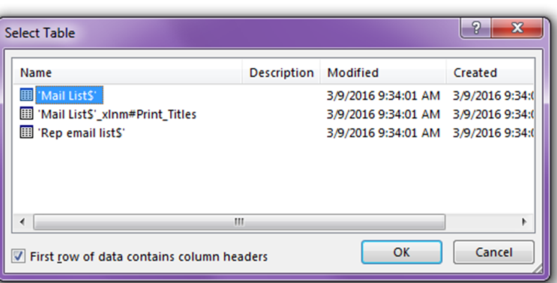At this point, you will need to go where your excel spreadsheet is located, most likely on the H Drive.
   4. When you have found your spreadsheet, double click to select it.
   5. A box will appear if there are multiple tabs in the spreadsheet, you will need to select that tab that has the addresses on it, click “ok”
5. In the mailings tab, click on “insert merge field”



* 1. Choose all the fields that you would like to appear in the address field – there are 2 ways to do this
     1. The first way is to use the drop down arrow and select each field individually.
     2. When selecting each field, you will need to remember to add a return after each field, with the exception of the “City, State Zip” fields. When you get to that row, add in a comma after inserting the city field, a space after the comma, insert State field, then add a space and insert the zip field.
     3. The second way to is to double click on the “page” located directly above “Insert Merge Field”
     4. 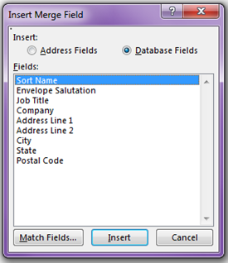A box will appear. At this point, you can select all the fields you need by double clicking on each field, or by selecting a field, then clicking “insert”.
     5. After everything is added, you will have to go into your letter and insert the returns and spaces because everything will be lumped together.

1. After you have added all the merge fields, you can preview the first envelope to make sure everything will work with the merge by doing the following:
   1. In the Mailings menu, click on “preview results”, this will show you what the letter will look like after the address has been merged into it.
   2. This is a good time to make sure that everything still fits on the one page and there aren’t any extra spaces anywhere. It’s a good time to proof everything.
2. If everything looks good, you can select the “Finish & Merge” field.
   1. Click on the down arrow
   2. Click on “Edit individual documents”



* 1. Everything will be merged into a new document

1. Always double check each letter to make sure the merge didn’t alter the envelope so that it’s now on 2 pages. (This can happen if the individual has a long address)
2. If everything looks great, then print your letters!