The Bradley Foundation’s
Summer Party

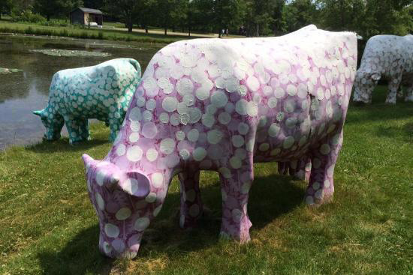

You and a guest are invited to
The Bradley Foundation’s summer party

Friday, August 28, 2015

Lynden Sculpture Garden
2145 West Brown Deer Road
Milwaukee, WI

5:30-7:00 p.m. Cocktails and hors d’oeuvres

6:00-6:30 p.m. Docent Tour

7:00 p.m. Dinner

8:00 p.m. Bradley family history with Dave Uihlein

RSVP by August 19th by returning the enclosed reply card to Susan Millard
