March 2010

Dear Friend:

I am pleased to send you a copy of the Bradley Foundation’s “Report to Wisconsin,” which highlights our charitable giving in Milwaukee and Wisconsin during 2009. This report is particularly meaningful to all of us at the Bradley Foundation because we are celebrating our 25th anniversary as a grantmaking institution.

A little over twenty-five years ago, on February 20, 1985, the sale of the Allen-Bradley Company to Rockwell International was consummated, with a significant portion of the proceeds dedicated to what is now the Bradley Foundation. One month later, at a special meeting of the Board of Directors of the Allen Bradley Foundation, the directors voted to change the name of the foundation to the Lynde and Harry Bradley Foundation. One of our directors, David Uihlein, served as a member of that Board, and today serves as our Vice Chairman.

Operating as a private foundation, later that year the Bradley Foundation received its share of the sale proceeds and began making grants in February of 1986. Since then, the Bradley Foundation has made grants to organizations in Milwaukee and Wisconsin in the aggregate amount of $292,000,000.

The Bradley Foundation is institutionally “at home” in Milwaukee, where our donors, Lynde and Harry Bradley, established the family legacy that it is our trust to preserve. Please review the enclosed report. As always, we welcome any and all comments and questions as we endeavor to be a good corporate citizen of our community and strive to be open and transparent about our philanthropy.

Sincerely,
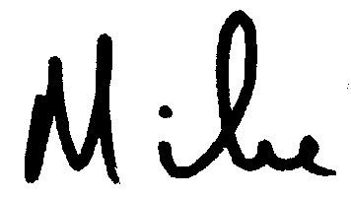
Michael W. Grebe

