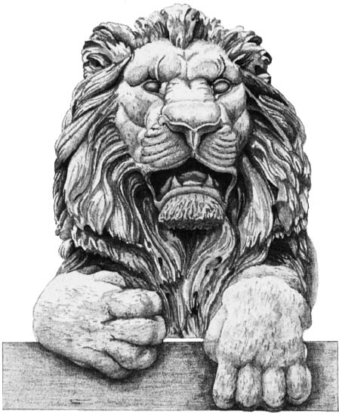

MICHAEL W. GREBE

Michael W. Grebe is the President and CEO of the Lynde and Harry Bradley Foundation. Prior to becoming the Foundation’s CEO, Mr. Grebe was a member of the Foundation’s Board of Directors for six years.

Prior to joining the Bradley Foundation, Mr. Grebe was the Chairman and CEO of Foley & Lardner, one of the country’s largest law firms, where he was a partner for more than 25 years. Mr. Grebe concentrated his practice on corporate and financial law.

Mr. Grebe is a former member and president of the Board of Regents for the University of Wisconsin System and past member and chairman of the Board of Visitors for the United States Military Academy. He is a former member of the board of directors of the Oshkosh Corporation; the Church Mutual Insurance Company; the Milwaukee Brewers Baseball Club; the Philanthropy Roundtable; and the Charter School Growth Fund. He is a former chairman of the Greater Milwaukee Committee and co-chairman of the seven-county M7 economic development project in southeastern Wisconsin.

Mr. Grebe is a former general counsel to the Republican National Committee and was the Republican National Committeeman for Wisconsin during 1984-2002. Mr. Grebe was a delegate to the Republican National Conventions in 1984, 1988, 1992, 1996, 2000
and 2012.

Mr. Grebe received his Bachelor's degree with honors from the United States Military Academy and his law degree, magna cum laude, from the University of Michigan. He served in the United States Army and was awarded the Combat Infantryman’s Badge and two Bronze Stars (one for valor) for his service in Vietnam.

Mr. Grebe lives in Milwaukee and is married to Patricia Perry. He has two children, a son and daughter.

The Lynde and Harry Bradley Foundation is a private foundation, providing grants in support of democratic capitalism; limited, competent government; a dynamic marketplace for economic, intellectual, and cultural activity; and a vigorous defense at home and abroad of American ideas and institutions.

