POSITIVE PAY FILE

After the checks are mailed, you must notify Wells Fargo so they know what checks to clear. Below are the steps for running the Positive Pay SmartList in Great Plains, reformatting the file, and importing it into Commercial Electronic Office (CEO).

- Run the SmartList report in Great Plains
  - To access SmartLists, click on the light bulb icon in the upper left corner of the GP screen or select the path Microsoft Dynamics GP/SmartList
  - In the Smart List screen, select the path Purchasing/Payables Transactions/Positive Pay File. Double click on the wording “Positive Pay File” and the following screen will appear:

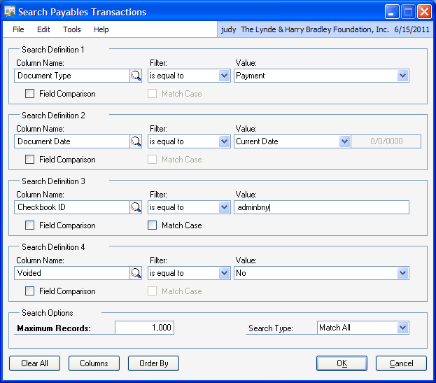

- Make sure the date is the same as the date of the checks.
- Enter the appropriate Checkbook ID and click OK.
  - For payables, the Checkbook ID should be ADMINWF
  - For grants, the Checkbook ID should be GRANTSWF
- When you click OK, the Search Payables Transactions screen should close, and the SmartList should show transactions that match your search instructions

- Export to Excel and format your SmartList
  - To export your SmartList, click on the Excel icon along the top of the screen. Your Excel file should look like this:

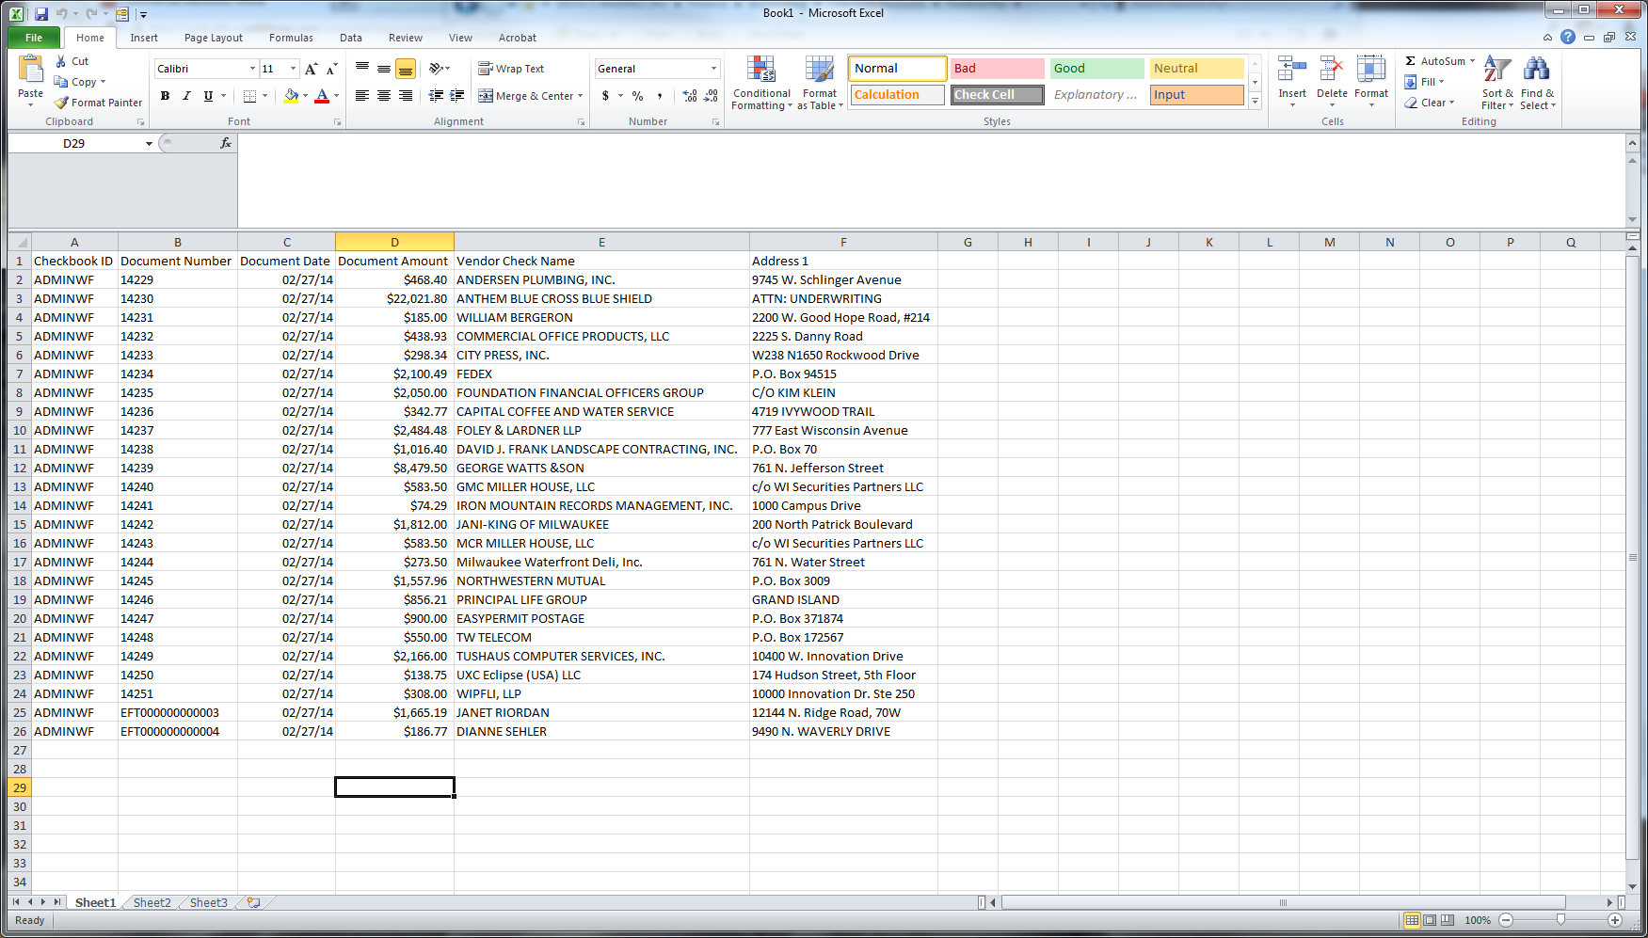

- Delete the headers in the Excel file.
- Delete any EFT transactions included in the Excel file. These are imported into CEO separately.
- The columns in the Excel file should be in the following order. Note that all fields should be formatted as Text.
  - Column A: Bank Routing Number - 075911988
  - Column B: Account Number – needs to be changed from Checkbook ID to the appropriate account number
    - ADMINWF should be changed to 2224906905
    - GRANTSWF should be changed to 2224906913
  - Column C: Check Number
  - Column D: Date
  - Column E: Amount of check
  - Column F: Enter code for type of entry. In this case, the code should be 320, which is the code for a new register entry.
- Delete the columns with vendor check name and address.
- Change the format of all cells to Text. The cells may require additional tweaking after this change, particularly the date column.
- Your file should now look like this:
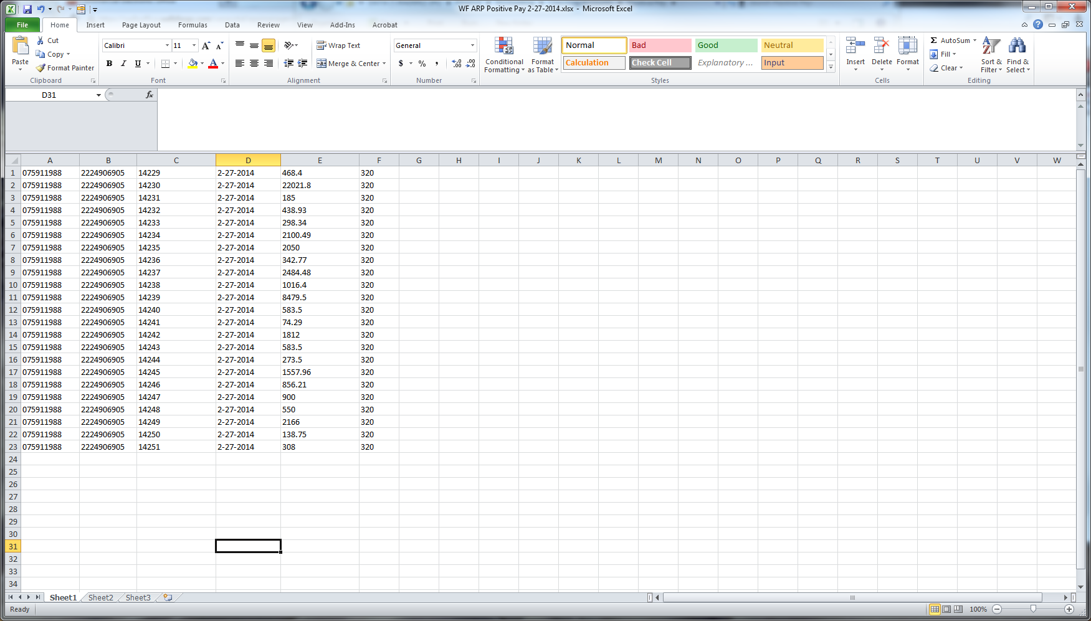

- Save the Positive Pay Excel file in H:\Finance\Accounting\Checking Accounts\Positive Pay
  - Title should be “WF ARP Positive Pay MM-DD-YY”
  - Format should be .xlsx

- Import the Positive Pay File into CEO and submit
  - Log onto Wells Fargo CEO
    - Go to https://wellsfargo.com/com
    - Click on the Sign On button
    - Enter the Company ID (LHBFOUND), your User ID and Password, and click the Sign On button
  - Along the left, click on Fraud Manager
  - A new window will pop up. Along the left side, click on Add Check Issues
  - Click on Upload File, Then browse to the file you just saved, and click Open
  - Click on Upload
  - Upload Check Issues File information will be shown (see below). Confirm that the number listed in the 320-New Issue Column, in the check issues column be sure it is equal to the number of checks cut.
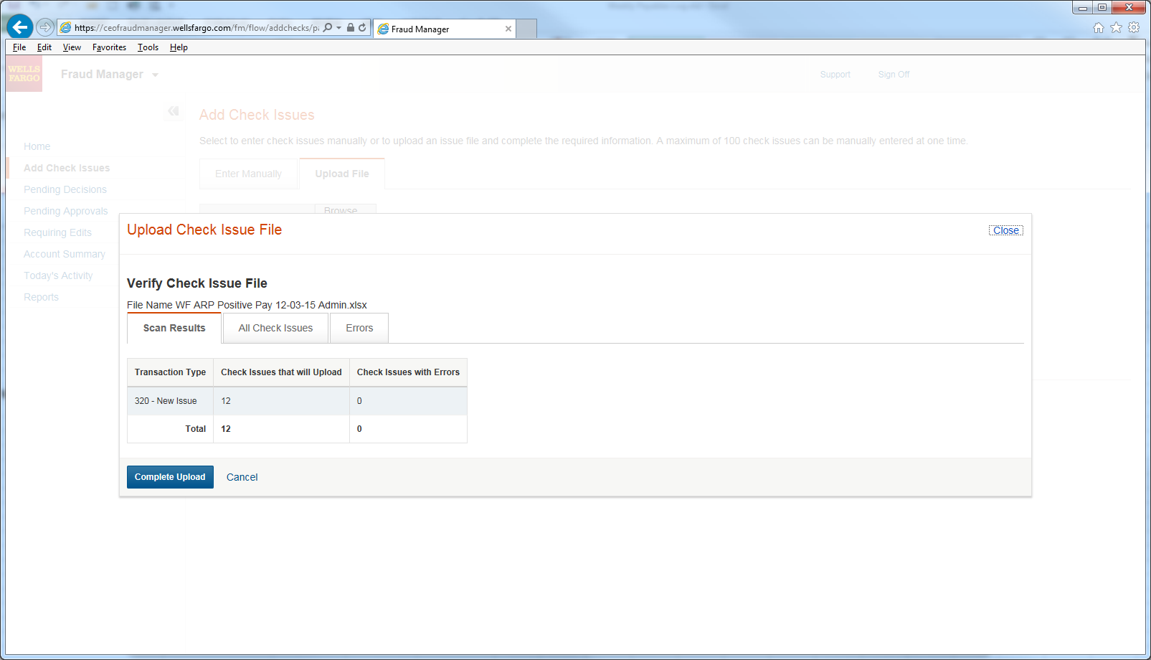

  - If items appear in the Check Issues with Errors column, then the formatting of the Uploaded file needs to be adjusted and rescanned before continuing the import process.
  - If the correct number of items appear in the Check Issues that will Upload then click Complete Upload. The screen below will appear.
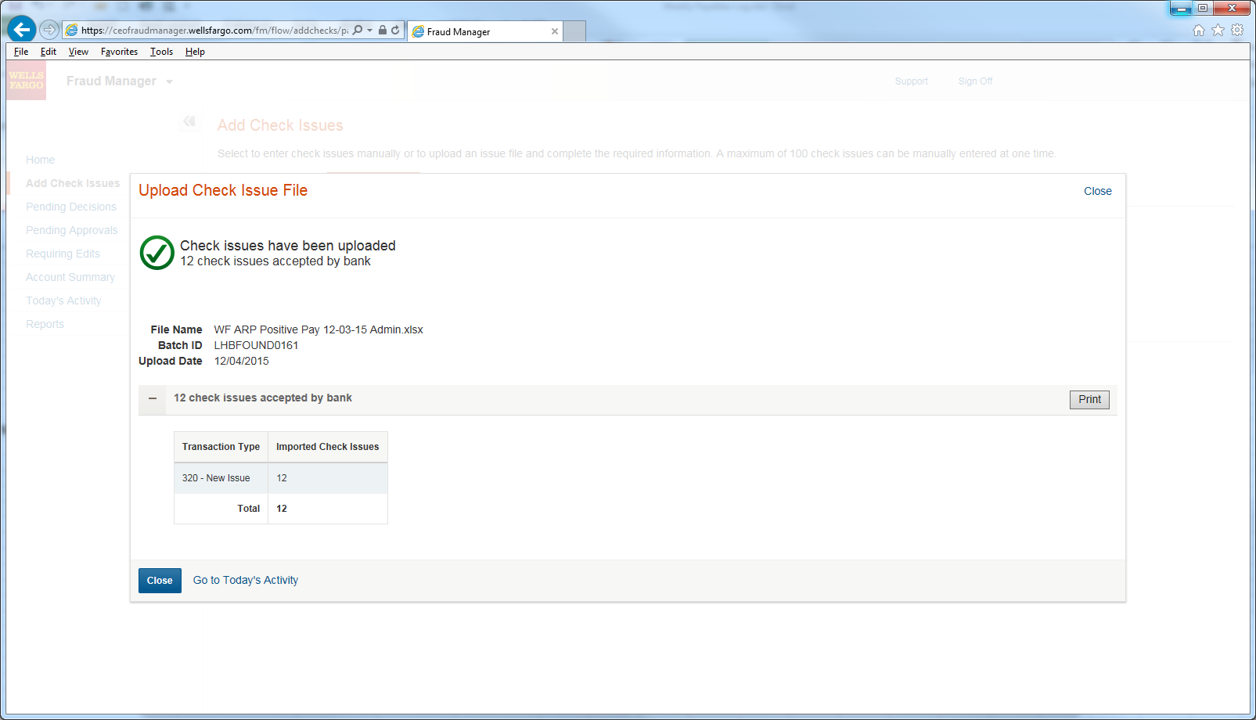

  - Click on the Print, and print the Confirmation.
  - Click on Go to Today’s Activity to view the File Details, and print that as well.
  - Staple the two summary and detail confirmations to the check register and file in the Check Register file for the current year.

