July 31, 2026

«Letter_Address_Block»

Dear «Letter_Salutation»:

Enclosed is the Foundation’s check payable to «Payee_Org_Legal_Name» in the amount of «Payment_Amount». This payment represents the «Payment_Payment_Number» installment of a «Request_Grant_Amount» grant that was awarded by our Board of Directors to support the 2009-2010 Bradley Graduate and Post Graduate Fellowship Program under the direction of Professor «Request_Reference_Number» in the «Request_Subdivision».

The Foundation directors are pleased to be able to support your work and wish you every success in your endeavors. Please provide periodic reports accounting for the funds expended for the grant.

Sincerely,

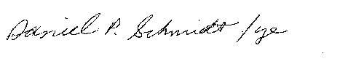
Daniel P. Schmidt

DPS/ye

Enclosure: Check #«Payment_Check_Number»

cc: Professor «Request_Reference_Number»

Grant ID #«Request_ID»
«Request_Docket_Number»

