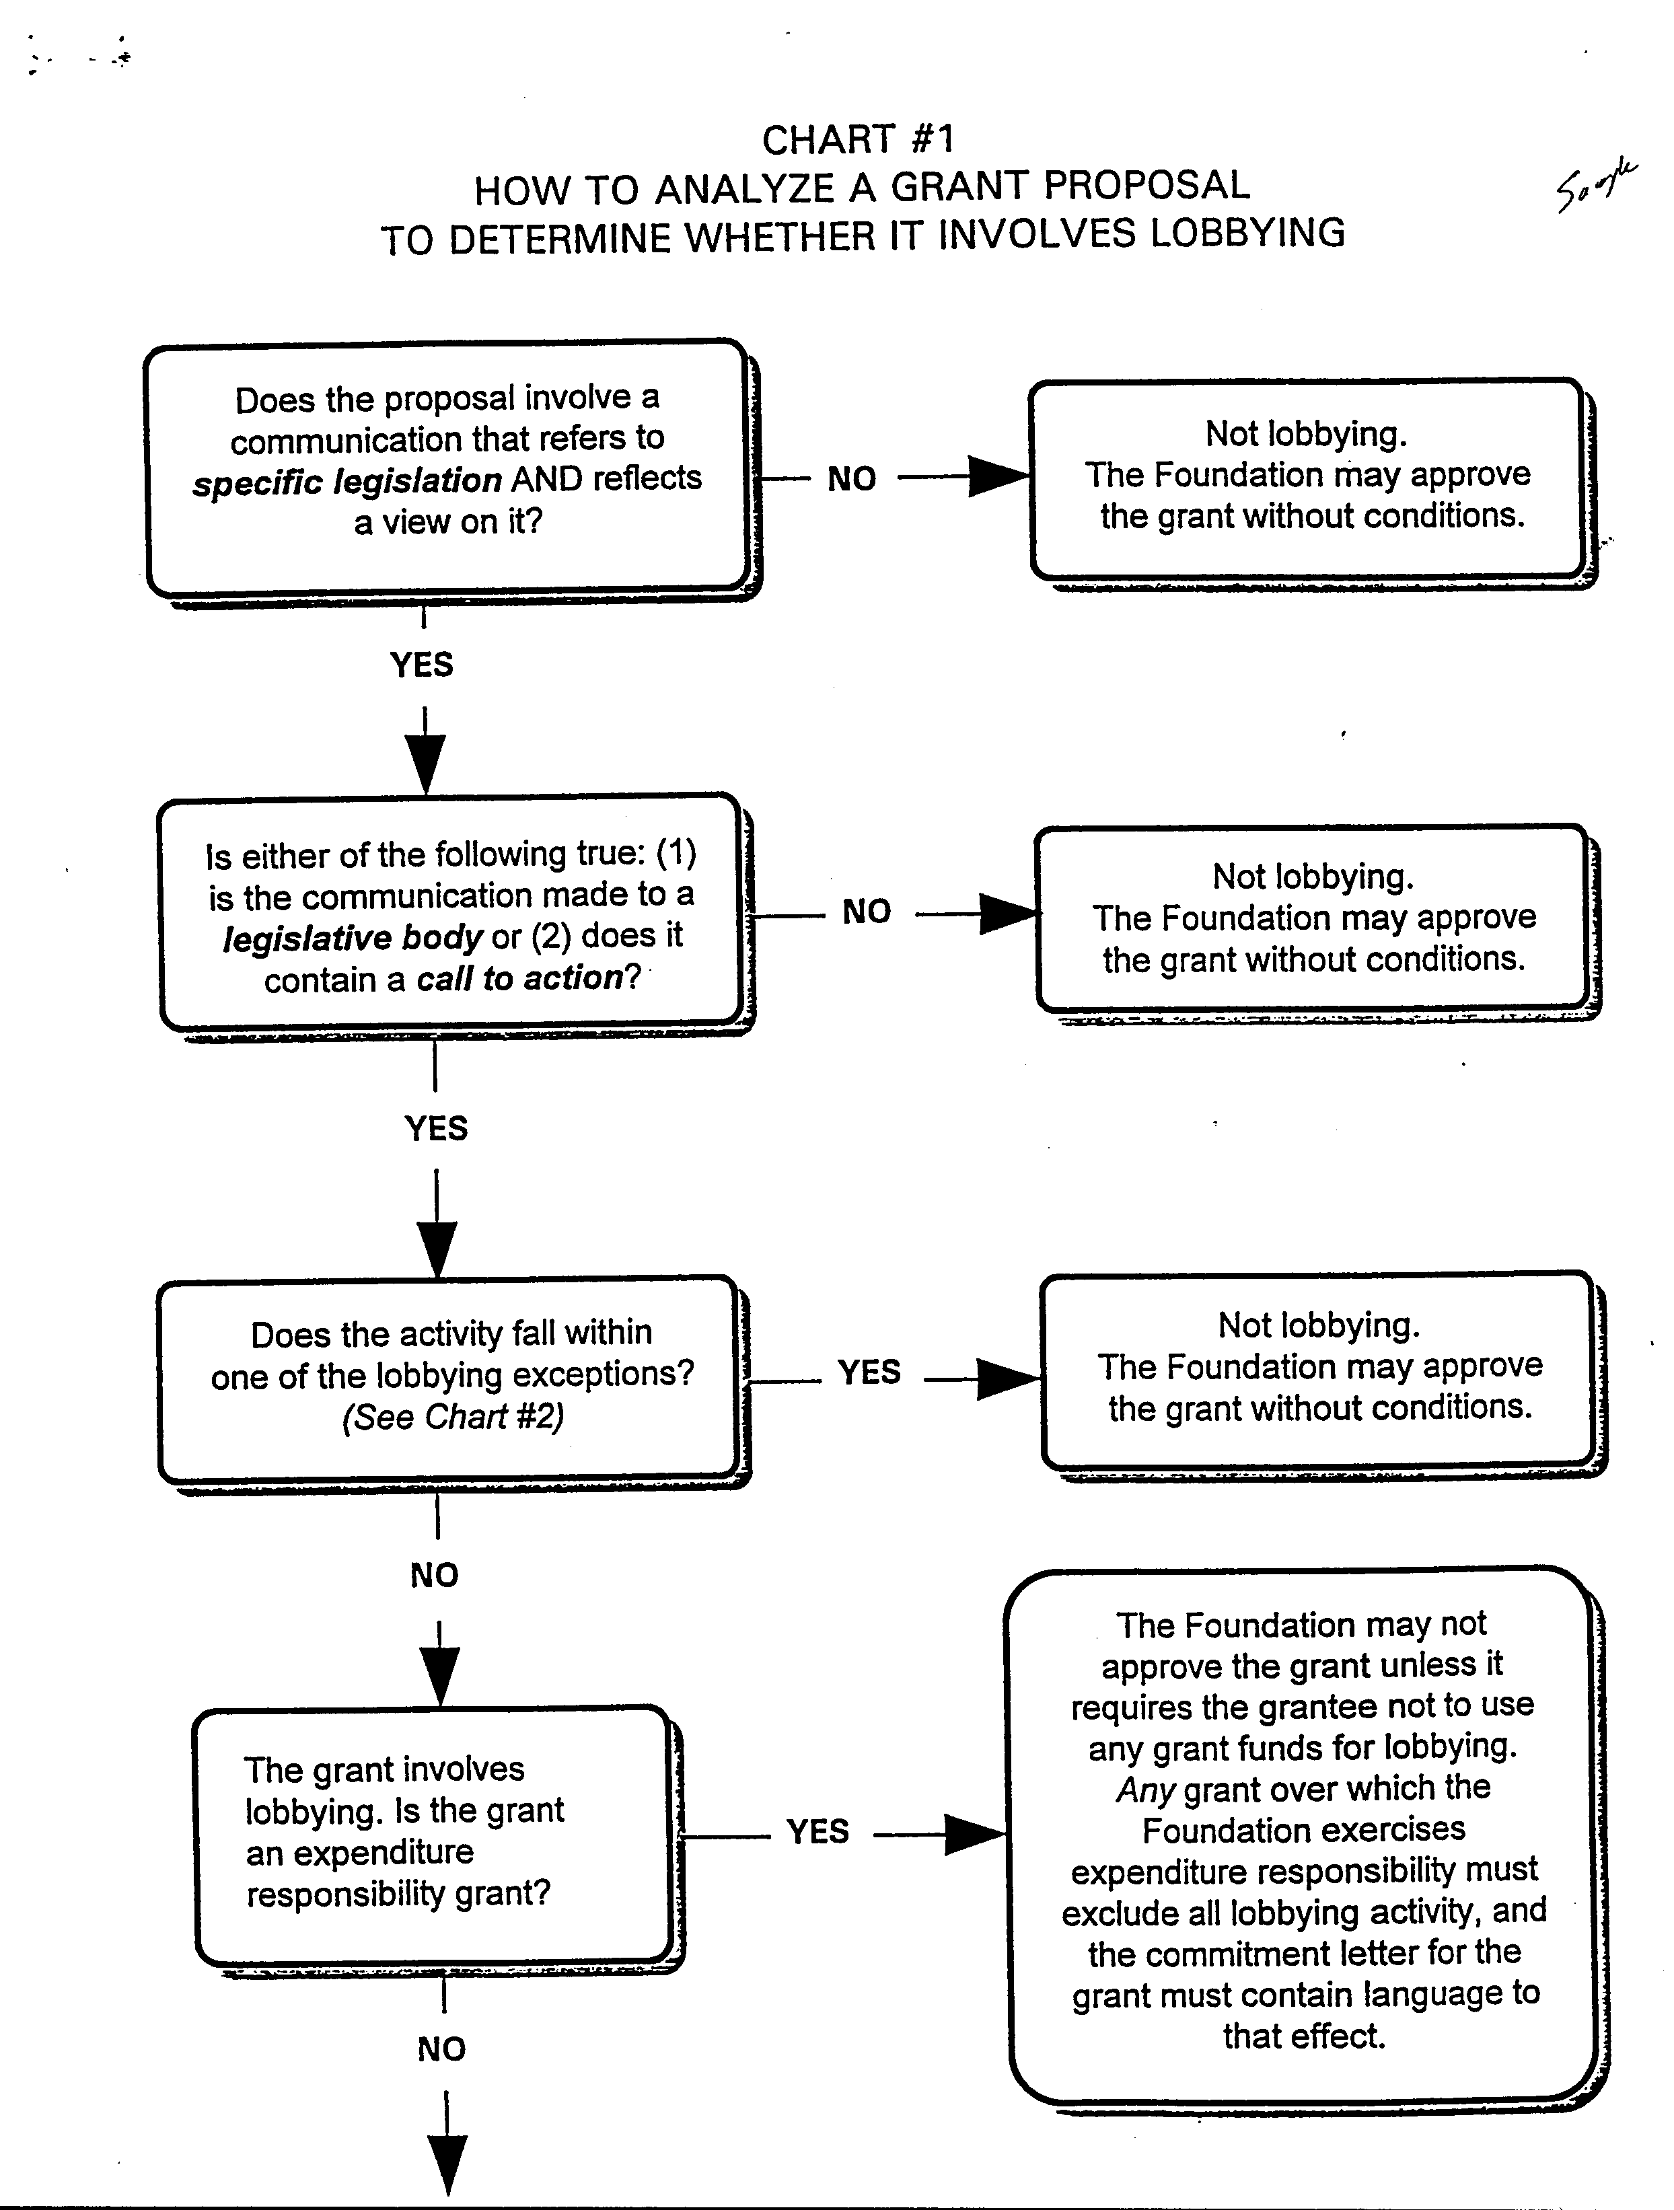

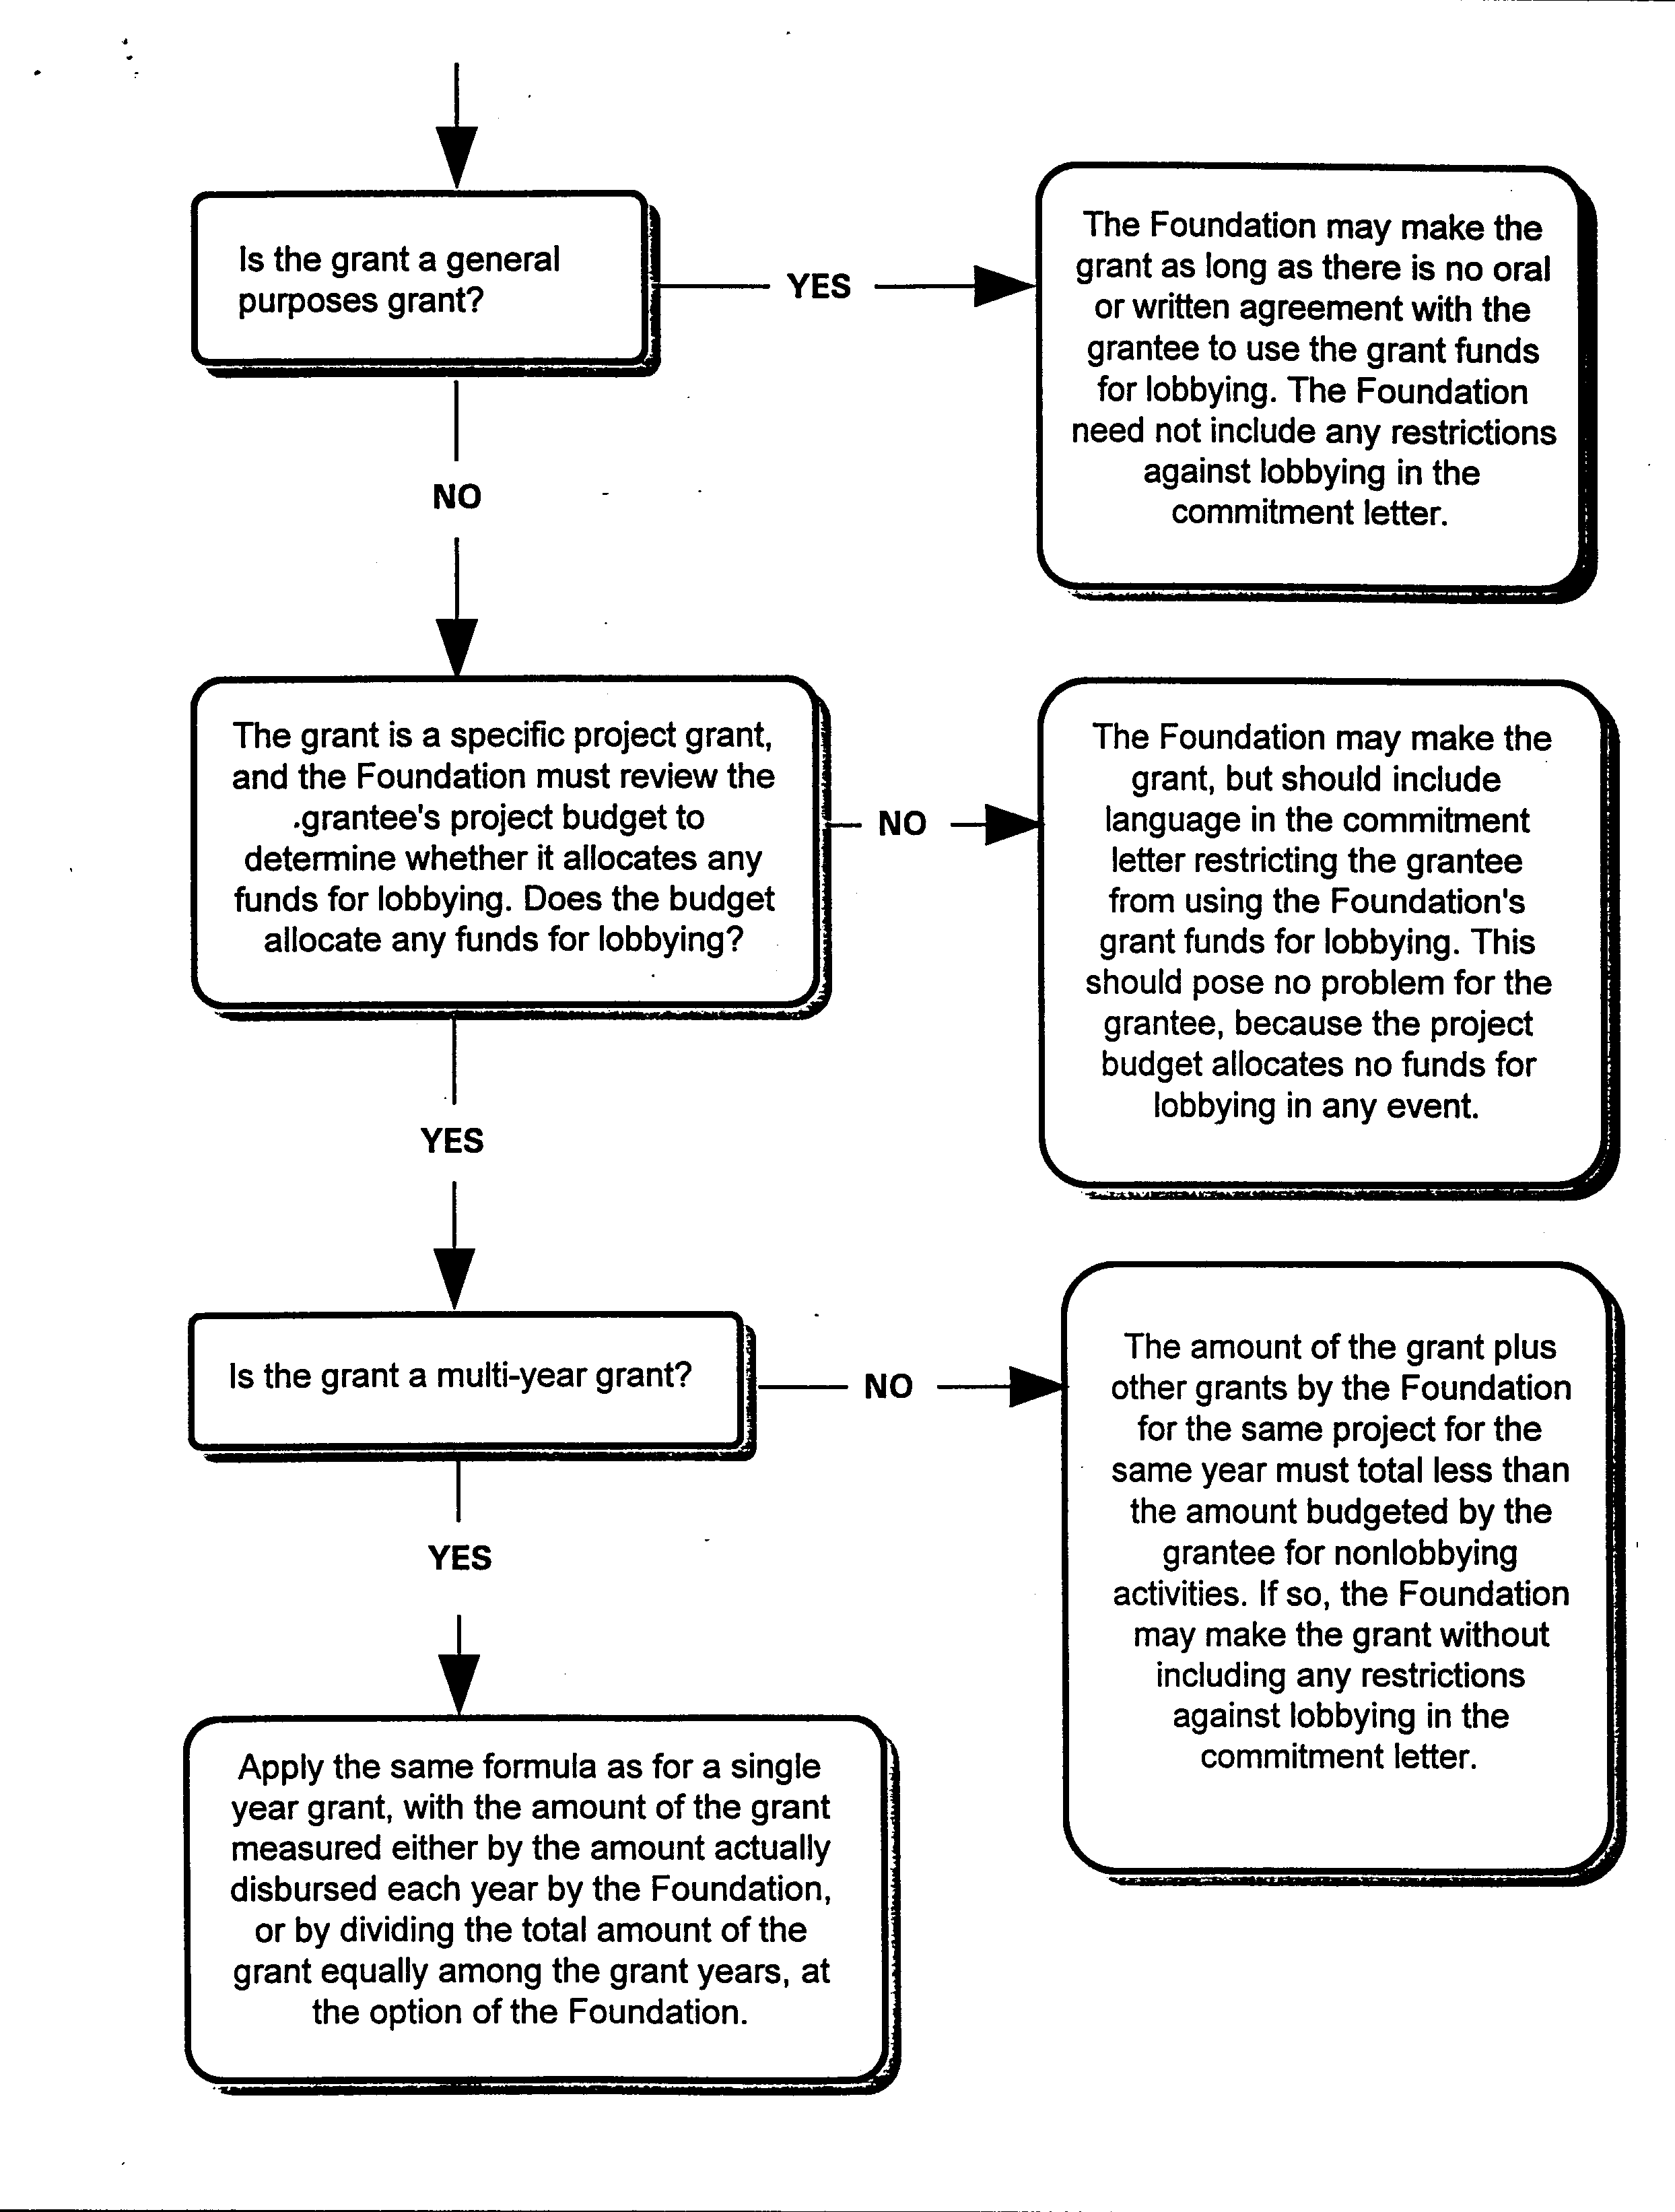

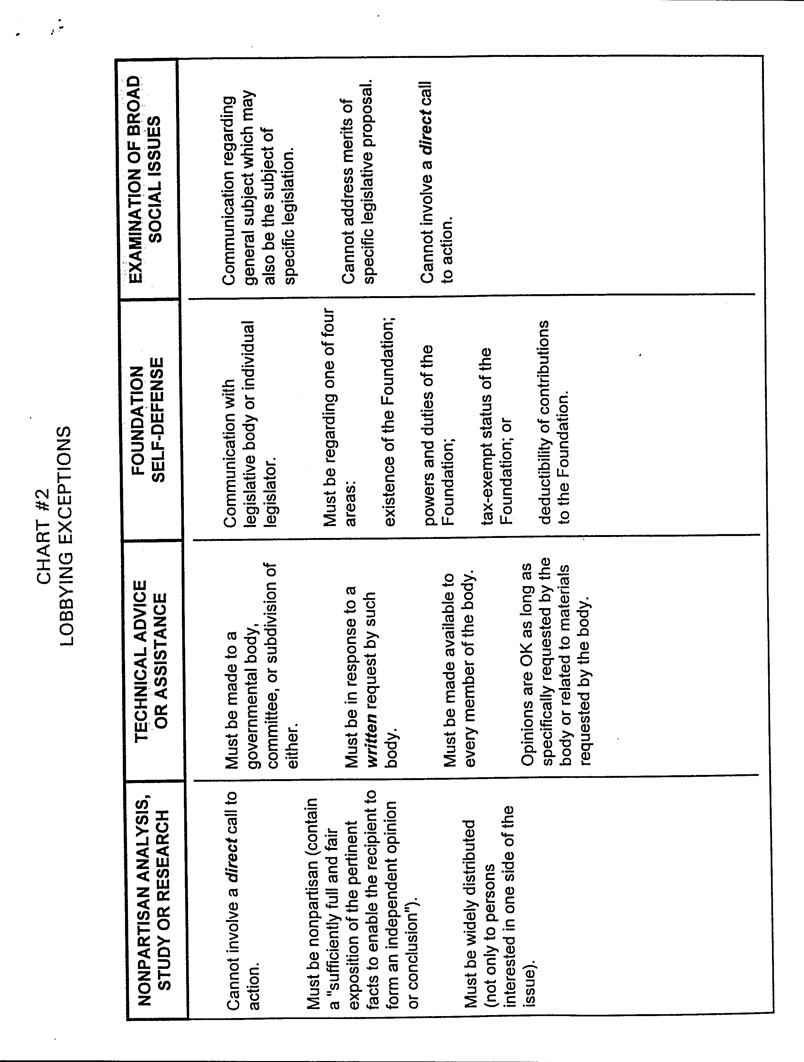

DEFINITIONS

- Legislation and specific legislation. Legislation "includes action by the Congress, any state legislature, any local council, or similar legislative body, or by the public in a referendum, ballot initiative, constitutional amendment, or similar procedure. 'Legislation' includes a proposed treaty required to be submitted by the President to the Senate for its advice and consent from the time the President's representative begins to negotiate its position with the prospective parties to the proposed treaty." Treas. Reg. § 56.4911-2(d)(1)(i).
Specific legislation "includes both legislation that has already been introduced in a legislative body and a specific legislative proposal that the organization either supports or opposes. In the case of a referendum, ballot initiative, constitutional amendment, or other measure that is placed on the ballot by petitions signed by a required number or percentage of voters, an item becomes 'specific legislation' when the petition is first circulated among voters for signature." Treas. Reg. § 56.4911-2(d)(1)(ii).
- Legislative body "does not include executive, judicial, or administrative bodies." Treas. Reg. § 56.4911-2(d)(3). The term administrative body "includes school boards, housing authorities, sewer and water districts, zoning boards, and other similar Federal, State, or local special purpose bodies, whether elective or appointive. Treas. Reg. § 56.49112(d)(4).

3. Call to Action

  - Direct call to action
    - A communication that "[s]tates that the recipient should contact a legislator or an employee of a legislative body, or should contact any other government official or employee who may participate in the formulation of legislation (but only if the principal purpose of urging contact with the government official or employee is to influence legislation)." Treas. Reg. § 56.4911-2(b)(2)(iii)(A).
    - A communication that “[s]tates the address, telephone number, or similar information of a legislator or an employee of a legislative body." Treas. Reg. § 56.4911-2(b)(2)(iii)(B).
    - A communication that "[p]rovides a petition, tear-off postcard or similar material for the recipient to communicate with a legislator or an employee of a legislative body, or with any other government official or employee who may participate in the formulation of legislation (but only if the principal purpose of so facilitating contact with the government official or employee is to influence legislation)."
Treas. Reg. § 56.4911-2(b)(2)(iii)(C).
  - Indirect call to action: Communication that "[s]pecifically identifies one or more legislators who will vote on the legislation as: opposing the communication's view with respect to the legislation; being the recipient's representative in the legislature; or being a member of the legislative committee or subcommittee that will consider the legislation. Encouraging the recipient to take action * * * does not include naming the main sponsor(s) of the legislation for purposes of identifying the legislation." Treas. Reg. § 56.4911-2(b)(2)(iii)(D).

