More contact error messages:

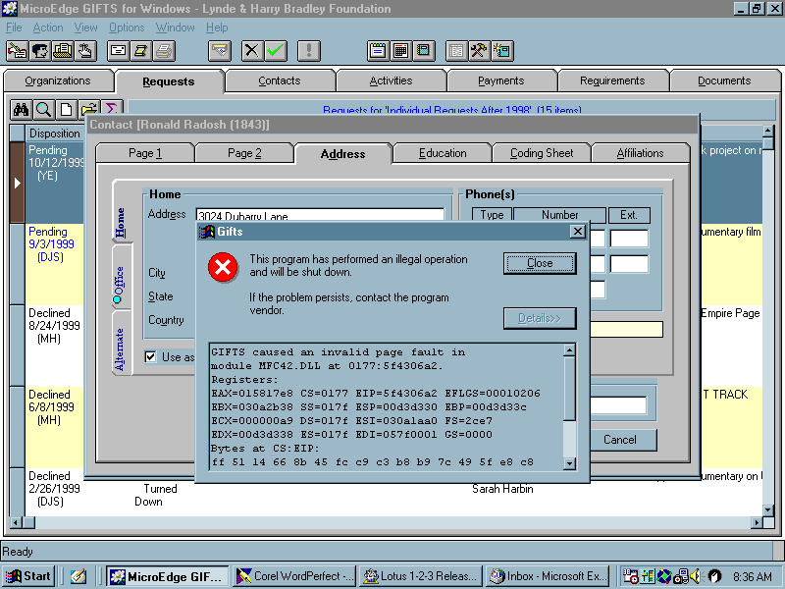

I’ve narrowed something down. I can open the contact record and go to the home address tab, add information and save the record. It’s when I select the “use as primary address” box that the system closes down. Here it is again, but I saved the home address information first. In this case I want to use the home address, instead of the organization address at school, in the correspondence I’m about to create.

