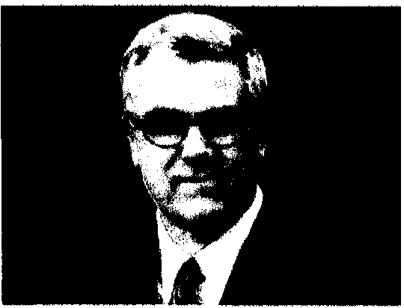
Alan Sears

President, CEO, and General Counsel
Alliance Defending Freedom

Alan Sears serves as president, CEO, and general counsel of Alliance Defending Freedom, an alliance-building legal ministry that advocates for religious freedom to uphold justice and preserve the right of people to freely live out their faith. He leads the strategy, training, funding, and litigation efforts of Alliance Defending Freedom that have resulted in various roles in 40 victories at the U.S. Supreme Court an.d wins in more than three out of four cases litigated to conclusion. Under his leadership, Alliance Defending Freedom has funded more than 2,600 grants and legal projects for allied lawyers and organizations, and Alliance Defending Freedom attorneys have successfully defended marriage as the union between one man and one woman in over 40 cases nationwide.

Since the launch of Alliance Defending Freedom in 1994, Sears has provided strategic leadership in the training of over I ,700 lawyers through the one-of-a-kind Alliance Defending Freedom Legal Academy, which is designed to equip attorneys to more effectively defend religious freedom, the sanctity of life, and marriage and the family. These attorneys have reported more than $165 million in pro-bono/dedicated time. Sears' visionary efforts have also resulted in the graduation of more than 1,350 outstanding law students- representing more than 140 law schools---from the unique Blackstone Legal Fellowship program. This in-depth summer internship program helps equip these students to assume leadership positions to shape the future of American law. Today, Alliance Defending Freedom has more than 2,300 allied attorneys.
Sears earned his Juris Doctor from Louis D. Brandeis School of Law. While serving in numerous positions within the government, he worked for the Department of Justice under Attorneys General William French Smith and Edwin Meese Ill, including service as an Assistant U.S. Attorney and Chief of the Criminal Section. Sears was also appointed as the director of the Attorney General's Commission on Pornography and served as associate solicitor with the Department of the Interior under Secretary Donald Hodel. A graduate of the University of Kentucky, Sears has continued his education with professional instruction at Stanford University, Harvard Law School, Harvard Business School, and Pepperdine University.
Practicing law for three decades, Sears is a memher in good standing with the American, Arizona, California, District of Columbia (inactive), and Kentucky bar associations. He has helped fashion the language for numerous state and federal laws and has testified before committees of the U.S. House and Senate, state legislatures, and many local governments and commissions. Legislators in 20 states have adopted his legislative recommendations. Sears has assisted legislators and law enforcement officials from many countries and has spoken before committees of the British Parliament.
Sears' numerous media appearances include television interviews and features on The Today Show, Nightline, CNN, Fox News, C-SPAN, The O'Reilly Factor, Oprah, and The Lou Dobbs Show. He has also been a radio guest on various programs, including The Laura Ingraham Show, National Public Radio, The Hugh Hewitt Show and The Dennis Prager Radio Show. Sears has been extensively covered in national print media, including the Washington Post, the Associated Press, the Washington Times, the Seattle Post-Intelligencer, the Arizona Republic, and theNational Catholic Register. He is a regular opinion contributor to Townhall.com and has co authored several books, including The Homosexual Agenda: Exposing the Principal Threat to Religious Freedom Today (2003) and The AC LU vs. America (2005), both with Craig Osten. His most recent books are In Justice (2009) and Trial and Error (2011).

