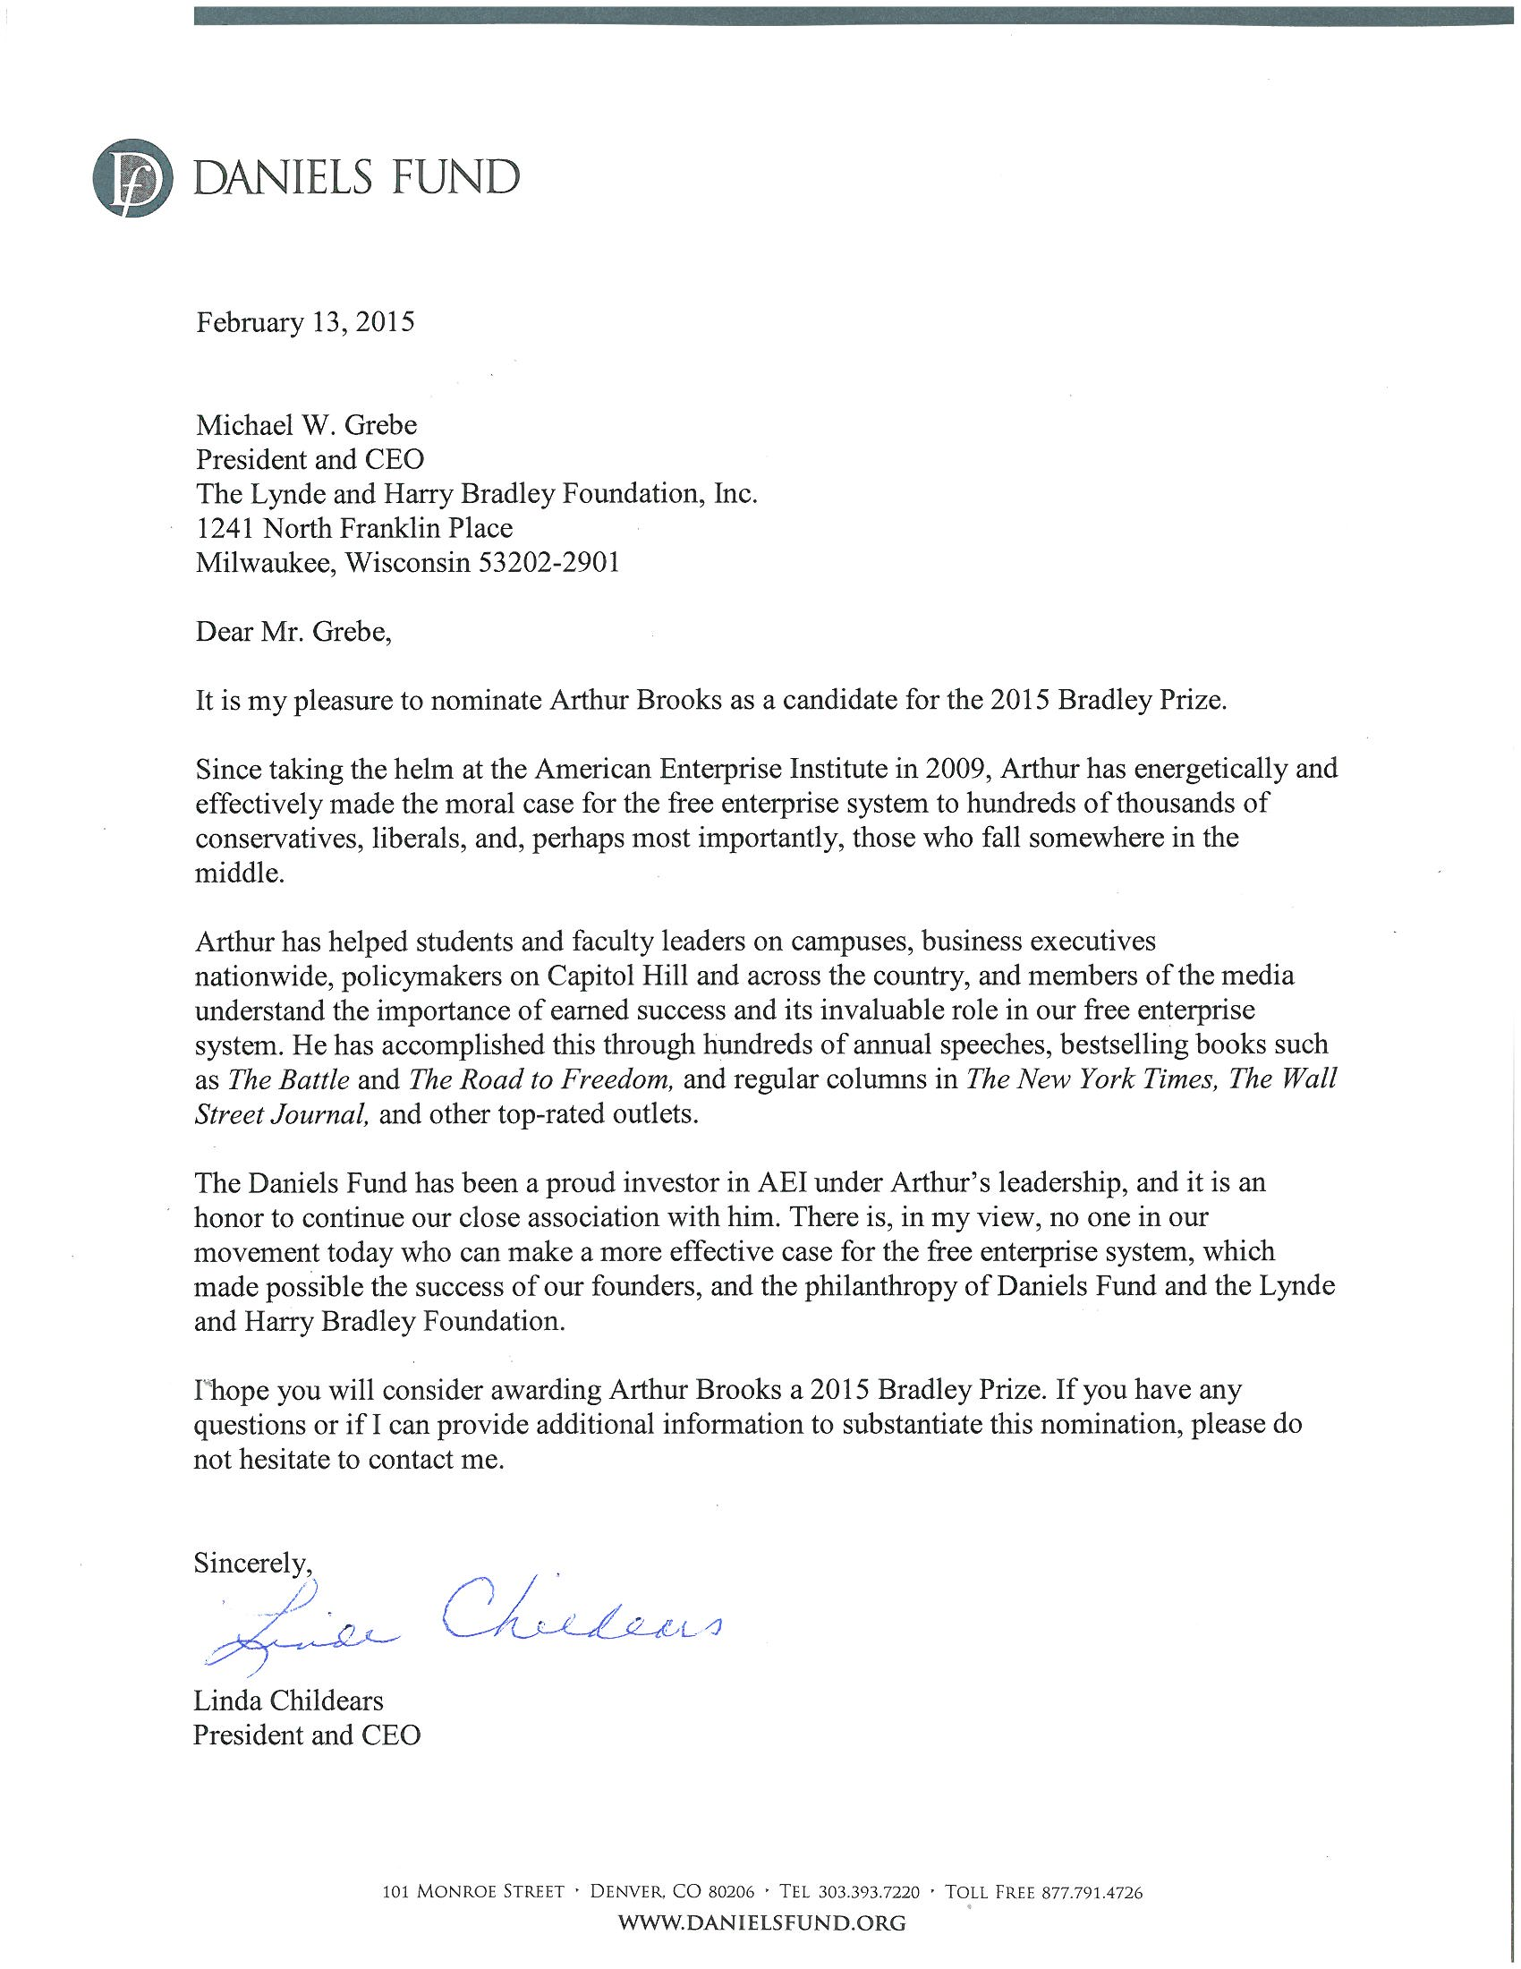

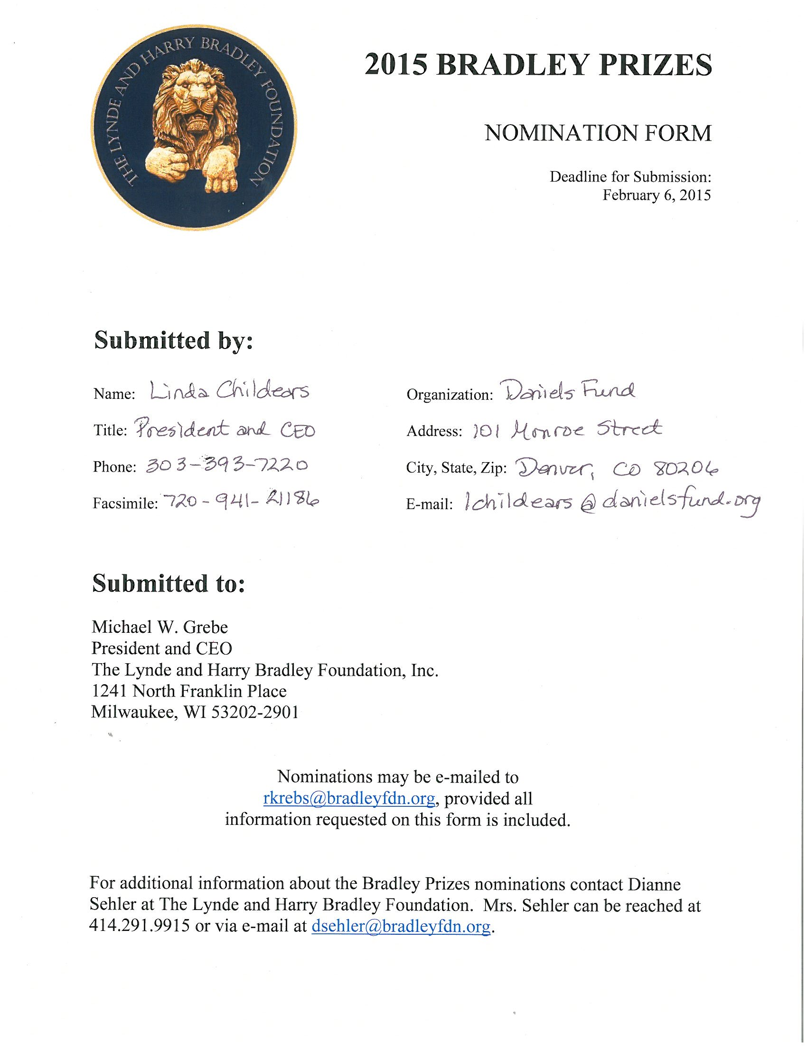

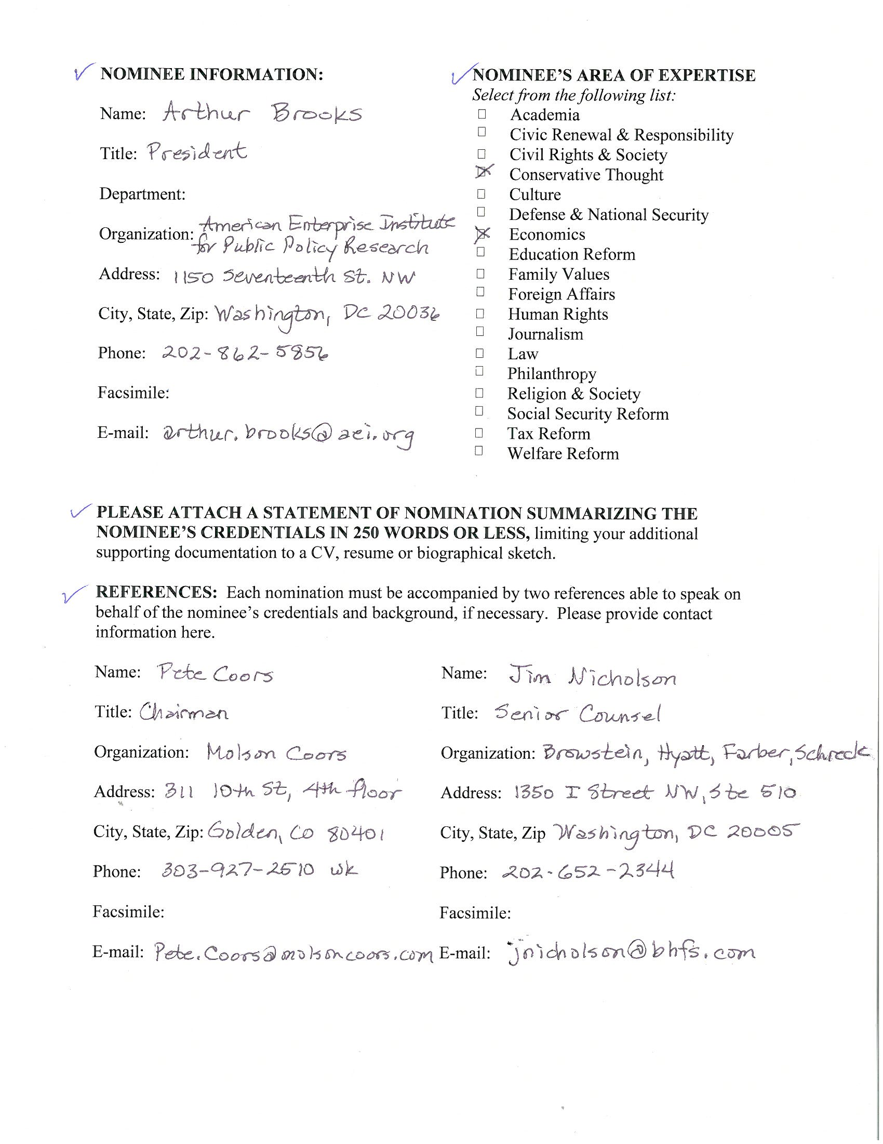
ARTHUR C. BROOKS Curriculum Vitae February 2015
Address: American Enterprise Institute for Public Policy Research
1150 17th St. NW; Washington, DC 20036, Tel: (202) 862-5856
Email: arthur.brooks@aei.org
Citizenship: U.S.A.

EDUCATION
PhD (Policy Analysis), The RAND Graduate School, 1998 MPhil (Policy Analysis), The RAND Graduate School, 1997 MA (Economics), Florida Atlantic University, 1994 BA (Economics), Thomas Edison State College, 1994

PROFESSIONAL POSTS
2009-present: American Enterprise Institute for Public Policy Research, Washington, DC President Beth and Ravenel Curry Scholar in Free Enterprise (2013-present)
2014-present: The New York Times Contributing Opinion Writer
2001-2008: The Maxwell School of Citizenship and Public Affairs and Martin J. Whitman School
of Management, Syracuse University Louis A. Bantle Professor of Business and Government Policy (2007-2008) Professor of Public Administration (2006-2008) Director, Nonprofit Studies Program (2003-2007) Associate Professor of Public Administration (2001-2005)
2007-2008: American Enterprise Institute, Washington, DC Visiting Scholar
1998-2006: The RAND Corporation; Washington, DC, and Santa Monica, CA Consultant
1998-2001: Georgia State University; Atlanta, GA Assistant Professor of Public Administration & Economics
1996-1998: The RAND Corporation; Santa Monica, CA Doctoral Fellow
1
1992-1995: Harid Conservatory of Music; Boca Raton, FL French horn Instructor/Department Chair
1989-1992: City Orchestra of Barcelona (Orquestra Ciutat de Barcelona); Barcelona, Spain Associate Principal French Horn
1983-1989: Annapolis Brass Quintet; Baltimore, MD French Hornist
PUBLICATIONS

Books
- Brooks, Arthur C. (In progress, 2015 publication). The Conservative Heart. New York: HarperCollins.
- Brooks, Arthur C. (May 2012). The Road to Freedom: How to Win the Fight for Free Enterprise. New York: Basic Books. New York Times bestseller. USA Today bestseller. Washington Post #1 bestseller. Translated into Italian. Winner of CNBC’s Blue Chip Book Award. Included in Politico’s “Top Books of 2012.”
- Brooks, Arthur C. (2010). The Battle: How the Fight Between Free Enterprise and Big Government Will Shape America’s Future. New York: Basic Books. Translated into Spanish and Chinese. WORLD Magazine’s Book of the Year, 2010.
- Peter Wehner and Arthur C. Brooks (2010). Wealth and Justice: The Morality of Democratic Capitalism. Lanham, MD: Rowman & Littlefield.
- Brooks, Arthur C. (2008). Gross National Happiness: Why Happiness Matters for America—and How We Can Get More of It. New York: Basic Books.
- Brooks, Arthur C. (2008). Social Entrepreneurship: A Modern Approach to Social Value Creation. Upper Saddle River, NJ: Prentice-Hall. Editions also in Chinese, Korean, and Greek.
- Brooks, Arthur C. (2006). Who Really Cares: The Surprising Truth About Compassionate Conservatism. New York: Basic Books. Edition also in Chinese.
- Brooks, Arthur C., Editor (2005). Gifts of Time and Money: The Role of Charity in America's Communities. Lanham, MD: Rowman & Littlefield.
- McCarthy, Kevin F., Elizabeth H. Ondaatje, Arthur C. Brooks, and Andras Szanto (2005). A Portrait of the Visual Arts: Meeting the Challenges of a New Era. Santa Monica, CA: Rand.
- McCarthy, Kevin F., Elizabeth H. Ondaatje, Laura Zakaras, and Arthur C. Brooks (2005) Gifts of the Muse: Reframing the Debate about the Benefits of the Arts. Santa Monica, CA: Rand.
- McCarthy, Kevin F., Arthur C. Brooks, Julia Lowell, and Laura Zakaras (2001). The Performing Arts in a New Era. Santa Monica, CA: RAND.

Op-eds and magazine articles
1. Brooks, Arthur C. (January 7, 2015). “An Aging Europe in Decline.” The New York Times.

- Brooks, Arthur C. (December 14, 2014). “Abundance without Attachment.” The New York Times.
- Brooks, Arthur C. (November 28, 2014). “The Trick to Being More Virtuous.” The New York Times.
- Brooks, Arthur C. (October 18, 2014). “Start Helping the Helpers.” The New York Times.
- Brooks, Arthur C. (October 5, 2014). “Smelling Liberal, Thinking Conservative.” The New York Times.
- Brooks, Arthur C. (August 19, 2014). “Breaking Out of the Party Box.” The New York Times.
- Brooks, Arthur C. (July 18, 2014). “Love People, Use Things.” The New York Times.
- Brooks, Arthur C. (July 8, 2014). “Inspire Real Hope, Not The Bumper-Sticker Kind.” The Wall Street Journal.
- Brooks, Arthur C. (June 14, 2014). “The Father’s Example.” The New York Times.
- Brooks, Arthur C. (May 17, 2014). “Beware the City Dolls.” The New York Times.
- Brooks, Arthur C. (April 18, 2014). “Capitalism and the Dalai Lama.” The New York Times.
- Brooks, Arthur C. (March 30, 2014). “Why Fund-Raising Is Fun.” The New York Times.
- Brooks, Arthur C. (March 22, 2014). “Vocation lies at the heart of a happy and meaningful life.” Orange County Register.
- Brooks, Arthur C. (March 5, 2014). “A social justice fight.” USAToday.
- Brooks, Arthur C. (March 2, 2014). “The Downside of Inciting Envy.” The New York Times.
- Brooks, Arthur C. (February, 2014). "Be Open-Handed Toward Your Brothers.” Commentary Magazine.
- Brooks, Arthur C. (January 19, 2014). "The secret to happiness at work isn’t about money.” The Philadelphia Inquirer.
- Brooks, Arthur C. (December 15, 2013). “A Formula for Happiness.” The New York Times.
- Brooks, Arthur C. (November 26, 2013). "Handsome Is as Handsome Gives.” The Wall Street Journal.
- Brooks, Arthur C. (October 4, 2013). "Obama is ducking a leader's duty.” The Los Angeles Times.
- Brooks, Arthur C. (August 1, 2013). "How Obama Neglects the Poor.” The Wall Street Journal.
- Brooks, Arthur C. (July 11, 2013). "Why the competition of ideas matters.” Foxnews.com.
- Brooks, Arthur C. (May 16, 2013). "The GOP's Hispanic Opening.” The Wall Street Journal.
- Brooks, Arthur C. (March 3, 2013). "Republicans and Their Faulty Moral Arithmetic.” The Wall Street Journal.
- Brooks, Arthur C. (February 1, 2013). "My Valuable, Cheap College Degree.” The New York Times.
- Brooks, Arthur C. (January 29, 2013). "It Isn’t Time to Thank President Obama for Helping Charities.” The Chronicle of Philanthropy.
- Brooks, Arthur C. (January 3, 2013). "Michigan helps itself with jobs.” The Orange County Register.
- Brooks, Arthur C. (December 20, 2012). "America's Dangerous Powerball Economy.” The Wall Street Journal.
- Brooks, Arthur C. (December 17, 2012). "The Once and Future Conventional Wisdom.” National Review.
- Brooks, Arthur C. and Edwin J. Feulner (December 5, 2012). "Why tax increases don't

work.” USAToday.
- Brooks, Arthur C. (October 21, 2012). "Making a Moral Case for Capitalism.” The Philadelphia Inquirer.
- Brooks, Arthur C. (October 5, 2012). "A '47%' Solution for Romney.” The Wall Street Journal.
- Brooks, Arthur C. (September 25, 2012). "Why the Stimulus Failed.” National Review Online.
- Brooks, Arthur C. (August 22, 2012). "The Virtues of ‘Ryanism’.” The Weekly Standard.
- Brooks, Arthur C. (August 6, 2012). "Obama and ‘Earning Your Success’.” The Wall Street Journal.
- Brooks, Arthur C. (July 15, 2012). "Five Myths About Free Enterprise.” The Washington Post.
- Brooks, Arthur C. (July 9, 2012). "America Already Is Europe.” The Wall Street Journal.
- Brooks, Arthur C. (July 8, 2012). "Why Conservatives Are Happier Than Liberals.” The New York Times.
- Brooks, Arthur C. (June 19, 2012). "Why free enterprise is about morals, not materialism.” (http://www.foxnews.com/opinion/2012/06/19/free-enterprise-is-about-morals-notmaterialism/) Foxnews.com.
- Brooks, Arthur C. (May 14, 2012). "Uncle Sam or Uncle Sugar?” The Washington Examiner.
- Brooks, Arthur C. (May 9, 2012). "America and the Value of ‘Earned Success’.” The Wall Street Journal.
- Brooks, Arthur C. (May 8, 2012). "Fixing America's 'statist quo'.” The Washington Examiner.
- Brooks, Arthur C. (May 7, 2012). "First, Make the Moral Case for Free Enterprise.” Breitbart.com.
- Brooks, Arthur C. (May 1, 2012). "Time to make a moral case for free enterprise.” The Washington Examiner.
- Brooks, Arthur C. (April 13, 2012). "Winning the fight on 'fairness'.” The Washington Examiner.
- Brooks, Arthur C., Edwin J. Feulner and William Kristol (March 28, 2012). "Ryan's Budget Protects Defense." The Wall Street Journal.
- Brooks, Arthur C. (March 3, 2012). "Social Science with a Soul." The Wall Street Journal.
- Brooks, Arthur C. (February 24, 2012). "Obama’s Budget Flunks the Marshmallow Test." The Wall Street Journal.
- Brooks, Arthur C. (November 25, 2011). "Fairness and the 'Occupy' Movement." The Wall Street Journal.
- Brooks, Arthur C. (November 2011). "Are You Optimistic or Pessimistic About America’s Future?" Commentary, pp. 17-18.
- Brooks, Arthur C. (July 25, 2011). "The Debt Ceiling and the Pursuit of Happiness." The Wall Street Journal.
- Brooks, Arthur C. (July 18, 2011). "Not Taking Other People’s Money." The Weekly Standard.
- Brooks, Arthur C. (April 24, 2011). "Obama Says It’s Only ‘Fair’ to Raise Taxes on the Rich. He’s Wrong." The Washington Post.
- Brooks, Arthur C. (March 7, 2011). "The Unhappy Paradox of Santa-Statism." The Wall Street Journal.
- Brooks, Arthur C. (December 24, 2010). "Tea Partiers and the Spirit of Giving." The Wall Street Journal.
- Brooks, Arthur C. (December 11, 2010). “Human Nature and Capitalism.” The American.com.
- Brooks, Arthur C. (October 31, 2010). " La victoria conservadora en EE.UU." La Vanguardia (Barcelona, Spain).
- Brooks, Arthur C. (October 19, 2010). "Top 10 ways government kills jobs in America.” The Washington Examiner.
- Brooks, Arthur C., Edwin J. Feulner, and William Kristol (October 4, 2010). "Peace Doesn't Keep Itself.” The Wall Street Journal.
- Brooks, Arthur C. and Paul Ryan (September 13, 2010). "The Size of Government and the

Choice This Fall.” The Wall Street Journal.
- Brooks, Arthur C. (September 5, 2010). "¿Por qué no es feliz España?" La Vanguardia (Barcelona, Spain). In English: “Why Isn't Spain Happy?” The American.com (September 10, 2010).
- Brooks, Arthur C. (June 5, 2010). "Slouching Towards Athens." The Wall Street Journal.
- Brooks, Arthur C. (June 2, 2010). "Happy Now?” National Review Online.
- Brooks, Arthur C. (May 23, 2010). "America's new culture war: Free enterprise vs.

government control.” The Washington Post.
- Brooks, Arthur C. (April 14, 2010). "'Spreading The Wealth' Isn't Fair." The Wall Street Journal.
- Streeter, Ryan, and Arthur C. Brooks (October 27, 2009). "Freedom to Prosper." The Wall Street Journal.
- Brooks, Arthur C. (October 26, 2009). "Why Government Health Care Keeps Falling in the Polls." The Wall Street Journal.
- Brooks, Arthur C. (August 18, 2009). "Why Obama's Ratings Are Sinking." The Wall Street

Journal. In Italian: “Obama, ecco perché i sondaggi bocciano la linea del presidente” Il
Giornale (August 22, 2009).
- Brooks, Arthur C. (April 30, 2009). "The Real Culture War Is Over Capitalism." The Wall Street Journal. In Italian: “Perché negli Usa c'ê la rivolta contro le tasse” Il Giornale (May 2, 2009).
- Brooks, Arthur C. (April 2009). "Q&A: Frank Hanna on the Meaning of Money." Reader’s Digest, p. 41.
- Brooks, Arthur C. (February 9, 2009). "Drinking to Success." Forbes Magazine, p. 26. In

Italian: “Chi beve (poco) ê più sano e diventa anche più ricco” Il Giornale (February 12,
2009).
72. Brooks, Arthur C. (January 22, 2009). "Conservatives Have Answered Obama's Call." The Wall Street Journal. In Italian: “I veri filantropi? Noi conservatori” Il Giornale (January 26, 2009).
73. Brooks, Arthur C. (November 12, 2008). “La vittoria di Obama? Fa felici i repubblicani.” Il Giornale (Italy).
74. Viard, Alan D., Alex Brill, and Arthur C. Brooks (October 29, 2008). “The Real Problem With Obama's Tax Plan.” The Washington Post, p. A17.
75. Brooks, Arthur C. (September 16, 2008). "Don’t Live Simply." Forbes.com. In Italian: “Per favore consumate di piu'” Il Giornale (September 17, 2008).
76. Brooks, Arthur C. (July 31, 2008). "Where's the Outrage? Really." The Wall Street Journal,
p. A15.
77. Brooks, Arthur C. (July, 2008). "Why We’re Happy." Reader’s Digest, pp. 162-169.
78. Brooks, Arthur C. (June 24, 2008). "Does Money Make You Happy?" The Christian Science Monitor.
79. Brooks, Arthur C. (May/June, 2008). "Can Money Buy Happiness?" The American.
80. Brooks, Arthur C. (May 9, 2008). "Hug the Children, Not the Trees." The Weekly Standard (online edition).
81. Brooks, Arthur C. (April 19, 2008). "Trigger Happy." The Wall Street Journal, p. A10.
82. Brooks, Arthur C. (April 9, 2008). “Recession’s Gift.” The New York Sun.
83. Brooks, Arthur C. (April 1, 2008). "Barack as Scrooge?" National Review Online.
84. Brooks, Arthur C. (March 25, 2008). “Hypocrisy’s Virtue.” The New York Sun.
85. Brooks, Arthur C. (March, 2008). "The Poor Give More." Condé Nast Portfolio.
86. Brooks, Arthur C. (March 4, 2008). “Democrats and ‘Diversity’.” The New York Sun.
87. Brooks, Arthur C. (March/April 2008). “A Nation of Givers.” The American.
88. Brooks, Arthur C. (February 14, 2008). "Looking for Love in All the Right (and Left) Places." National Review Online.
89. Brooks, Arthur C. (January 17, 2008). "Liberal Hatemongers." The Wall Street Journal, p. A16.
90. Brooks, Arthur C. (January 8, 2008). "The Upside of Bush's Foreign Policy." The New York Sun.
91. Brooks, Arthur C. (December 28, 2007). "Why Giving Makes You Happy." The New York Sun.
92. Brooks, Arthur C. (November 30, 2007). "Party of Disbelief." National Review Online.
93. Brooks, Arthur C. (November 2007). "Giving Makes You Rich." Condé Nast Portfolio, p. 83-84.
94. Brooks, Arthur C. (October 22, 2007). "Happiness and Inequality." The Wall Street Journal,
p. A18.
95. Brooks, Arthur C. (September 24, 2007). "The Ennui of Saint Teresa." The Wall Street Journal, p. A18.
96. Brooks, Arthur C. (September/October 2007). "I Love My Work." The American, pp. 2029.
97. Brooks, Arthur C. (August 20, 2007). "Our Religious Destiny." The Wall Street Journal, p. A11.
98. Brooks, Arthur C. (July 19, 2007). "The Left's 'Inequality' Obsession." The Wall Street Journal, p. A16.
99. Brooks, Arthur C. (July 12, 2007). "The Political Gender Gap." The Wall Street Journal, p. A17.

100.Brooks, Arthur C. (June 20, 2007). " Happy for the Work." The Wall Street Journal, p. A16.
101.Brooks, Arthur C. (May 21, 2007). "The Politics of Happiness." The Wall Street Journal, p. A17.
102.Brooks, Arthur C. (April 18, 2007). "Conspicuous Charity." The Wall Street Journal, p. A17.
103.Brooks, Arthur C. (March 19, 2007). "What's Wrong With Billionaires?" The Wall Street Journal, p. A13.
104.Brooks, Arthur C. (February 17, 2007) "Worth the Weight." The Wall Street Journal, p. A8.
105.Brooks, Arthur C. (January 24, 2007) "Who Cares About the Poor?" The Wall Street Journal, p. A13.
106.Brooks, Arthur C. (December 28, 2006) "Charity for Charities." The Wall Street Journal, p. A14.
- Brooks, Arthur C. (November 27, 2006). “Charitable Explanation.” The Wall Street Journal, p. A12.
- Brooks, Arthur C. (November 7, 2006). “The True Ideological Battle.” The Wall Street Journal, p. A12.
- Brooks, Arthur C. (October 3 & 8, 2006). “All in the Family.” The Wall Street Journal, p. A26.

110.Brooks, Arthur C. (September 14, 2006). "Early Admissions." The Wall Street Journal, p. A20.
111.Brooks, Arthur C. (August 22, 2006). "The Fertility Gap." The Wall Street Journal, p. A12.
112.Brooks, Arthur C. (July 28, 2006). "Caveat Benefactor." The Wall Street Journal, p. A14.
113.Brooks, Arthur C. (June 26, 2006). "He Who Whines First Laughs Last." The Wall Street Journal, p. A14
114. Brooks, Arthur C. (June 6, 2006). “Taking America's Temperature.” CBSNEWS.com
115.Brooks, Arthur C. (April 21, 2006). "Door-to-Door Faith." The Wall Street Journal, p. W15. Also in Opinion Journal.
- Brooks, Arthur C. (April 11, 2006). “Right-Wing Heart, Left-Wing Heart.” CBSNEWS.com
- Brooks, Arthur C. (February 14, 2006). “Extreme Makeover.” The Wall Street Journal, p. A22. Reprinted in Opinion Journal (February 21, 2006)
- Brooks, Arthur C. (January 16, 2006). “Bleeding Hearts.” The Wall Street Journal, p. A14.
- Brooks, Arthur C. (2006). “Are Americans Generous?” Philanthropy, 20(3): 11-13.

120.Brooks, Arthur C. (2006). The Great Divide in American Giving. The International Journal of Not-for-Profit Law 9(1).
121. Brooks, Arthur C. (December 8, 2005). “Money Buys Happiness.” The Wall Street Journal,
p. A16.
122. Brooks, Arthur C. (November 21, 2005). “The Way We Give Now.” The Wall Street Journal, p. A16.
123.Brooks, Arthur C. (September 25, 2005). “CNY Needs Don't Stop for Katrina.” Syracuse Post-Standard.
- Brooks, Arthur C. (September 13, 2005). “Heir Tonic for Charities.” The Wall Street Journal, p. A16.
- Brooks, Arthur C. (July 13, 2005). “Drink More, Earn More (& Give More).” The Wall Street Journal, p. A14.
- Brooks, Arthur C. (April 15, 2005). “Why Museums Trump Churches.” The Wall Street Journal, p. A10.
- Brooks, Arthur C. (Summer 2005), “Nonprofits Help Make Us Good Citizens.” The Nonprofit Quarterly, pp. 70-71.

128.Brooks, Arthur C. (December 2004/January 2005), “Can Governments Kill Non-profits with Kindness?” Fraser Forum, pp. 5-6.
129. Brooks, Arthur C. (December 22, 2004), “One Scandal Closer to More Nonprofit Regulation.” The Wall Street Journal.
130.Brooks, Arthur C. (October 25, 2004), “The Compassionate Ones.” The Chronicle of Philanthropy.
- Brooks, Arthur C. (April 15, 2003). “The Nonprofit Sector’s Stealthy Subsidy.” The Nonprofit Times.
- Brooks, Arthur C. (February 2003). “Motivating Public Workers: Lessons from Nonprofit Management.” Public Management and Policy Association Review 20: 7-8.
- Brooks, Arthur C. (June 1, 2002), “Welfare Reform May Stimulate Charitable Giving by the Poor.” The Chronicle of Philanthropy.
- Brooks, Arthur C. (April 28, 2002), “As arts enrich other cities, they can do the same here.” Syracuse Post Standard, p. D1.

135.Brooks, Arthur C. (June 13, 2001), Op-ed: “Giving, volunteering up: Mistrust of government has benefits.” Atlanta Journal-Constitution, p. B4.
136.Brooks, Arthur C. (July 2, 2000), Op-ed: “Government subsidies taking toll on nonprofits' private donations.” Atlanta Journal-Constitution, p. B4.
137. Brooks, Arthur C. (October 15, 1999). “Assessing the Benefits and Costs of Company Volunteer Programs.” Atlanta Business Chronicle.

Scholarly articles and chapters
1. Brooks, Arthur C. (Spring 2013). "The Art of Limited Government." National Affairs 15: 104-120.
2. Brooks, Arthur C. and Robin Currie (2009). “Religion: Why Faith Is a Good Investment,” In Indivisible: Social and Economic Foundations of American Liberty, The Heritage Foundation, Washington DC, 2009, pp. 52 – 55.
3. Brooks, Arthur C. (2009). “Volunteerism.” In Cross, Gary, Robert Maddox, and William Pencak (Eds.) Dictionary of American History, Dynamic Reference. New York: Scribner.
4. Brooks, Arthur C. and Charles Wolf, Jr. (June 2008). "All Inequality Is not Equal." Far Eastern Economic Review: 23-24.
5. Brooks, Arthur C. (Summer 2008). "Free People Are Happy People." City Journal 18(2): 31-36.
6. Brooks, Arthur C. (2008). “Philanthropy and the Nonprofit Sector.” In Schuck, Peter and James Q. Wilson (Eds.) Understanding America. New York: Public Affairs, 2008, pp. 539562.
7. Brooks, Arthur C. (2007). “Does Giving Make Us Prosperous?” Journal of Economics and Finance 31(3): 403-411.
8. Brooks, Arthur C. (2007). "What Really Buys Happiness?" City Journal 17(3): 59-63.
9. Brooks, Arthur C. (2007). “Income Tax Policy and Charitable Giving.” Journal of Policy Analysis and Management 26(3): 599-612.
10. Brooks, Arthur C., and Jan I. Ondrich (2007). “Quality, Service Level, or Empire: Which is the Objective of the Nonprofit Arts Manager?” Journal of Cultural Economics 31: 129-142.
11. Brooks, Arthur C. (2007). “The Public Value of Controversial Art: The Case of the Sensation Exhibit.” In C. David Throsby and Michael Hutter (Eds.). Beyond Price: Value in Culture, Economics, and the Arts. New York: Cambridge University Press, pp. 270-282.
12. Brooks, Arthur C. (2006). “Efficient Nonprofits?” Policy Studies Journal 34(3): 303-311.
13. Brooks, Arthur C., and Jan I. Ondrich (2006). “How Public Is Public Television?” Public Finance Review 34(1): 101-113.
14. Brooks, Arthur C. (2006). “Nonprofit Performing Arts Firms.” In Ginsburgh, Victor, and C. David Throsby (Eds.). The Handbook on the Economics of Art and Culture. North Holland Handbooks in Economics. Amsterdam: Elsevier Science, pp. 473-506.
15. Rushton, Michael, and Arthur C. Brooks (2006). “Government Funding of Nonprofit Organizations.” In Dennis R. Young (Editor). An Integrated Theory of Nonprofit Finance.

Lanham, MD: Lexington Books.
16. Louie, Alison, and Arthur C. Brooks (2006). “Engaging Business with Nonprofits." In Young, Dennis R. (Ed.). Wise Decision-making in Uncertain Times: Using Nonprofit Resources Effectively. Washington, DC: The Foundation Center, pp. 191-204.
17. Brooks, Arthur C. (2005). “What Do Nonprofit Organizations Seek? (And Why Should Policymakers Care?)” Journal of Policy Analysis and Management 24(3): 543-558.
18. Brooks, Arthur C. (2005). “Does Social Capital Make You Generous?” Social Science Quarterly 86(1): 1-15.
19. Lewis, Gregory B. and Arthur C. Brooks (2005). “A Question of Morality: Artists’ Values and Public Funding for the Arts.” Public Administration Review 65(1): 8-17.
20. Van Slyke, David M., and Arthur C. Brooks (2005). “Why Do People Give? New Evidence and Strategies for Nonprofit Managers” American Review of Public Administration 35(3): 199-222.
21. Brooks, Arthur C. (2005). "Philanthropy Vs. National Security: Should CARE Criticize the Military?." In Franke, Volker C. (Eds.). Terrorism and Peacekeeping: New Security Challenges. Westport, Conn.: Praeger, pp. 196-211.
22. Brooks, Arthur C. (Fall 2004). “Compassion, Religion, and Politics.” The Public Interest
157: 57-66.
23. Brooks, Arthur C. (2004). “The Effects of Public Policy on Private Charity.” Administration & Society 36(2): 166-185.
24. Brooks, Arthur C. (2004). “In Search of True Public Arts Support.” Public Budgeting & Finance 24(2): 88-100.
25. McClelland, Robert, and Arthur C. Brooks (2004). “Comparing Theory and Evidence on the Relationship Between Income and Charitable Giving.” Public Finance Review 32(5): 483497.
26. Brooks, Arthur C. (2004). “Do People Really Care About the Arts for Future Generations?” Journal of Cultural Economics 28:275-284.
27. Brooks, Arthur C. (2004). “Evaluating the Effectiveness of Nonprofit Fundraising.” Policy Studies Journal 32(3): 363-374.
28. Brooks, Arthur C. (2004). “What Do ‘Don’t Know’ Responses Really Mean in Giving Surveys?” Nonprofit and Voluntary Sector Quarterly 33(3) 423-434.
29. Brooks, Arthur C. (2004). “Faith, Secularism, and Charity.” Faith and Economics 43: 1-8.
30. Brooks, Arthur C. (2004). “Valoración Contingente y la Maldición del Ganador en las Subastas de Arte en Internet.” Revista Asturiana de Economía (Spain) 29: 17-32.
31. Brooks, Arthur C. (2004). “What Is Art Really Worth?” Journal of Arts Management, Law, and Society 34(3): 163-165.
32. Brooks, Arthur C. (2003). “Religious Faith and Charitable Giving.” Policy Review 121: 3950 (October/November).
33. Brooks, Arthur C. (2003). “Taxes, Subsidies, and Listeners Like You: Public Policy and Contributions to Public Radio.” Public Administration Review 63(5): 554-561.
34. Brooks, Arthur C. (2003). “Do Government Subsidies to Nonprofits Crowd Out Donations or Donors?” Public Finance Review 31(2): 166-179.
35. Brooks, Arthur C. (2003). “Public Goods and Posterity: An Empirical Test of Intergenerational Altruism.” Journal of Public Administration Research and Theory 13(2): 165-176.
36. Brooks, Arthur C. (2003). “Charitable Giving to Humanitarian Organizations in Spain.” Hacienda Pública Española/Revista de Economía Pública (Spanish Journal of Public Economics) 165-(2/2003): 9-24.
37. Brooks, Arthur C. (2003). “Public Opinion and the Role of Government Arts Funding in Spain.” Journal of Comparative Policy Analysis: Research and Practice 5(1): 29-38.
38. Brooks, Arthur C. (2003). “Charity, Christianity, and the Poor: An Outsider’s View of the Pew Christian Scholars Program.” Faith & Economics 41(1): 22-26.
39. Brooks, Arthur C. (2003). “The Changing Role of Arts Intermediaries: Introduction.” Journal of Arts Management, Law, and Society 33(2): 83-84.
40. Brooks, Arthur C. (2003), Book review essay: “Challenges and Opportunities Facing Nonprofit Organizations.” Public Administration Review 63(4): 503-506.
41. Brooks, Arthur C. (2002). “Charitable Giving in Transition Economies: Evidence from Russia.” National Tax Journal 55(4): 743-754.
42. Brooks, Arthur C. (2002). “Welfare Receipt and Private Charity.” Public Budgeting and Finance 22(3): 100-113.
43. Brooks, Arthur C. (2002). “Can Nonprofit Management Help Answer Public Management's 'Big Questions'?” Public Administration Review 62(3): 259-265.
44. Brooks, Arthur C. and Gregory B. Lewis (2002). “Enhancing Policy Models with Exploratory Analysis.” Journal of Public Administration Research and Theory 12(1): 129136.
45. Brooks, Arthur C. (2002). “Artists as Amateurs and Volunteers.” Nonprofit Management & Leadership 13(1): 5-16.
46. Brooks, Arthur C. (2002). “Does Civil Society Stop the Downward Spiral of Bad Government, or Speed it Up?” Nonprofit and Voluntary Sector Quarterly 31(1): 139-143.
47. Brooks, Arthur C. and Roland J. Kushner (2002). “What Makes an Arts Capital? Quantifying a City’s Cultural Environment.” International Journal of Arts Management

5(1): 12-23.
48. Myers, David E. and Arthur C. Brooks (2002). “Policy Issues Connecting Music Education and Arts Education.” In Colwell, Richard J. and Carol P. Richardson (Eds.). The New Handbook of Research on Music Teaching and Learning. New York: Oxford Univ. Press., pp. 909-930.
49. Brooks, Arthur C. (2002). “Contingent Valuation and the Winner’s Curse in Internet Art Auctions.” In Mossetto, Gianfranco, and Marilena Vecco (Eds.). Economics of Art Auctions. Milan, Italy: FrancoAngeli: 153-170.
50. Brooks, Arthur C. (2002). Book Review: Albino Barrera, Modern Catholic Social Documents & Political Economy. Washington, DC: Georgetown University Press. In Faith & Economics 40: 36-37.
51. Brooks, Arthur C. and Gregory B. Lewis (2001). “Giving, Volunteering, and Mistrusting Government.” Journal of Policy Analysis and Management 20(4): 765-770.
52. Brooks, Arthur C. (2001). “Who Opposes Government Arts Funding?” Public Choice 108(3/4): 355-367.
53. Brooks, Arthur C., and Roland J. Kushner (2001). “Cultural Districts and Urban Development.” International Journal of Arts Management 3(2): 4-15.
54. Brooks, Arthur C. (2000). “Public Subsidies and Private Giving: Crowding Out, Crowding In, or Both?” Journal of Policy Analysis and Management 19(3): 451-464.
55. Brooks, Arthur C. (2000). “Is There a Dark Side to Government Support for Nonprofits?” Public Administration Review 60(3): 211-218.
56. Brooks, Arthur C. (2000). “Genetic Algorithms and Public Economics.” Journal of Public Economic Theory 2(4): 493-513.
57. Brooks, Arthur C. (2000). “The Use and Misuse of Adjusted Performance Measures” Journal of Policy Analysis and Management 19(2): 323-328.
58. Brooks, Arthur C. (2000). “The 'Income Gap' and the Health of Arts Nonprofits: Arguments, Evidence, and Strategies” Nonprofit Management & Leadership 10(3): 271286.
59. Kushner, Roland J., and Arthur C. Brooks. (2000). “The One-Man Band by the Quick Lunch Stand: Modeling Audience Response to Street Performance.” Journal of Cultural Economics 24(1): 65-77.
60. Brooks, Arthur C. (2000). Book Review: Andrew L. Pincus, Tanglewood: The Clash Between Tradition and Change. Boston: Northeastern Univ. Press. In the Journal of Cultural Economics.
61. Brooks, Arthur C. (1999). “Do Public Subsidies Leverage Private Philanthropy for the Arts? Empirical Evidence on Symphony Orchestras.” Nonprofit and Voluntary Sector Quarterly

28(1): 32-45.
- Brooks, Arthur, Steve Bankes, and Bart Bennett (1999). “An Application of Exploratory Analysis: The Weapon Mix Problem.” Military Operations Research 4(1): 67-80.
- Brooks, Arthur C. (1997). “Toward a Demand-Side Cure for Cost Disease in the Performing Arts.” Journal of Economic Issues 31(1): 197-207.
- Brooks, Arthur C. (1997). “A Note on the Performing Arts: Counterpoint.” Journal of Economic Issues 31(4): 1060-1061.
- Brooks, Arthur C. (1996). “The Price of a Free Concert.” Empirical Studies of the Arts 14(1): 79-87.

White papers and other publications
- Brooks, Arthur C. (2008). Where the Winners Meet: Why the happiest, most successful people gravitate toward associations. Chicago, IL: William E. Smith Institute for Association Research.
- Freakonomics blog, New York Times (Five posts, April-May 2008).
- Brooks, Arthur C. (2006). Generations and the Future of Association Participation. Chicago, IL: William E. Smith Institute for Association Research.
- Brooks, Arthur C. (March 2005). “Are Culture Wars Inevitable in the Arts? Cultural Commons, Center for Arts and Culture (http://www.culturalcommons.org)
- Brooks, Arthur C. (Winter 2003). “Why Do Countries Disagree on Government Support for the Arts?” Artsline.
- Brooks, Arthur C. and Roland J. Kushner (2001). The State of the Arts in Charlotte. Charlotte, NC: Charlotte Arts and Science Council.
- Van Slyke, David M., and Arthur C. Brooks. (2001). Philanthropy Patterns in Metro Atlanta. Atlanta: Research Atlanta.
- Brooks, Arthur C. (2001). Policy Assessment with Experimental Designs: The Case of the Commercial Space Act of 1998. Santa Monica, CA: The RAND Corporation.
- Charles, Richard A., and Arthur C. Brooks (2000). The Economic Impact of Avionics Standardization on the Airline Industry. Aeronautical Radio, Inc. (ARINC).
- Pace, Scott, David Frelinger, Beth Lachman, Arthur Brooks, And Mark Gabriele (2000). The Earth Below: Purchasing Science Data and the Role of Public-Private Partnerships. Santa Monica, CA: The RAND Corporation.
- Kushner, Roland J., and Arthur C. Brooks. (2000). The Arts Economy in 20 Cities: Where Does Atlanta Stand? Atlanta: Research Atlanta.
- Brooks, Arthur C., and , Roland J. Kushner. (2000). A Cultural District for Downtown Atlanta: Lessons Learned from Urban Cultural District Strategies. Atlanta: Research Atlanta.
- Brooks, Arthur C. (1998). Arts, Markets, and Governments: A Study in Cultural Policy Analysis. Santa Monica, CA: RAND.
- Brooks, Arthur C. (1997). Economic Strategies for Orchestras. Evanston, IL: Symphony Orchestra Institute.
- Brooks, Arthur C. (1998). “Sobre cómo mejorar los ingresos de una orquesta.” Boletín de la Asociación de Orquestas Sinfónicas 6: 1-9.
- Brooks, Arthur C. (1997). “Improving the Orchestra’s Revenue Position: Practical Tactics and General Strategies.” Symphony Orchestra Institute Research Studies Series 1.
- Brooks, Arthur, Steve Bankes, and Bart Bennett (1997). Weapon Mix and Exploratory Analysis: A Case Study. Santa Monica, CA: RAND Corporation.

PROFESSIONAL SERVICE
Board of Trustees, Ave Maria University, 2012-present Board of Advisors, Templeton Religion Trust, 2012-present Contributing Editor, Reader’s Digest, 2008-present Editorial Board, Strategic Entrepreneurship Journal, 2006-2015 Editorial Board, Journal of Policy Analysis and Management, 2004-2009 Editorial Board, Journal of Cultural Economics, 2007-2011 Editorial Board, Public Administration Review, 2002-2009 Editorial Board, Nonprofit and Voluntary Sector Quarterly, 2001-2008 Editorial Board, Journal of Public Administration Research and Theory, 2004-2009 Editorial Board, State and Local Government Review, 2006-2009 Co-editor, Journal of Arts Management, Law, and Society, 2002-2005 Advisory Board, John Templeton Foundation, 2008-2011 Executive Committee, Association for Cultural Economics International, 2005-2011 Research Advisory Council member, National Center on Nonprofit Enterprise, 2003-2009 National Policy Board member, Americans for the Arts, 1999-2001

FELLOWSHIPS AND AWARDS
Honorary Doctorate in Humane Letters, Thomas Edison State College, 2013. Judith Greenberg Seinfeld Distinguished Fellow, Syracuse University, 2005. Daniel Patrick Moynihan Award for outstanding teaching, research and service, The Maxwell
School, 2003.
Birkhead-Burkhead Teaching Excellence Award and Professorship, Public Administration Department, Maxwell School at Syracuse University, 2003. Richard H. Barchi Prize for best paper of the year in military operations research, Military
Operations Research Society, 1997.

PERSONAL
Married 23 years, three children. Languages: English, Spanish and Catalan.

