Breakout 3

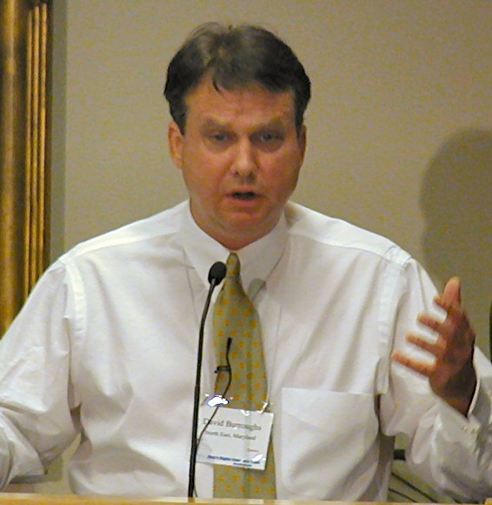
David Burroughs
VAWA Reauthorization: ACTION TIME
Get updated on our campain to make VAWA gender neutral from
our top VAWA lobbyist David Burroughs. Learn how you can
make a contribution. Discuss and learn more about our strategies that
are being employed.

