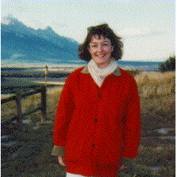
Carol McNamara
Lecturer
Department of Political Science
0725 Old Main Hill
Utah State University
Logan, Utah 84322-0725
Main Office: (435) 797-1306
Fax: (435) 797-3751

M 324C | (435)797-1835 | carol.mcnamara@.usu.edu
Education:
Ph.D. Boston College, 1996
Specialization:
Political Philosophy
Courses Offered:
PolS 2350 Introduction to Political Theory
PolS 3140 The Presidency
PolS 4310 History of Political Thought I
PolS 4320 History of Political Thought II
Special Awards:
Top Prof, Utah State University Mortar Board, 1994
Current Research:
Ancient Greek Political Thought
Politics and Literature
Publications:
"The Pursuit of Happiness, American Style: Tome Wolfe's Study of Status and Freedom," Forthcoming in Perspectives in Political Science, Winter 2005
Book Review: Socratic Citizenship, Dana Villa, in Canadian Journal of Political Science, December 2003.
"Men and Money in Tom Wolfe's America," book chapterin Seers and Judges: American Literature as Political Philosophy, Lexington Books, 2002.

Other Interests:
Reading, hiking, traveling.

Carol McNamara is a lecturer in Political Science at Utah State University in Logan. She received her Ph. D. from Boston College in 1996. She teaches political theory and a course on the American Presidency. Her research interests are in ancient political thought and politics and literature. In particular, she works on the thought of Xenophon and Plato. Currently, she is working on the writings, both fiction and non-fiction, of Tom Wolfe. She is the author of "Men and Money in Tom Wolfe’s America," published in Seers and Seekers (Lexington Press, 2001), and a recent as yet unpublished paper, "Transcendence in Tom Wolfe’s America," (presented at the American Political Science Association Annual Meeting, Boston, 2002).

