University of Wisconsin-Madison

Political Economy Colloquium

Jennifer Brick (jcbrick@wisc.edu)
Graduate Student Coordinator
Political Economy Colloquium
Department of Political Science
University of Wisconsin - Madison
110 North Hall, 1050 Bascom Mall
Madison, Wisconsin 53706

1997: Jennifer Brick served in Uzbekistan in Samarkand beginning in 1997

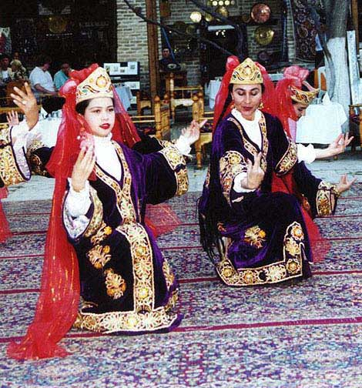
Returned Peace Corps Volunteer Jennifer Brick can be contacted at jcbrickawiscdedu
Country of Service: Uzbekistan
Training Group: 5
Cities you served in: Samarkand
Arrival Year: 1997
Departure Year: 1999
Work Description:
Teacher of English as a Second Language, Community Development
Originally posted: April 28, 2005

