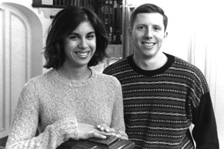

Sara Karimbhoy (GRS'01) and Matthew Altenburger (GRS'01)

