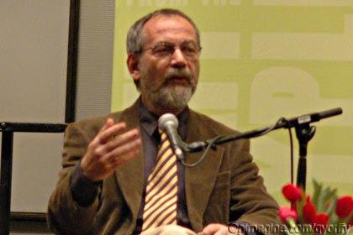
Gaspard Milkos Tamas

