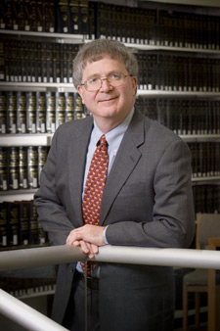
Federal Judge Michael McConnell

