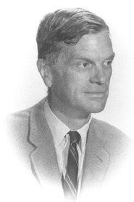 | Adam B. Ulam  1922-2000  Professor Emeritus  Harvard University  Former Director,  Russian Research Center  and Gurney Professor of History  and Political Science

