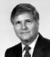
  J. Clayburn La Force, Jr.
  Dean Emeritus

