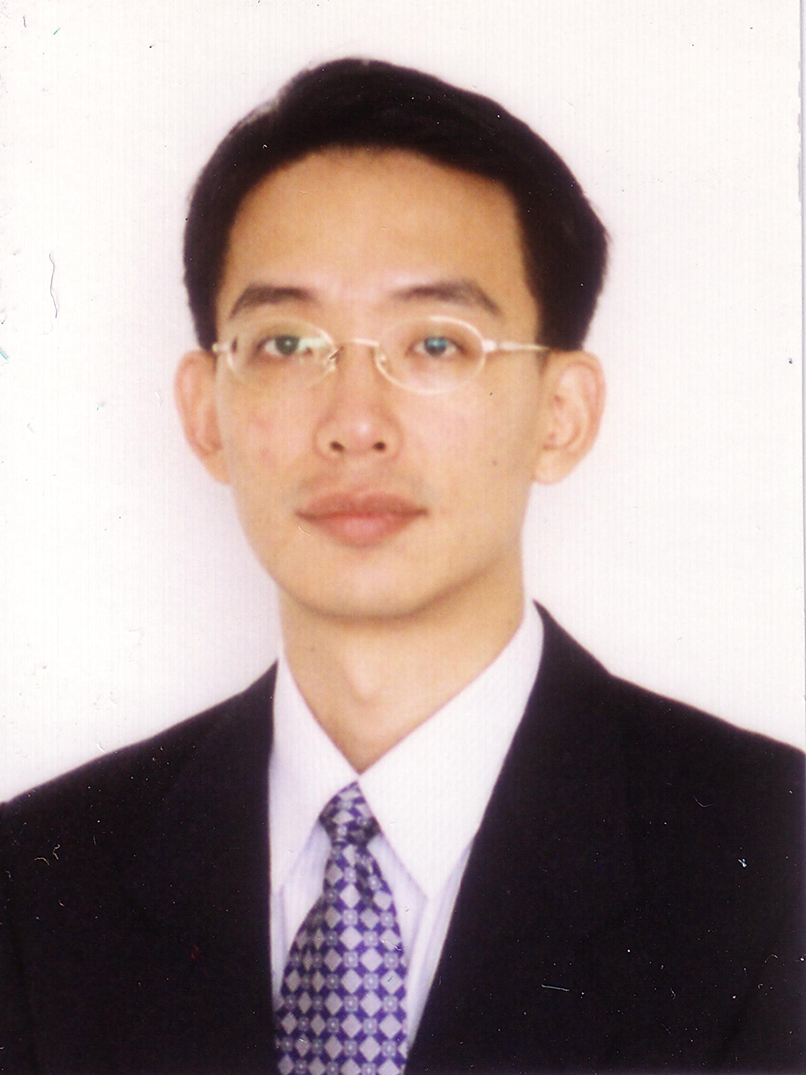
Sang-Yong Tom Lee

