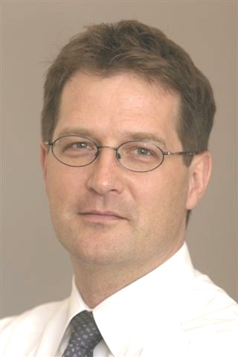 |  | Volker Wieland  Chair for Monetary Theory and Policy at  Goethe University Frankfurt

