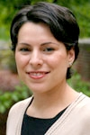Neva Kerbeshian Novarro

