BEAT’ACHON is the world’s premier Jewish A Cappella singing group

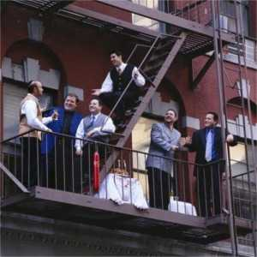
Daniel Matkowsky on ladder

