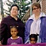Marla Brettschneider
and family
(on right)
2 adopted children and partner

