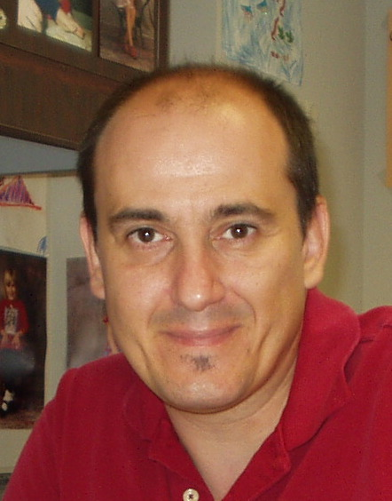

Sami Friedrich Dakhlia

