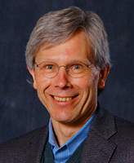 | David Austen-Smith  Earl Dean Howard Distinguished Professor of Political Economy

