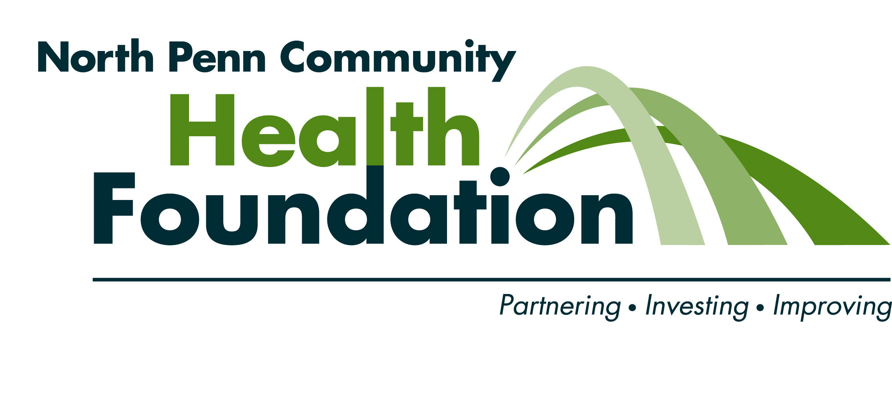

Matching Gift Request Form

North Penn Community Health Foundation Matching Gift program allows its board members; volunteers and employees to have their personal gifts to non-profit 501(c) (3) organizations matched up to $3,000 each calendar year. The donor must fill out Part A and send this form with their check to the organization. The organization completes Part B and returns the entire form to the North Penn Community Health Foundation. Upon receipt of a completed Matching Gift Request Form, assuming eligibility requirements are met; the Foundation will match the donor's gift and send a check directly to the organization.

PART A: DONOR INFORMATION [To be completed by individual making gift]

1.
Recipient Organization Phone number

Street Address City State Zip

2. Enclosed is my personal gift in the amount of: $
Date of Gift
3. This gift is:  unrestricted
 designated for support of:

4. Donor’s relationship (if any) to the Recipient Organization

I certify that this gift is solely for the use of the organization named and that neither I, nor any member of my family, will derive and direct or indirect financial benefit from this contribution. I further certify that the amount above is an individual gift and is not pooled with funds belonging to others. This gift meets the qualifications of the Matching Gift program and the purpose of this gift is consistent with the North Penn Community Health Foundation’s mission to improve the health, welfare and quality of life of the community.

Print full name of Donor Signature of Donor Date

PART B: CHARITABLE ORGANIZATION CONFIRMATION [To be completed by recipient organization]

1. Verify that your organization’s name and address listed in Part A are correct. If you need to make any changes, please note them in Part A.

2. Please attach a copy of your organization’s IRS determination letter indicating your status as a 501(c)(3) organization.

3. If you are a first time recipient organization, please provide a brochure, report or other descriptive materials that describes your organization and its work in the Foundation’s service community.

I certify that the amount of $ was received on (date) and this organization is classified as exempt from federal income tax under Code Section 501(c)(3). I further certify that no direct, tangible benefit will accrue to the donor, to any member of their family as a result of their gift and that the matching gift will be used for purposes consistent with the North Penn Community Health Foundation’s mission to improve the health, welfare and quality of life of the community.

Print name and title Signature of Organization’s Authorized Representative Date

4. Submit this completed form (and appropriate necessary documentation) to the address noted below.

Office Use Only: Approval Grant # 501(c)(3) Amount Date YTD Total ________

Matching Gift Request Procedures

- NPCHF board member, employee or volunteer (donor) completes all items in Part A.

- NPCHF donor sends the form along with their contribution to the recipient organization.

- Authorized representative from recipient organization completes Part B.

- Recipient organization returns the completed form along with their IRS determination letter to the Foundation. If the recipient organization is a first time recipient of Foundation grant funds, they must provide a brochure, report or other descriptive materials that describes the organizations work in the Foundation’s service community.
Foundation verifies the eligibility of the organization and that the match is in compliance with the Foundation’s policy. Our policy is to offer a matching gift to organizations that have a health/human service mission/focus and that contribute to the health and welfare of residents/organizations in the foundation’s service community. We do not provide matching gifts to:
  - Individuals or for-profit organizations, firms or companies;
  - Disease-specific charities;
  - Endowments;
  - Debt reduction;
  - Clinical or academic research;
  - Publications unless such publications are an integral component for a specific grant initiative;
  - Student projects;
  - Athletic recreational clubs or alumni activities;
  - Replacement of lost government-funds or supplementation of private/public insurance;
  - Religious congregations; or
  - Fraternal, political or civic groups.
- Foundation mails a check in the amount of a one-for-one match to the recipient organization subject to the limitations of the Foundation’s matching gifts policy.

